A PROJECT REPORT

on

**“****Malware Analysis Lab”**

*Submitted By*

**Mr. Yash Chitranjan Singh**

**Seat Number- 2222401**

*in partial fulfillment for the award of the degree*

*of*

**BACHELOR OF SCIENCE**

in

**COMPUTER SCIENCE**

*Under the guidance of*

**Department of Computer Science**



**D. G. RUPAREL COLLEGE of Arts, Science & Commerce**

**SEM VI**

**(2023 – 2024)**



**D. G. RUPAREL COLLEGE OF ARTS, SCIENCE & COMMERCE**

**SENAPATI BAPAT MARG, MAHIM, MUMBAI, MAHARASHTRA 400016**

**Department of Computer Science**

# CERTIFICATE

This is to certify that **Mr. Yash Chitranjan Singh,** Seat Number- **2222401** Roll Number- **CS-6150** of T. Y. B. Sc. C.S. (Sem VI**)** class has satisfactorily completed the **Malware Analysis Lab,** to be submitted in the partial fulfillment for the award of **Bachelor of Science in Computer Science** during the academic year 2023 - 2024.

**Date of Submission:**

**Project Guide: Head / Incharge,**

**Department of Computer Science**

**College Seal Signature of Examiner**

# DECLARATION

I, Yash Chitranjan Singh, hereby declare that the project entitled “Malware Analysis Lab” submitted in the partial fulfillment for the award of **Bachelor** **of Science** in **Computer Science** during the academic year **2023 – 2024** is my original work and the project has not formed the basis for the award of any degree, associateship, fellowship or any other similar titles.

**Signature of the Student:**

**Place:**

**Date:**

# ACKNOWLEDGEMENT

I am completely satisfied at this moment to present my project "LearnIt (Web Application)", it has been a challenging but learning experience for me. Though challenging it made me more confident with the technologies that I have used. I enjoyed working on this project a lot.

I feel very grateful to my friends and teachers, for testing my project & giving me hints and feedback which made my project even better.

# Table of Contents

CERTIFICATE 2

DECLARATION 3

ACKNOWLEDGEMENT 4

Table of Contents 5

Table of Figure 7

Table 7

CHAPTER 1: INTRODUCTION 8

1.1. Background 8

1.2. Objectives 8

1.3. Purpose, Scope and Applicability 9

1.3.1. Purpose of this System 9

1.3.2. Scope of this System 9

1.3.3. Applicability 10

1.4. Achievements 11

1.4.1. Comprehensive Course and Content Development 11

1.4.2. User Friendly Interface 12

1.5. Requirement Analysis 12

1.6. System Requirements 15

1.7. Software Requirements 17

1.8. Gantt Chart 18

CHAPTER 2: REQUIREMENT AND ANALYSIS 20

2.1. Problem Definition 20

2.2. Requirement Specification 21

2.3. Planning and Scheduling 21

2.3.1. Work Breakdown Structure 21

2.3.2. Resource Allocation 22

2.3.3. Documentation and Reporting 22

2.4. Software and Hardware Specification 22

2.4.1. System Requirements 22

2.4.2. Software Requirements 22

2.4.3. Justification of Platform 23

CHAPTER 3: SYSTEM DESIGN 24

3.1. Basic Modules 24

3.1.1. User Management 24

3.1.2. Course Management 24

3.1.3. Content Delivery 24

3.1.4. Admin Dashboard 24

3.2. Data Design 24

3.2.1. Schema Design 24

3.2.2. Data Integrity and Constraints 28

3.3. Logic Diagrams 29

3.3.1. Event Table 29

3.3.2. Use Case Diagram 30

3.3.3. Activity Diagram 32

3.3.4. Class Diagram 36

3.3.5. Object Diagram 38

3.3.6. Sequence Diagram 40

3.3.7. State Chart Diagram 42

3.3.8. Component Diagram 44

3.3.9. Deployment Diagram 46

3.4. User Interface Design 48

3.5. Test Cases Design 61

3.5.1. Test Case Development Process 61

3.5.2. Test Case Structure 61

3.5.3. Test Case Coverage 63

3.5.4. Test Data and Environment Setup 66

CHAPTER 4: IMPLEMENTATION AND TESTING 68

4.1. Source Code 68

4.1.1. Login Module 68

4.1.2. Course Upload Module 69

4.1.3. Course Access Module 71

4.1.4. Payment Module 72

4.2. Testing Approach 75

4.2.1. Unit Testing 75

4.2.3. Integrated Testing 76

4.2.3. Beta Testing 76

4.3. Test Cases Results 77

CHAPTER 5: CONCLUSION 81

5.1. Conclusion 81

5.2. Limitation of the System 82

5.3. Future Scope of the Project 82

REFERENCES 83

GLOSSARY 84

# Table of Figure

Figure 1: Gantt Chart 19

Figure 2: Schema Diagram 27

Figure 3: Use Case Diagram 31

Figure 4: Student Activity Diagram 33

Figure 5: Instructor Activity Diagram 34

Figure 6: Admin Activity Diagram 35

Figure 7: Class Diagram 37

Figure 8: Object Diagram 39

Figure 9: Sequence Diagram 41

Figure 10: State Chart Diagram 43

Figure 11: Component Diagram 45

Figure 12: Deployment Diagram 47

# Table

Table 1: Event Table 29

Table 2: Test Case Structure Example 62

Table 3: Test Cases 65

Table 4: Test Cases Result 80

# CHAPTER 1: INTRODUCTION

## Background

"LearnIt" functions as an expansive and user-centric online learning hub, dedicated to fostering a culture of continuous learning and skill development among individuals from diverse academic and professional backgrounds. The platform boasts an extensive repertoire of courses spanning a broad spectrum of subjects and fields of interest, meticulously curated to cater to the multifaceted needs and aspirations of its users.

Central to the ethos of LearnIt is the ethos of inclusivity, providing an inclusive environment for learners across various proficiency levels. Whether users are novices seeking foundational knowledge or experts aiming to delve deeper into intricate subjects, LearnIt offers an assortment of courses tailored to accommodate different skill levels. This approach ensures that learners have access to a plethora of resources and materials, allowing for continuous growth and expertise enhancement at their own pace and convenience.

Moreover, LearnIt actively encourages a vibrant community of learners, educators, and subject matter experts. By inviting experts to contribute as instructors, the platform enhances its educational offerings, enriching the learning experience for all users. Through engaging video lectures, interactive quizzes, downloadable materials, assignments, and discussion forums, the platform ensures a diverse range of resources to cater to various learning preferences.

Flexibility and convenience are paramount in LearnIt's design. Its self-paced learning model empowers users to dictate their learning journey, enabling them to decide when and where they engage with the wealth of educational content available on the platform. This approach accommodates users' personal and professional commitments while fostering a conducive learning environment.

In essence, LearnIt isn't merely an online learning platform; it is a dynamic ecosystem that values and encourages lifelong learning, personal development, and knowledge acquisition. By nurturing an environment that prioritizes curiosity, growth, and achievement, LearnIt endeavors to be a cornerstone of learning excellence for individuals worldwide.

## 1.2. Objectives

"LearnIt" functions as an expansive and user-centric online learning hub, dedicated to fostering a culture of continuous learning and skill development among individuals from diverse academic and professional backgrounds. The platform boasts an extensive repertoire of courses spanning a broad spectrum of subjects and fields of interest, meticulously curated to cater to the multifaceted needs and aspirations of its users.

Central to the ethos of LearnIt is the ethos of inclusivity, providing an inclusive environment for learners across various proficiency levels. Whether users are novices seeking foundational knowledge or experts aiming to delve deeper into intricate subjects, LearnIt offers an assortment of courses tailored to accommodate different skill levels. This approach ensures that learners have access to a plethora of resources and materials, allowing for continuous growth and expertise enhancement at their own pace and convenience.

Moreover, LearnIt actively encourages a vibrant community of learners, educators, and subject matter experts. By inviting experts to contribute as instructors, the platform enhances its educational offerings, enriching the learning experience for all users. Through engaging video lectures, interactive quizzes, downloadable materials, assignments, and discussion forums, the platform ensures a diverse range of resources to cater to various learning preferences.

Flexibility and convenience are paramount in LearnIt's design. Its self-paced learning model empowers users to dictate their learning journey, enabling them to decide when and where they engage with the wealth of educational content available on the platform. This approach accommodates users' personal and professional commitments while fostering a conducive learning environment.

In essence, LearnIt isn't merely an online learning platform; it is a dynamic ecosystem that values and encourages lifelong learning, personal development, and knowledge acquisition. By nurturing an environment that prioritizes curiosity, growth, and achievement, LearnIt endeavors to be a cornerstone of learning excellence for individuals worldwide.

## 1.3. Purpose, Scope and Applicability

### 1.3.1. Purpose of this System

The e-learning portal we've envisioned embodies a groundbreaking and highly efficient application system designed to revolutionize the management of educational courses, user enrollments, and content dissemination. At its core, our system's primary purpose is to streamline and innovate the entire educational process, significantly reducing manual administrative burdens and enhancing the overall learning experience for all stakeholders involved.

Central to our system's purpose is the seamless management of educational courses. We aim to provide a robust and user-friendly platform that simplifies the creation, organization, and delivery of diverse courses. By leveraging innovative technologies, our system endeavors to automate tedious administrative tasks associated with course management. This includes course creation, scheduling, updating content, and ensuring easy accessibility for both learners and instructors.

Moreover, our system is engineered to efficiently handle user enrollments. It facilitates a hassle-free enrollment process, enabling users to effortlessly sign up for courses, manage their profiles, and track their learning progress. By automating enrollment procedures and providing a user-centric interface, our platform ensures a frictionless experience, thereby enhancing user engagement and satisfaction.

A significant facet of our system's purpose lies in optimizing content distribution. Through the integration of cutting-edge technologies and user-centric design principles, we aspire to create a content distribution framework that ensures seamless access to resources. The platform will offer an extensive repository of educational materials, including videos, downloadable resources, interactive modules, and assessments. This comprehensive content distribution system aims to provide learners with rich, diverse, and easily accessible educational content to support their learning objectives.

Furthermore, by minimizing manual administrative work and optimizing system functionalities, our platform aims to empower administrators, educators, and instructors. It provides them with intuitive tools and functionalities within the system's administrative portal, enabling efficient course management, user engagement, and content delivery. This empowerment allows educators to focus more on delivering quality content and engaging with learners, thereby enriching the overall educational experience.

Ultimately, the overarching goal of our e-learning portal is to transform the landscape of online education by creating a sophisticated, user-friendly, and efficient system that redefines the way educational courses are managed, accessed, and delivered. Through automation, innovation, and a user-centric approach, we endeavor to revolutionize the educational experience, making learning more accessible, engaging, and impactful for all users.

### 1.3.2. Scope of this System

The scope of our innovative e-learning portal extends to a comprehensive and all-encompassing platform that aims to revolutionize the landscape of educational content accessibility, engagement, and utility. Designed with meticulous attention to detail, our platform endeavors to serve a wide spectrum of users, embracing learners, educators, and administrators within its ambit.

For learners, our system offers an immersive and versatile educational experience, transcending the boundaries of traditional learning paradigms. With a vast array of courses spanning diverse subjects and skill levels, learners can explore, engage with, and acquire knowledge tailored to their specific interests and proficiency levels. From beginners seeking foundational understanding to seasoned professionals aiming for advanced expertise, our platform is a beacon of learning opportunity for all.

Educators and instructors find a dynamic and enriching environment within our system, where they can showcase their expertise and contribute to a growing repository of educational content. Through the platform, they can craft and deliver engaging courses, share their knowledge with a broad audience, and interactively engage with learners, thereby fostering a collaborative and stimulating learning atmosphere.

Administrators wield powerful tools and functionalities through the system's administrative portal, allowing them to seamlessly manage courses, monitor user engagement, and ensure the smooth functioning of the platform. This administrative scope extends to overseeing enrollments, maintaining user accounts, updating content, and optimizing the overall learning management process.

Furthermore, the scope of our e-learning portal transcends geographical barriers, offering accessibility to a global audience. It accommodates varied learning preferences by providing a spectrum of learning resources, including video lectures, downloadable materials, interactive modules, assessments, and forums for collaborative discussion.

The platform's scope also encompasses a commitment to innovation and continual evolution. Through regular updates, enhancements, and integration of cutting-edge technologies, we aim to ensure that the system remains dynamic, responsive, and at the forefront of the ever-evolving landscape of online education.

In essence, the scope of our e-learning portal is expansive and inclusive, aimed at transforming the educational experience into a dynamic, engaging, and accessible journey for all stakeholders. By embracing a diverse range of users and offering a multifaceted learning ecosystem, we aspire to redefine educational paradigms and empower individuals on their quest for knowledge and personal development.

### 1.3.3. Applicability

* Learner Account Registration:

The learner account registration facet within our e-learning platform embodies the foundational gateway for users to access a world of educational opportunities. Seamlessly designed and user-centric, this segment streamlines the process for learners to create and manage their accounts efficiently. Through a simplified and intuitive registration process, individuals can swiftly sign up, personalize their profiles, and gain entry to a plethora of courses spanning diverse subjects and skill levels.

The registration interface prioritizes user convenience while collecting essential information, ensuring a smooth onboarding experience for learners. Furthermore, the system incorporates robust security measures to safeguard user data, implementing encryption and authentication protocols to maintain the confidentiality and integrity of learners' personal information.

* Course Discovery and Access:

Our platform's course discovery and access feature embody an expansive gateway for learners to explore, engage with, and benefit from an extensive array of educational content. Rooted in user-centric design principles, this facet empowers learners to navigate through a rich tapestry of courses effortlessly. Through an intelligently curated interface, users can discover courses aligned with their interests and proficiency levels.

The platform ensures a user-friendly search and filtering mechanism, allowing individuals to explore courses based on subjects, categories, skill levels, and user reviews. Once identified, learners can easily access their chosen courses, ensuring a seamless transition from discovery to active engagement. This segment emphasizes accessibility, ensuring that learners can navigate, enroll in, and commence their learning journey with unparalleled ease and efficiency.

* Interactive Learning:

The interactive learning facet within our platform serves as the cornerstone of an enriched educational experience. It encompasses a dynamic and engaging environment that encourages active participation and knowledge absorption. Through an amalgamation of diverse resources such as video lectures, downloadable materials, interactive quizzes, assignments, and discussion forums, learners are provided with multifaceted tools to deepen their understanding and engagement.

The platform facilitates interactive sessions, enabling learners to collaborate with instructors and peers, seek guidance, and foster a conducive environment for learning. Moreover, it emphasizes adaptive learning methodologies, allowing users to progress at their preferred pace and style, ensuring a personalized and impactful learning experience tailored to individual needs.

* Administrative Control:

The administrative control segment within our e-learning platform represents a sophisticated yet intuitive interface designed to empower administrators with comprehensive oversight and management capabilities. Anchored in efficiency and functionality, this feature equips administrators with robust tools to effortlessly monitor and manage various aspects of the platform. From overseeing enrollments, managing user accounts, and updating course content to analyzing user engagement metrics and ensuring the seamless operation of the learning management system, this segment streamlines administrative tasks.

The system provides customizable dashboards, analytics tools, and reporting mechanisms, allowing administrators to gain insights, make informed decisions, and optimize the platform's performance. Additionally, stringent access controls and permission settings are integrated to ensure that administrative functions are executed securely and efficiently.

## 1.4. Achievements

### 1.4.1. Comprehensive Course and Content Development

* Diverse Course Offerings:

LearnIt embarked on a transformative journey in course development, meticulously curating an extensive and diverse catalog that transcends conventional boundaries. The platform prides itself on offering a multifaceted array of courses, exceeding multiple disciplines, and catering to varying proficiency levels. Through tireless dedication and collaboration with subject matter experts,

LearnIt has amassed a treasure trove of knowledge, boasting an extensive collection that spans an array of subjects, encompassing technology, business, arts, sciences, languages, and more. The catalog stands as a testament to LearnIt's commitment to providing a holistic learning experience, addressing the varied learning needs and aspirations of users worldwide.

* Rigorous Content Curation:

LearnIt's commitment to excellence extends beyond mere course offerings. The platform meticulously scrutinizes and crafts course content to ensure relevance, accuracy, and educational value. Employing rigorous standards, content is curated, vetted, and continually updated to resonate with the latest trends, industry standards, and best practices.

The content development team collaborates with domain experts, leveraging their insights to create enriching materials, including engaging video lectures, comprehensive study resources, interactive modules, and assessments. Each piece of content undergoes rigorous scrutiny and refinement, aiming not just to disseminate information but to inspire and empower learners on their educational journey.

### 1.4.2. User Friendly Interface

* Revolutionizing User Experience:

LearnIt prioritizes the user experience and embarked on a transformative journey of UI/UX enhancements. These enhancements revolved around refining the platform's interface to create an intuitive, user-friendly environment. The interface underwent a holistic makeover, meticulously designed to streamline navigation, optimize course accessibility, and facilitate seamless interaction. By implementing user-centric design principles and conducting extensive usability testing, the platform achieved a harmonious fusion of aesthetics and functionality.

It incorporates intuitive navigation tools, clear course categorization, and personalized dashboards, fostering an environment where users effortlessly navigate through the platform. Additionally, the revamped interface promotes a responsive design, ensuring compatibility across diverse devices, catering to the dynamic learning preferences of users accessing LearnIt from various technological platforms.

* Enhanced Interactivity and Engagement:

The redesigned user interface fosters not only ease of navigation but also facilitates increased engagement. Through strategic placement of interactive elements, such as forums, live sessions, and collaborative tools, LearnIt catalyzes active participation and knowledge exchange among learners.

The platform's redesigned interface serves as a bridge that connects users to an enriched educational ecosystem, inspiring a vibrant learning community. Moreover, the interface evolves continually, incorporating user feedback and data-driven insights to ensure a dynamic and evolving user experience that resonates with the needs and preferences of its diverse user base.

## 1.5. Requirement Analysis

Requirement analysis, also referred to as requirements engineering, stands as a pivotal phase within the product development lifecycle, tasked with comprehensively understanding, documenting, and defining the needs, objectives, and expectations of a new product or system. It serves as a foundational pillar that underpins the success of the entire development process, ensuring alignment between the stakeholders' vision and the final product delivered.

* Understanding Stakeholder Needs:

The requirement analysis process initiates by engaging with stakeholders from diverse backgrounds, including end-users, clients, domain experts, and business analysts. The aim is to elicit and comprehend their expectations, aspirations, challenges, and anticipated functionalities from the prospective product.

Through workshops, interviews, surveys, and collaborative sessions, a comprehensive understanding of stakeholders' needs and objectives is garnered. This phase involves active listening, probing, and empathy to identify implicit and explicit requirements, encompassing functional, non-functional, and technical aspects.

* Requirement Elicitation and Documentation:

The next crucial step involves the systematic gathering and documentation of requirements in a clear, structured manner. This stage often employs various techniques such as use case analysis, interviews, surveys, prototyping, and brainstorming sessions. Requirements are categorized, prioritized, and articulated using standardized formats like requirement documents, user stories, use cases, and wireframes. These documents serve as the foundation for communication and reference throughout the development lifecycle, ensuring a shared understanding among all stakeholders.

* Analysis and Validation:

Once requirements are documented, they undergo rigorous analysis to ensure clarity, feasibility, and consistency. This involves evaluating requirements for completeness, correctness, relevance, and feasibility within the constraints of the project, including technical, budgetary, and time limitations.

Validation involves constant collaboration and verification with stakeholders to confirm that the documented requirements accurately capture their needs. Any discrepancies or ambiguities are addressed through iterative discussions and refinement, ensuring alignment with the overarching project goals.

* Requirement Traceability and Management:

Throughout the development lifecycle, requirement traceability is maintained to establish clear links between various requirements and the final product. This aids in tracking the evolution of requirements, facilitating change management, and ensuring that every development effort aligns with the intended outcomes. Requirements are managed using specialized tools or software, enabling version control, change tracking, and collaboration among teams.

In essence, requirement analysis serves as the cornerstone of product development, laying the groundwork for a successful and impactful product by ensuring that the final solution aligns with stakeholders' needs, expectations, and business objectives. It fosters a collaborative environment, where stakeholders and development teams work hand-in-hand to transform envisioned ideas into tangible and valuable products.

The following are the activities of requirements analysis.

* Clean User Interface:

**Objective**: Develop an aesthetically pleasing and user-friendly interface that ensures an engaging and intuitive user experience. Emphasize minimalist design principles, consistent layout, and easy navigation, fostering user engagement and ease of use across the platform.

* User Authentication and Authorization:

**Objective**: Implement a robust and secure system for user authentication, enabling users to securely log in while maintaining the confidentiality of their credentials. Additionally, establish an authorization framework to regulate access permissions based on user roles, ensuring data security and privacy.

* Course Management:

**Objective**: Create a comprehensive course management system, empowering administrators and instructors to efficiently organize, update, and oversee courses. Prioritize functionalities such as curriculum structuring, scheduling, content uploading, and management tools for course materials.

* Payment Integration:

**Objective**: Seamlessly integrate secure payment gateways to facilitate smooth and secure transactions for course enrollment. Ensure compatibility with multiple payment methods, implement stringent security measures, and optimize the payment process for user convenience.

* Content Delivery:

**Objective**: Develop a reliable and efficient content delivery system, ensuring swift and accessible distribution of educational materials. Incorporate features for seamless video streaming, downloadable resources, interactive content, and adaptive delivery for varied learning needs.

* Student Features:

**Objective**: Enrich the learning experience by integrating features tailored to students' needs. Implement tools for progress tracking, interactive quizzes, assignments, discussion forums, and personalized learning paths to enhance engagement and knowledge acquisition.

* Instructor Features:

**Objective**: Provide instructors with a suite of tools and functionalities to create and manage courses effectively. Offer content creation tools, grading systems, analytics, communication channels, and administrative capabilities to facilitate effective course delivery.

* One-on-One Doubt Sessions:

**Objective**: Establish a platform facilitating direct interactions between instructors and learners for personalized doubt resolution. Enable communication channels or sessions dedicated to addressing learners' queries promptly and comprehensively.

* Content Moderation:

**Objective**: Develop robust content moderation mechanisms to maintain the quality, accuracy, and appropriateness of educational materials. Implement tools for monitoring, reviewing, and moderating user-generated content to ensure compliance with platform guidelines.

* Search:

**Objective**: Design and implement a robust search functionality allowing users to discover courses, materials, and resources efficiently. Incorporate advanced search options, filters, and tags to enhance discoverability and navigation across the platform.

* Admin Panel:

**Objective**: Create a comprehensive administrative dashboard equipped with tools for effective management of users, courses, payments, content moderation, analytics, and system configurations. Empower administrators with functionalities to oversee and optimize platform operations efficiently.

* Security:

**Objective**: Implement a robust security infrastructure to safeguard sensitive user data, transactions, and platform integrity. Incorporate encryption, secure authentication mechanisms, and stringent access controls to prevent unauthorized access, data breaches, and ensure compliance with data protection regulations (such as GDPR or HIPAA). Regular security audits, vulnerability assessments, and timely patches or updates are essential to maintaining a secure environment.

* Feedback and Reporting:

**Objective**: Establish mechanisms for users to provide feedback on courses, platform usability, and overall experience. Develop reporting tools that generate insights through analytics, allowing administrators and instructors to assess user engagement, performance metrics, and areas needing improvement. Incorporate feedback loops to continuously enhance the platform based on user input.

* Scalability and Performance:

**Objective**: Design the platform to accommodate scalability requirements and ensure optimal performance, even with increased user traffic or content volume. Employ scalable architecture, load balancing, caching mechanisms, and optimized database structures to maintain responsiveness and seamless functionality during peak usage periods.

* Support and Maintenance:

**Objective**: Provide efficient and responsive support channels to assist users with queries, technical issues, and troubleshooting. Establish user support mechanisms like help desks, FAQs. Additionally, plan for ongoing maintenance, bug fixes, updates, and regular system enhancements to ensure the platform's stability, reliability, and up-to-date functionality.

* Monetization Strategy:

**Objective**: Develop a clear monetization strategy to generate revenue from the platform. Explore diverse revenue streams such as subscription models, pay-per-course, freemium models, partnerships, or advertisements. Align the strategy with user needs and market trends while ensuring a fair value exchange for users and profitability for the platform.

## 1.6. System Requirements

System requirements in the context of software or hardware refer to the essential specifications, configurations, and capabilities necessary for a device or system to effectively run a particular software application or utilize specific hardware components. These requirements dictate the minimum standards a system must meet to ensure optimal performance, functionality, and compatibility with the intended software or hardware.

**Software System Requirements**:

Software system requirements outline the necessary conditions for a computer or device to efficiently run a specific software application. These requirements encompass:

* Operating System Compatibility: Specify the compatible operating systems (such as Windows, macOS, Linux, etc.) and their versions required to run the software effectively.
* Hardware Specifications: Define the minimum hardware components necessary, including CPU (processor) type and speed, RAM (memory) capacity, available storage space (hard disk or SSD), and GPU (graphics processing unit) requirements.
* Software Dependencies: Identify any essential software dependencies or frameworks required for the application to function correctly, such as specific runtime environments, libraries, or additional software tools.
* Network Requirements: Specify network-related requirements, such as minimum internet speed or network connectivity prerequisites if the software relies on cloud services or online functionalities.

**Hardware System Requirements:**

Hardware system requirements pertain to the specifications and capabilities a device or system must possess to effectively utilize specific hardware components, such as:

* Compatibility with Peripherals: Detail the compatibility of the hardware with external devices or peripherals, such as printers, scanners, external drives, or specialized input/output devices.
* Hardware Interface Support: Specify the required hardware interfaces, such as USB, HDMI, DisplayPort, Ethernet, or other connectivity options, necessary for seamless integration with other devices or systems.
* Power and Cooling Requirements: Outline power supply needs, voltage requirements, and cooling mechanisms necessary to support and sustain the hardware's performance and prevent overheating or system failures.

In essence, system requirements serve as a guideline for users, administrators, or IT personnel to ensure that their devices or systems meet the essential criteria needed to successfully deploy, operate, and utilize a software application or hardware component. Adhering to these requirements ensures optimal performance, compatibility, and functionality while minimizing potential issues or incompatibilities.

The provided system requirements serve as guidelines for users intending to access our web application. These specifications ensure optimal performance and compatibility with the application, allowing users to experience the platform's functionalities seamlessly.

* Operating System Compatibility:
  + Linux: The web application is compatible with various distributions of the Linux operating system, allowing users on Linux-based systems to access and utilize the platform efficiently.
  + Windows 10 or Later: Users with Windows 10 or newer versions can access the web application, ensuring compatibility with one of the widely used operating systems.
  + macOS High Sierra 10.13 or Later: The compatibility with macOS High Sierra 10.13 or later ensures that users on Apple devices running these versions can access the application without compatibility issues.
* Processor Requirements:
  + Intel Pentium 4 or Later: The processor requirement specifies the minimum processor model needed for users' devices to effectively run the web application. Intel Pentium 4 or later processors are capable of handling the application's computational needs.
* System Memory (RAM) and Storage (ROM):
  + 2GB RAM: Users' devices are recommended to have at least 2GB of RAM available. Sufficient RAM ensures smooth execution of the application, allowing it to run efficiently without performance bottlenecks.
  + 15GB of ROM: The specified ROM (Read-Only Memory) or storage space requirement indicates the minimum available storage needed on users' devices for the application's installation or data caching purposes.

Adhering to these guidelines ensures that users' devices meet the necessary criteria to effectively access and utilize your web application. It helps prevent potential compatibility issues, ensures optimal performance, and provides a consistent user experience across different operating systems and hardware configurations.

## 1.7. Software Requirements

* Code Editor - Eclipse IDE:
  + Purpose: Eclipse IDE serves as the integrated development environment for writing, editing, debugging, and managing the website's Java-based server-side code.
  + Functionality: Eclipse IDE provides a comprehensive set of tools, including code editing, syntax highlighting, debugging features, and project management capabilities, facilitating efficient development and maintenance of the website's codebase.
* Java Version - 17:
  + Purpose: Java serves as the primary programming language for the server-side development of the website.
  + Functionality: Java 17, being the specified version, provides the necessary language features, libraries, and functionalities required to develop robust and scalable server-side components for the web application.
* Server - Apache Tomcat Version 9.0:
  + Purpose: Apache Tomcat functions as the web server and servlet container responsible for hosting and executing Java-based web applications.
  + Functionality: Tomcat Version 9.0 provides an environment to render JavaServer Pages (JSP) code onto web browsers, handling HTTP requests, managing servlets, and ensuring the delivery of dynamic content to users.
* Database - MongoDB:
  + Purpose: MongoDB serves as the database management system, handling data storage, retrieval, and management for the web application.
  + Functionality: MongoDB offers a scalable, NoSQL database solution, providing flexibility in data handling, JSON-like document storage, and efficient query capabilities, enhancing the website's data management capabilities.
* Supported Browsers - Chrome | Brave | Edge:
  + Purpose: The web application is optimized for and supports multiple browsers to ensure a consistent user experience across different platforms.
  + Functionality: Compatibility with browsers such as Chrome, Brave, and Edge signifies that the website is tested and optimized to function seamlessly on these browsers, ensuring accessibility and usability for a broader user base.

Adhering to these specified software requirements ensures a cohesive and functional development environment, enabling efficient coding, server-side processing, data management, and ensuring compatibility with popular browsers, thereby enhancing the accessibility and usability of the web application across different user environments.

## 1.8. Gantt Chart

A Gantt chart is a popular project management tool used to visually represent the scheduling and timing of various tasks or activities within a project. It provides a structured and graphical representation of a project's timeline, task dependencies, start and end dates, and progress tracking.

**Key Components of a Gantt Chart:**

* Task List: The chart contains a list of tasks or activities required to complete the project. Each task is represented as a separate bar or line in the chart.
* Timeline: The horizontal axis of the chart represents time, typically broken down into days, weeks, months, or other relevant timeframes based on the project's duration.
* Task Duration: Each task is depicted as a horizontal bar or line spanning across the timeline, indicating its start date, end date, and duration. The length of the bar corresponds to the estimated or actual time required to complete the task.
* Task Dependencies: Gantt charts often display task dependencies or relationships between different activities. For instance, some tasks might be dependent on the completion of others, and these dependencies are indicated through linking or arrows between the related tasks.
* Milestones: Significant project milestones, such as key deliverables or major accomplishments, are highlighted on the Gantt chart to mark important points in the project's timeline.

**Purpose of a Gantt Chart:**

* Planning and Scheduling: Gantt charts aid in planning project timelines, allocating resources, and scheduling tasks efficiently. They provide a clear overview of the project's progress and help in managing deadlines.
* Task Coordination: They assist project managers and team members in understanding task sequences, dependencies, and how each task aligns with the overall project timeline.
* Communication and Tracking: Gantt charts serve as effective communication tools, allowing stakeholders to visualize the project's status, identify bottlenecks, and track progress against the planned schedule.
* Resource Allocation: By displaying task durations and their overlaps, Gantt charts help in optimizing resource allocation and preventing overloading of team members.

**Advantages of Using Gantt Charts:**

* Clear Visualization: Offers a visual representation of the project's timeline and tasks.
* Task Dependencies: Shows relationships between tasks, highlighting dependencies.
* Progress Tracking: Enables easy tracking of task progress and overall project status.
* Efficient Planning: Aids in effective planning, scheduling, and resource allocation.

Gantt charts are versatile and widely used across various industries and project types due to their effectiveness in planning, monitoring, and managing project timelines and activities.

Figure 1: Gantt Chart

# CHAPTER 2: REQUIREMENT AND ANALYSIS

## 2.1. Problem Definition

**Existing Problem with Online Learning Platforms:**

* Lack of Personalized Instruction:

The current challenge faced by many existing online learning platforms, such as Udemy, lies in their inability to facilitate direct and personalized interaction between instructors and learners. This absence of direct engagement hampers the learning experience significantly. Learners encounter difficulties seeking clarification, addressing specific learning needs, and receiving personalized support during their educational journey.

* Impediment to Optimal Learning Outcomes:

This limitation inhibits learners from fully comprehending complex concepts and subjects. As a result, achieving optimal learning outcomes becomes challenging. The one-size-fits-all approach adopted by many platforms fails to cater to the diverse learning needs and preferences of individual students and professionals across various academic disciplines.

* Growing Demand for Personalized Learning:

There's an increasing demand for flexible and accessible learning options in the educational landscape. Learners seek the convenience of online education but still require personalized attention and guidance to maximize their learning potential. The lack of adequate personalized instruction and support leads to disengagement, difficulty in grasping concepts, and ineffective application of acquired knowledge.

**The Solution Offered by LearnIt:**

* Bridging the Gap with Personalized Instruction:

The development of the LearnIt platform aims to address these challenges by introducing a solution that allows learners to book personalized doubt-clearing sessions directly with instructors. By filling the gap left by existing platforms, LearnIt seeks to provide learners with an interactive and supportive learning environment that fosters individualized instruction.

* Enabling Tailored Guidance and Engagement:

LearnIt endeavors to empower learners by offering them the opportunity to engage directly with instructors, clear doubts, and receive individualized feedback. This approach ensures that learners receive tailored guidance aligned with their unique learning needs. The platform's emphasis on personalized instruction aims to enhance comprehension, engagement, and overall learning outcomes for users across diverse academic backgrounds and skill levels.

* Empowering Learners for Success:

Through personalized instruction and support, LearnIt strives to create an environment conducive to effective learning experiences. By bridging the gap between learners and instructors, the platform aims to empower learners, helping them upskill, excel in their educational pursuits, and succeed in achieving their learning objectives.

In essence, the development of the LearnIt platform responds to the critical need for personalized instruction in online education, aiming to revolutionize the learning experience by offering tailored guidance and support to learners, thereby enhancing their learning outcomes and overall educational journey.

## 2.2. Requirement Specification

Requirement Specification or requirements engineering is a process used to determine the needs and expectations of a new product. The following are the activities of requirements analysis.

* Clean User Interface
* User Authentication and Authorization
* Course Management
* Payment Integration
* Content Delivery
* Student Features
* Instructor Features
* One-on-One Doubt Sessions
* Content Moderation
* Search
* Admin Panel
* Security
* Feedback and Reporting
* Scalability and Performance
* Support and Maintenance
* Monetization Strategy

*Note: - Points explained in* *1.5**.*

## 2.3. Planning and Scheduling

### 2.3.1. Work Breakdown Structure

* Frontend Development
  + User Interface Design:

User Interface Design: This involves creating an intuitive and visually appealing interface for the LearnIt platform, ensuring ease of navigation and user engagement.

* + Course Browsing and enrollment features:

Designing and implementing functionalities that allow users to explore courses, view details, and enroll in desired courses seamlessly.

* + Video Lecture Playback Functionality:

Developing the feature that enables users to access and view video lectures within the platform, ensuring smooth playback and user-friendly controls.

* Backend Development
  + Database Design and Implementation:

Planning and creating the database structure for storing user data, course details, and other necessary information.

* + User Authentication and Enrollment Feature:

Implementing secure authentication mechanisms and enrollment functionalities for users to sign up, log in, and enroll in courses.

* + Content Management System:

Developing the system that manages course content, including uploading, editing, and organizing educational materials.

* + Admin Portal Development:

Creating a robust administrative portal that allows administrators to manage user accounts, monitor enrollments, and oversee platform operations.

* Testing and Quality Assurance
  + Comprehensive platform Testing for Functionality and Usability:

Conducting thorough testing of the entire platform for functionality, usability, and user experience, ensuring a bug-free and user-friendly environment.

* + Bug Fixing and Iterative Improvement.

Addressing identified issues, bugs, and user feedback through iterative improvements, ensuring continuous enhancement of the platform's performance and features.

### 2.3.2. Resource Allocation

* Human Resources
  + Development (Frontend, Backend, Testing):

The project involves a single skilled professional proficient in frontend development, backend implementation, and testing. This individual assumes all responsibilities, encompassing UI/UX design, database development, and comprehensive testing throughout the project cycle.

Their multifaceted skills allow for a streamlined, iterative development approach, ensuring continual enhancements and bug resolution within a cohesive workflow.

* Financial Resources
  + Project Report:

Allocating financial resources for the preparation and documentation of the project report, detailing the planning, execution, and outcomes of the LearnIt platform development.

### 2.3.3. Documentation and Reporting

Comprehensive Documentation of Development Process:

* Thoroughly documenting each phase of the development process, including design decisions, coding methodologies, testing strategies, and project management methodologies.
* Preparing detailed reports encompassing project progress, challenges faced, resolutions implemented, and achievements made throughout the development lifecycle.

## 2.4. Software and Hardware Specification

### 2.4.1. System Requirements

System requirements are the required specifications that a device must have to use certain hardware or software. For example, a computer may require a specific piece of software and hardware to interact with the software.

* Operating System: Linux | Windows 10 or later | macOS High Sierra 10.13 or later
* Processor: Intel Pentium 4 or later
* System Memory and Storage: 2GB RAM and 15GB of ROM

### 2.4.2. Software Requirements

For the development of this website Java is used as a server-side language and Apache Tomcat Server. MongoDB is used for handling the data. Tomcat is used to render the JSP code onto the web browser for the user.

* Code Editor: Eclipse IDE
* Java Version: 17
* Server: Apache Tomcat Version 9.0
* Database: MongoDB
* Browser: Chrome | Brave | Edge

Note: - Points explained in 1.6.

### 2.4.3. Justification of Platform

The selection of Java as the server-side language, coupled with the Apache Tomcat Server, and MongoDB as the database system, is rooted in a sound technical rationale. This combination presents an ideal ecosystem for developing a robust and efficient e-learning portal.

* **Java (Version 17):** Java's stability, scalability, and cross-platform compatibility make it a prudent choice for the server-side language. Its vast library of frameworks and tools simplifies development, ensuring a consistent and secure experience for users.
* **Apache Tomcat (Version 9.0):** Apache Tomcat's reputation as a reliable and widely adopted web server and servlet container is a key reason behind its selection. It seamlessly handles the rendering of JSP code, ensuring rapid and responsive user experiences.
* **MongoDB:** As a NoSQL database, MongoDB offers flexibility and scalability, enabling the storage and retrieval of diverse data types with ease. Its document-oriented structure aligns well with the dynamic content requirements of an e-learning portal.
* **Eclipse IDE:** Eclipse IDE provides an integrated development environment that streamlines the coding process. Its comprehensive set of features enhances productivity and code quality, ensuring the effective development of the e-learning portal.
* **Browser Compatibility (Chrome | Brave | Edge):** Ensuring compatibility with widely used web browsers is essential for providing users with a seamless and accessible experience. The selected browsers offer extensive user bases, making them suitable choices.

In summary, this platform selection is underpinned by the principles of stability, scalability, versatility, and accessibility. It paves the way for the creation of an e-learning portal that not only aligns with modern development standards but also provides a robust foundation for an exceptional user experience.

# CHAPTER 3: SYSTEM DESIGN

## 3.1. Basic Modules

### 3.1.1. User Management

* User Authentication: Provides secure registration, login, and account management functionalities for users, ensuring secure access to the platform's features.
* Profile Management: Enables users to update personal information, change passwords, and have visibility into their enrolled courses, facilitating personalized user experiences.
* Instructor Access: Grants instructors the ability to manage and update their courses and lesson materials, ensuring they can curate and modify content effectively.

### 3.1.2. Course Management

* Course Creation: Empowers instructors to create, edit, and publish courses, incorporating various multimedia elements like videos, images, and text to enhance course content.
* Course Enrollment: Allows users to explore available courses, view details, and seamlessly enroll in courses of interest, providing an intuitive and user-friendly browsing experience.

### 3.1.3. Content Delivery

* Video Lectures: Offers streaming video content embedded within each course module, delivering engaging and interactive learning experiences.
* Downloadable Materials: Provides supplementary resources such as PDFs, documents, or slides, enabling users to access and download additional course-related materials for offline reference.

### 3.1.4. Admin Dashboard

* User Management (Admin): Facilitates administrative control over user accounts, allowing the admin to manage user data, accounts, permissions, and activities within the platform.

These fundamental modules form the backbone of the LearnIt platform, encompassing user-centric functionalities for authentication, personalized profiles, course management, content delivery, and administrative oversight. Each module contributes to an enriched and comprehensive learning environment for both users and instructors, ensuring effective management, delivery, and engagement within the e-learning ecosystem.

## 3.2. Data Design

### 3.2.1. Schema Design

Schema design refers to the process of defining the structure, organization, and relationships of data within a database. It involves creating a blueprint or a plan that outlines how data will be stored, organized, and accessed in a database management system (DBMS). A schema defines the database's logical and physical structure, including tables, fields, data types, relationships, constraints, and indexes.

**Key Aspects of Schema Design:**

1. Tables and Fields:

Tables: Represent entities or categories of data, such as users, courses, or lessons, and act as containers for related information.

Fields (Columns): Define specific data elements within a table, such as user names, email addresses, course titles, or timestamps.

1. Data Types:

Data Types: Specify the kind of data that can be stored in each field, such as text, numbers, dates, boolean values, or complex types like arrays or JSON objects.

1. Relationships:

Relationships: Determine how data in different tables are related to each other. Common relationships include one-to-one, one-to-many, and many-to-many relationships, established through primary keys and foreign keys.

1. Constraints:

Constraints: Define rules or conditions that restrict the data that can be stored. Common constraints include uniqueness (ensuring no duplicate entries), not null (requiring a value to be present), and check constraints (specifying a condition that must be true for data to be valid).

1. Indexes:

Indexes: Improve the performance of database queries by creating pointers or references to data, enabling faster retrieval based on specific columns or fields.

**Importance of Schema Design:**

* Data Integrity: A well-designed schema ensures data accuracy, consistency, and integrity by defining rules, relationships, and constraints.
* Efficient Querying: Properly structured schemas optimize database performance and query execution, reducing response times for data retrieval.
* Scalability and Maintenance: Effective schema design supports scalability, making it easier to manage and maintain the database as the application evolves or grows in complexity.
* Interoperability: A well-defined schema facilitates data exchange and interoperability between different systems or applications.

In summary, schema design is a critical phase in database development, laying the groundwork for an efficient and organized database structure that meets the application's requirements, enhances performance, and ensures data integrity and usability.

**Collections Structure:**

* Admin_Info Collection Schema

|  |  |  |
| --- | --- | --- |
| _id | UserName | Password |

_id

UserName

Password

* Courses Collection Schema

|  |  |  |  |  |  |  |  |
| --- | --- | --- | --- | --- | --- | --- | --- |
| _id | instructorName | courseName | courseDescription | courseDuration | coursePrice | discount | courseImage |

_id

instructorName

courseName

courseDescription

courseDuration

coursePrice

discount

courseImage

* Instructor_Info Collection Schema

|  |  |  |  |  |  |  |
| --- | --- | --- | --- | --- | --- | --- |
| _id | FirstName | LastName | Email | Qualification | Password | RetypedPassword |

_id

FirstName

LastName

Email

Qualification

Password

RetypedPaswword

* Lesson Collection Schema

|  |  |  |  |  |  |  |  |  |
| --- | --- | --- | --- | --- | --- | --- | --- | --- |
| _id | courseId | userEmail | courseName | epno | eptitle | epdesc | relativePathvid | RelativePathpdf |

_id

courseId

userEmail

courseName

epno

eptitle

relativePathvid

relativePathpdf

* Payment_Info Collection Schema

|  |  |  |  |  |  |  |  |  |  |  |  |  |  |
| --- | --- | --- | --- | --- | --- | --- | --- | --- | --- | --- | --- | --- | --- |
| _id | orderId | razorpayId | stdId | StudentName | stdEmail | courseId | courseName | coursePrice | discount | DiscountedPrice | Status | formattedDateTime | razorpayPaymentId |

_id

orderId

razorpayId

stdId

StudentName

stdEmail

courseId

courseName

coursePrice

discount

DiscountedPrice

Status

formattedDateTime

razorpayPaymentId

* User_Info Collection Schema

|  |  |  |  |  |  |
| --- | --- | --- | --- | --- | --- |
| _id | FirstName | LastName | Email | Password | RetypedPassword |

_id

FirstName

LastName

Email

Password

RetypedPassword



Figure 2: Schema Diagram

### 3.2.2. Data Integrity and Constraints

Example:

{

"_id": {

"$oid": "6543bda2e49f2744ecb73d9c"

},

"orderId": "OID8943457",

"razorpayId": "order_MveUGahLa4sIkp",

"stdId": {

"$oid": "651c459e0a1bfc7b4e8198a5"

},

"StudentName": "aman_singh",

"stdEmail": "yash70178@gmail.com",

"courseId": {

"$oid": "653ba80b2e27ca3e76658e83"

},

"courseName": "react",

"coursePrice": "1000",

"discount": "10",

"DiscountedPrice": "900.0",

"Status": "paid",

"formattedDateTime": "2023-11-02 20:48:12",

"razorpayPaymentId": "pay_MveUQdLyDfNMcj"

}

* Primary Key Constraints-

_id Field: In MongoDB, the _id field is a special field that uniquely identifies a document within a collection. It is automatically added to every document by default if not explicitly provided. The _id field ensures the uniqueness of each document in a collection and acts as a primary key.

* Foreign Key Constraints-

**stdId and courseId:** These fields (stdId and courseId) contain ObjectIds referencing documents in other collections (e.g., students and courses). Although represented as ObjectIds here, they imply relationships (foreign keys) with documents in their respective collections, ensuring referential integrity between related data across collections.

* Data Integrity Constraints:

Status Field Values: The Status field constrained to contain specific values (e.g., "paid", "pending", "cancelled") to maintain data integrity, standardize status representation, and facilitate clear order tracking and management.

* Validation Constraints:

formattedDateTime: This field represents a date-time value. It requires adherence to a specific format ("YYYY-MM-DD HH:MM:SS" or similar) for consistent storage and uniform representation of date and time information.

## 3.3. Logic Diagrams

### 3.3.1. Event Table

|  |  |  |  |  |  |
| --- | --- | --- | --- | --- | --- |
| Event | Trigger | Source | Activity | Response | Destination |
| Student Registration | Sign Up | User | Create New Account | Registration Successful | User |
| Student Login | Login | User | Checking Login Credentials | Login Successful | User |
| Explore Course | Explore | User | Navigate through available Courses | Platform displays course listing | User |
| Enroll in a Course | Buy Course | User | Purchase a Course | System registers user for the course | User |
| One-to-One Session Booking | Book Appointment | User | Schedules one-to-one doubt resolution session | Appointment booked | User |
| Give Feedback | Feedback | User | Feedback Submitted | Feedback Submitted | User |
| Instructor Registration | Sign Up | Instructor | Create New Account | Registration Successful | Instructor |
| Instructor Login | Login | Instructor | Checking Login Credentials | Login Successful | Instructor |
| Create a New Course | New Course Creation | Instructor | Course Creation | Course Created | Instructor |
| Add New Lesson | New Lesson | Instructor | New Lesson | Lesson Added | Instructor |
| Delete Course | Delete Course | Instructor | Course Deletion | Course Deleted | Instructor |
| Give Feedback | Feedback | Instructor | Feedback Submitted | Feedback Submitted | Instructor |

Table 1: Event Table

### 3.3.2. Use Case Diagram

A use case diagram in the Unified Modeling Language (UML) is a graphical representation that illustrates the interactions between actors (users or external systems) and a system, showcasing various use cases or functionalities that the system provides. It helps in understanding the functional requirements of a system from the perspective of its users.

Key Components of a Use Case Diagram:

Actors:

Represent external entities interacting with the system. Actors could be users, other systems, or entities external to the system being modeled.

Displayed as stick figures or labeled ovals.

Use Cases:

Represent functionalities or services offered by the system to its actors.

Described as ovals containing the name of the use case.

Each use case describes a specific interaction or task that the system performs for an actor.

Relationships:

Associations (lines) between actors and use cases, showing the interaction between them.

Actors are associated with use cases that they interact with or perform.

System Boundary:

Represents the scope or boundary of the system under consideration.

Encloses all the use cases and actors involved in the system.

Purpose of Use Case Diagrams:

Requirement Analysis:

Use case diagrams help in eliciting, organizing, and understanding the functional requirements of a system from the perspective of its users or external entities.

Communication:

They serve as a communication tool among stakeholders, aiding in understanding the system's functionalities and interactions.

System Design:

Use case diagrams provide a foundation for system design by outlining the system's functionalities and the actors involved.

Use case diagrams provide a high-level view of the system's functionalities and interactions, aiding in requirement analysis, system understanding, and communication among stakeholders during the early stages of system development.

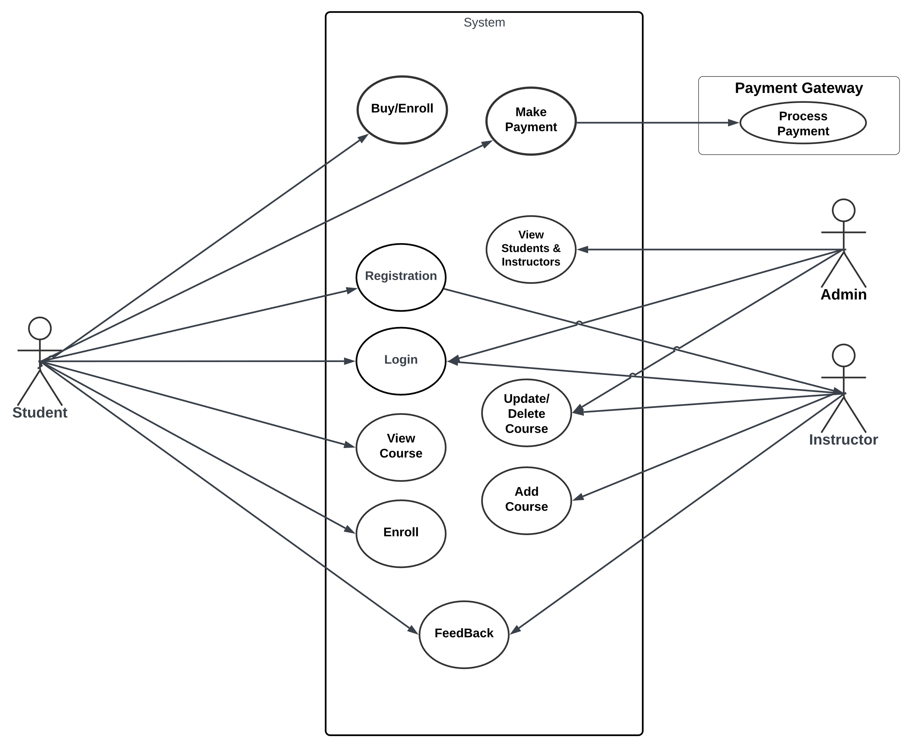

Figure 3: Use Case Diagram

### 3.3.3. Activity Diagram

An activity diagram in the Unified Modeling Language (UML) is a behavioral diagram that illustrates the flow of activities or actions within a system or a process. It displays the sequence of actions, decisions, and transitions that take place to accomplish a particular task or a series of tasks. Activity diagrams are particularly useful in modeling workflows, business processes, and system behaviors.

Key Components of an Activity Diagram:

Initial and Final Nodes:

Initial node: Represents the starting point of the activity diagram.

Final node: Indicates the end or completion point of the activity flow.

Activities:

Actions or tasks to be performed in the system/process.

Represented as rounded rectangles labeled with action names.

Activities can be simple actions or complex sub-activities.

Control and Object Flow:

Control flow arrows: Show the sequence of activities and the order in which actions are executed.

Object flow arrows: Illustrate the flow of objects or data between activities.

Decisions (Decisions and Branches):

Diamond-shaped nodes representing decision points.

Based on conditions or outcomes, the flow of activities diverges or converges.

Forks and Joins:

Fork nodes: Split the flow of activities into multiple concurrent paths.

Join nodes: Merge the concurrent paths back into a single flow.

Swimlanes (Partitions):

Horizontal or vertical lanes used to group activities based on responsible entities or systems.

Purpose of Activity Diagrams:

Modeling Workflows and Business Processes:

Activity diagrams help in modeling and understanding workflows and business processes within a system or organization.

Visualizing System Behavior:

They provide a visual representation of the sequence of actions and decisions in a system, aiding in understanding system behavior and logic.

Activity diagrams provide a clear visualization of the flow of actions, decisions, and control structures in a system or process, aiding in the analysis, understanding, and communication of complex workflows and business processes.

* **Student**

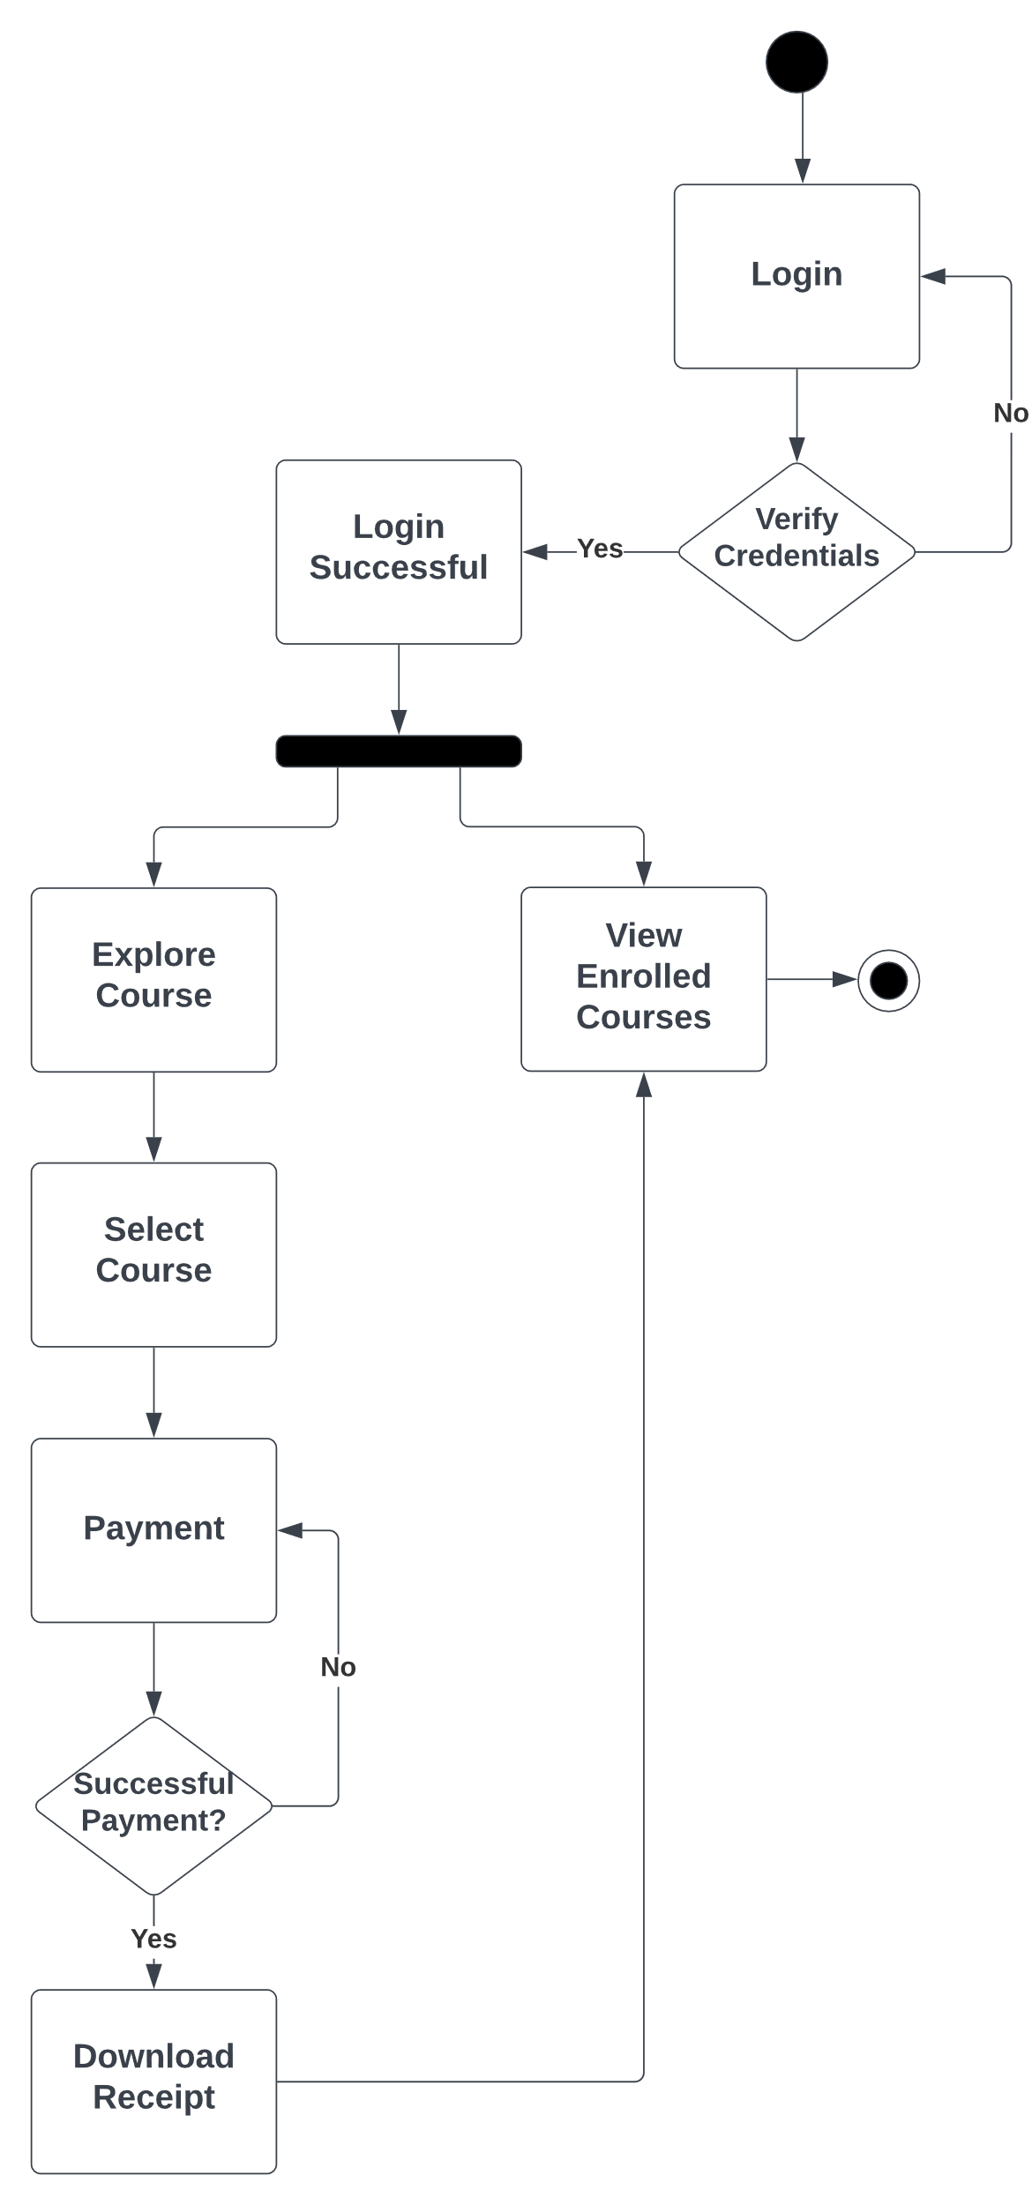

Figure 4: Student Activity Diagram

* **Instructor**

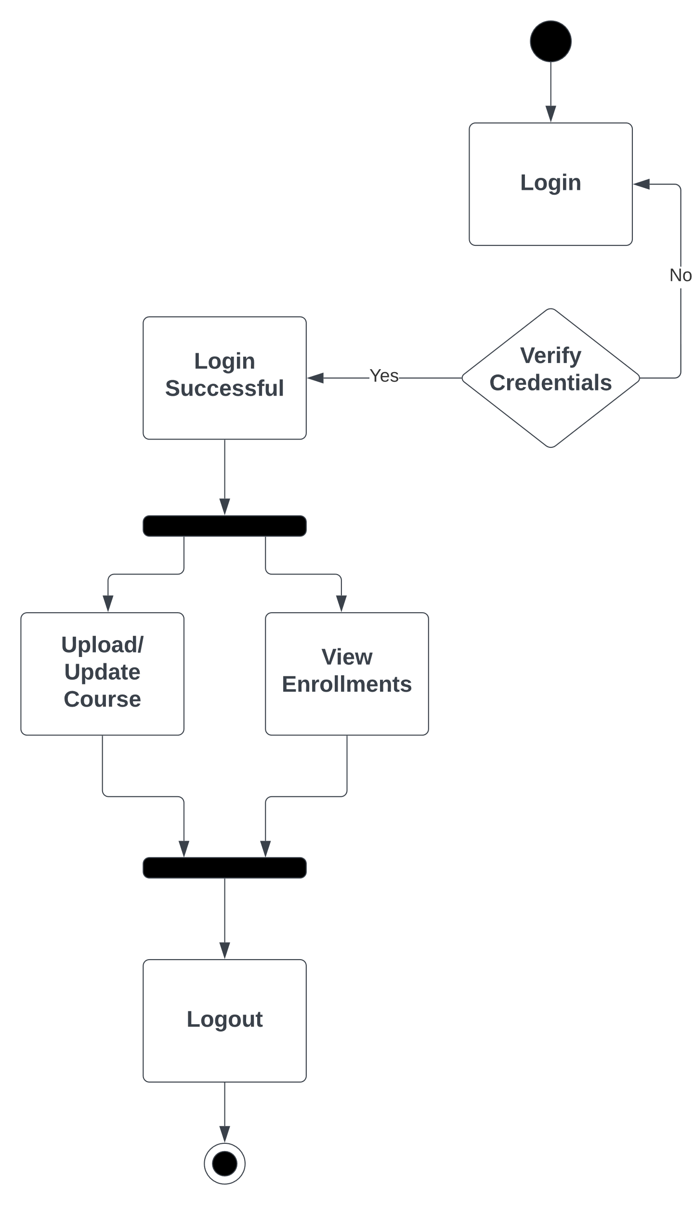

Figure 5: Instructor Activity Diagram

* **Admin**

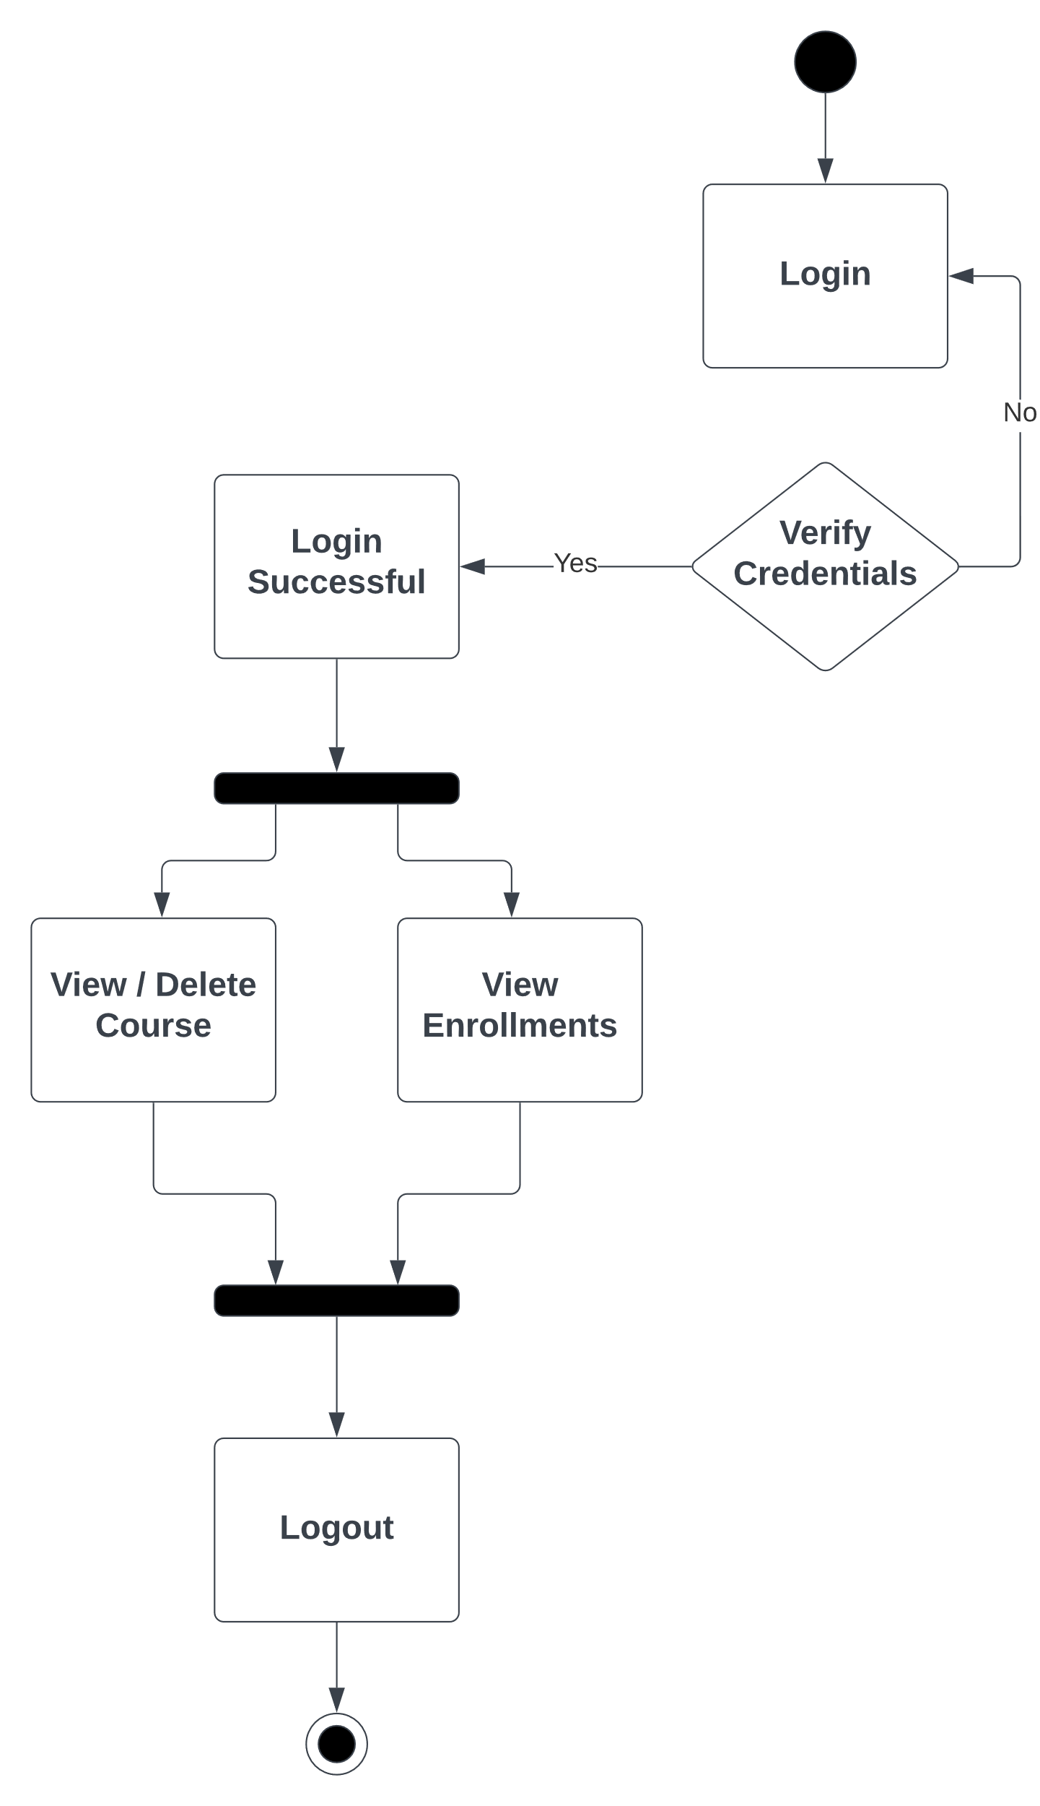

Figure 6: Admin Activity Diagram

### 3.3.4. Class Diagram

A class diagram is a type of UML (Unified Modeling Language) diagram that illustrates the structure and relationships of classes, their attributes, methods, and associations within an object-oriented system. It provides a graphical representation of the system's static structure, showcasing the various entities (classes) and how they relate to each other.

Components of a Class Diagram:

Class:

A class is represented as a rectangle with three compartments:

Top Compartment: Class name.

Middle Compartment: Class attributes (fields/properties).

Bottom Compartment: Class methods (functions/operations).

Attributes (Fields/Properties):

Attributes represent the properties or data elements of a class.

They are listed in the middle compartment of the class rectangle.

Attributes provide information about the state of an object.

Methods (Functions/Operations):

Methods define the behavior or operations that objects of the class can perform.

They are listed in the bottom compartment of the class rectangle.

Methods describe what the object can do.

Association:

Associations show the relationships between classes.

They are depicted by lines connecting classes, often with arrows indicating directionality.

Associations can have multiplicities denoting the number of objects involved in the relationship (e.g., 1, *, 0..1).

Multiplicity:

Indicates how many instances of one class are associated with instances of another class.

Common multiplicities include 1 (one), * (many), 0..1 (zero or one), etc.

Shown next to association lines.

Inheritance (Generalization):

Represents the "is-a" relationship between classes, denoting inheritance.

Depicted by a line with an open arrowhead pointing from the subclass to the superclass.

The subclass inherits attributes and methods from the superclass.

Dependency:

Represents a weaker relationship between classes where one class relies on another.

Shown as a dashed arrow pointing from the dependent class to the independent class.

Interface:

An interface defines a contract specifying a set of methods that a class implementing the interface must implement.

Represented similar to a class but with the stereotype "<<interface>>" above the class name.



Figure 7: Class Diagram

### 3.3.5. Object Diagram

An object diagram, also known as an instance diagram, is a type of UML (Unified Modeling Language) diagram that represents a snapshot of objects and their relationships at a specific point in time within a system. Unlike class diagrams that illustrate the structure and static relationships between classes, object diagrams focus on instances of classes and their associations at runtime.

Key Features of an Object Diagram:

Instances of Classes:

An object diagram portrays instances (objects) of classes, showing how these objects interact and relate to each other in a particular scenario.

Object Representation:

Each object is represented as a box or oval labeled with the object's name and values for its attributes.

Associations and Relationships:

Object diagrams display the associations and relationships between objects using lines connecting the objects, indicating how they are related or linked.

Snapshot in Time:

Object diagrams capture a specific moment or state in the execution of a system, depicting the current relationships between objects at that instant.

Clarity on Object Structure:

They provide clarity on the structure and associations between objects during system execution, aiding in understanding object interactions and dependencies.

Purpose of Object Diagrams:

Visualization of Object Structures:

Object diagrams offer a visual representation of how instances of classes interact, showcasing relationships and collaborations between objects in the system.

Debugging and Analysis:

They help in debugging and analyzing system behavior by illustrating object relationships at a particular point in time, aiding in identifying issues related to object interactions.

Communication and Design:

Object diagrams facilitate communication among stakeholders by presenting a tangible view of object instances and their relationships, assisting in the design and communication of system structures.



Figure 8: Object Diagram

### 3.3.6. Sequence Diagram

A sequence diagram is a type of UML (Unified Modeling Language) diagram that illustrates the interactions between objects or components within a system in a time-ordered sequence. It displays the sequence of messages exchanged between objects over time to accomplish a particular functionality or scenario.

Key Components of a Sequence Diagram:

Objects (Participants):

Represented as vertical lifelines (usually a dashed line) where objects or entities reside during the sequence of interactions.

Messages:

Represented as arrows between lifelines, indicating the flow of communication or messages passed between objects.

Messages can be synchronous (denoted by a solid arrow), asynchronous (denoted by a dashed arrow), or self-messages (looping back to the same lifeline).

Activation Boxes (Execution Occurrences):

Boxes along the lifeline representing the duration of time an object is performing an operation or processing a message.

Depicts the time span during which an object is actively engaged in processing.

Return Messages:

Represented as arrows in the opposite direction of the initial message, denoting the response or return from the recipient object to the sender.

Optional Elements:

Other optional elements include conditional statements, loops, parallel execution, and alternative scenarios depicted using combined fragments (e.g., loops, alternatives) and annotations (e.g., conditions).

Purpose of Sequence Diagrams:

Visualization of Interactions:

Sequence diagrams visually represent the flow and order of interactions between various objects or components, aiding in understanding the dynamic behavior of a system.

Understanding System Behavior:

They help in understanding how objects collaborate and communicate with each other to accomplish specific functionalities or use cases.

Design and Analysis:

Sequence diagrams assist in designing and analyzing the system by showcasing the sequence of messages exchanged between objects during a specific scenario or process.

Sequence diagrams provide a visual representation of the sequence of interactions between objects, helping in understanding system behavior and communication patterns during specific scenarios or processes within a system.

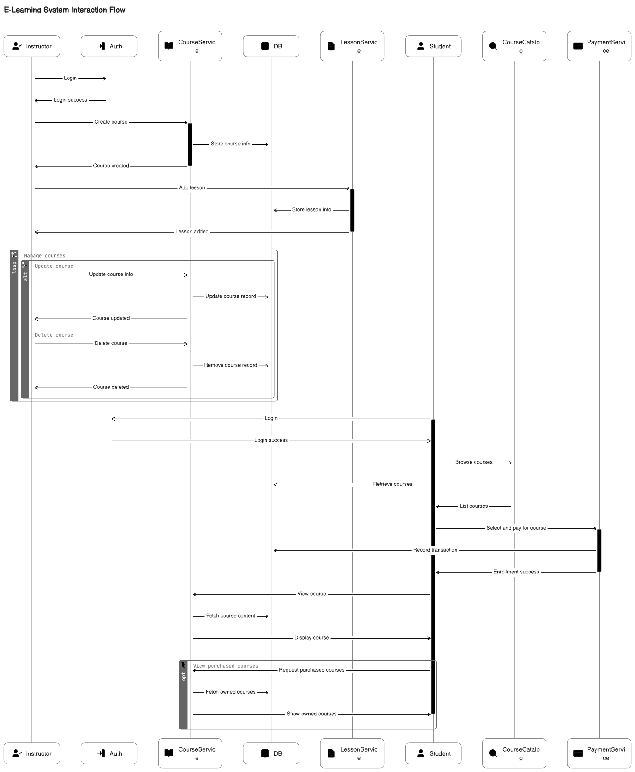

Figure 9: Sequence Diagram

### 3.3.7. State Chart Diagram

A state chart diagram, also known as a state machine diagram, is a type of UML (Unified Modeling Language) diagram used to model the dynamic behavior of a system or an entity in response to various events over time. It illustrates the different states that an object or system can be in and how it transitions between those states in response to external stimuli or events.

Key Components of a State Chart Diagram:

States:

* Represent the different conditions or situations in which an object or system exists.
* Depicted as rounded rectangles with the state name written inside.

Transitions:

* Arrows between states indicating the flow or change from one state to another.
* Triggered by events or conditions that cause the system to transition from one state to another.
* Labeled with the event triggering the transition.

Initial and Final States:

* Initial state denoting the starting point of the system before any event occurs.
* Final state indicating the completion or termination of the system's process.

Actions and Activities:

* Actions or activities associated with states or transitions, representing the operations performed when transitioning between states.

Events:

* External stimuli or occurrences that cause a transition between states.
* Events can be user actions, system inputs, time-based triggers, etc.

Purpose of State Chart Diagrams:

* Modeling System Behavior:

State chart diagrams model the behavior of a system or an entity by depicting how it responds to various events by transitioning between different states.

* Understanding State Transitions:

They aid in understanding the sequence and conditions under which a system transitions from one state to another, along with the associated actions or activities.

* Design and Analysis:

State chart diagrams assist in the design and analysis of systems, especially systems with complex behavior or numerous states, by visualizing the system's behavior in response to different events.

State chart diagrams effectively illustrate the behavioral aspects of systems by modeling their states, transitions, and associated events or actions, making it easier to understand and analyze the dynamic behavior of a system.



Figure 10: State Chart Diagram

### 3.3.8. Component Diagram

A component diagram in the Unified Modeling Language (UML) is a type of structural diagram that visualizes the components of a system and their relationships. It focuses on the physical components or modules in a system, showcasing how they interact to achieve the system's functionalities.

Key Components of a Component Diagram:

Components:

* Represent individual parts or building blocks of a system, often implemented or replaceable parts with well-defined interfaces.
* Shown as rectangles with the component name written inside.

Interfaces:

Represented by a small circle on the edge of a component.

Interfaces define the communication points or contracts provided by the component to interact with other components or systems.

Dependencies:

* Arrows indicating the relationships and dependencies between components.
* Dependencies can be directed (indicating a unidirectional relationship) or bidirectional (indicating mutual reliance).

Connectors:

* Represent the communication paths or associations between components.
* Connectors might be lines, arrows, or dashed lines, depending on the nature of the relationship between components.

Ports:

* Entry or exit points of a component, often linked to interfaces.
* Represented by small squares on the edge of a component.

Purpose of Component Diagrams:

* System Architecture Visualization:

Component diagrams provide a high-level view of the system's architecture, depicting the physical components and their relationships within the system.

* Component Identification:

They help in identifying the individual components/modules of a system and their interconnections, facilitating system understanding.

* Design and Development:

Component diagrams aid in system design and development by defining the structure and relationships between components, guiding developers in implementing and integrating system components.

Component diagrams visually represent the physical components and their relationships within a system, helping in system design, architecture visualization, and understanding the system's structure and interconnections.

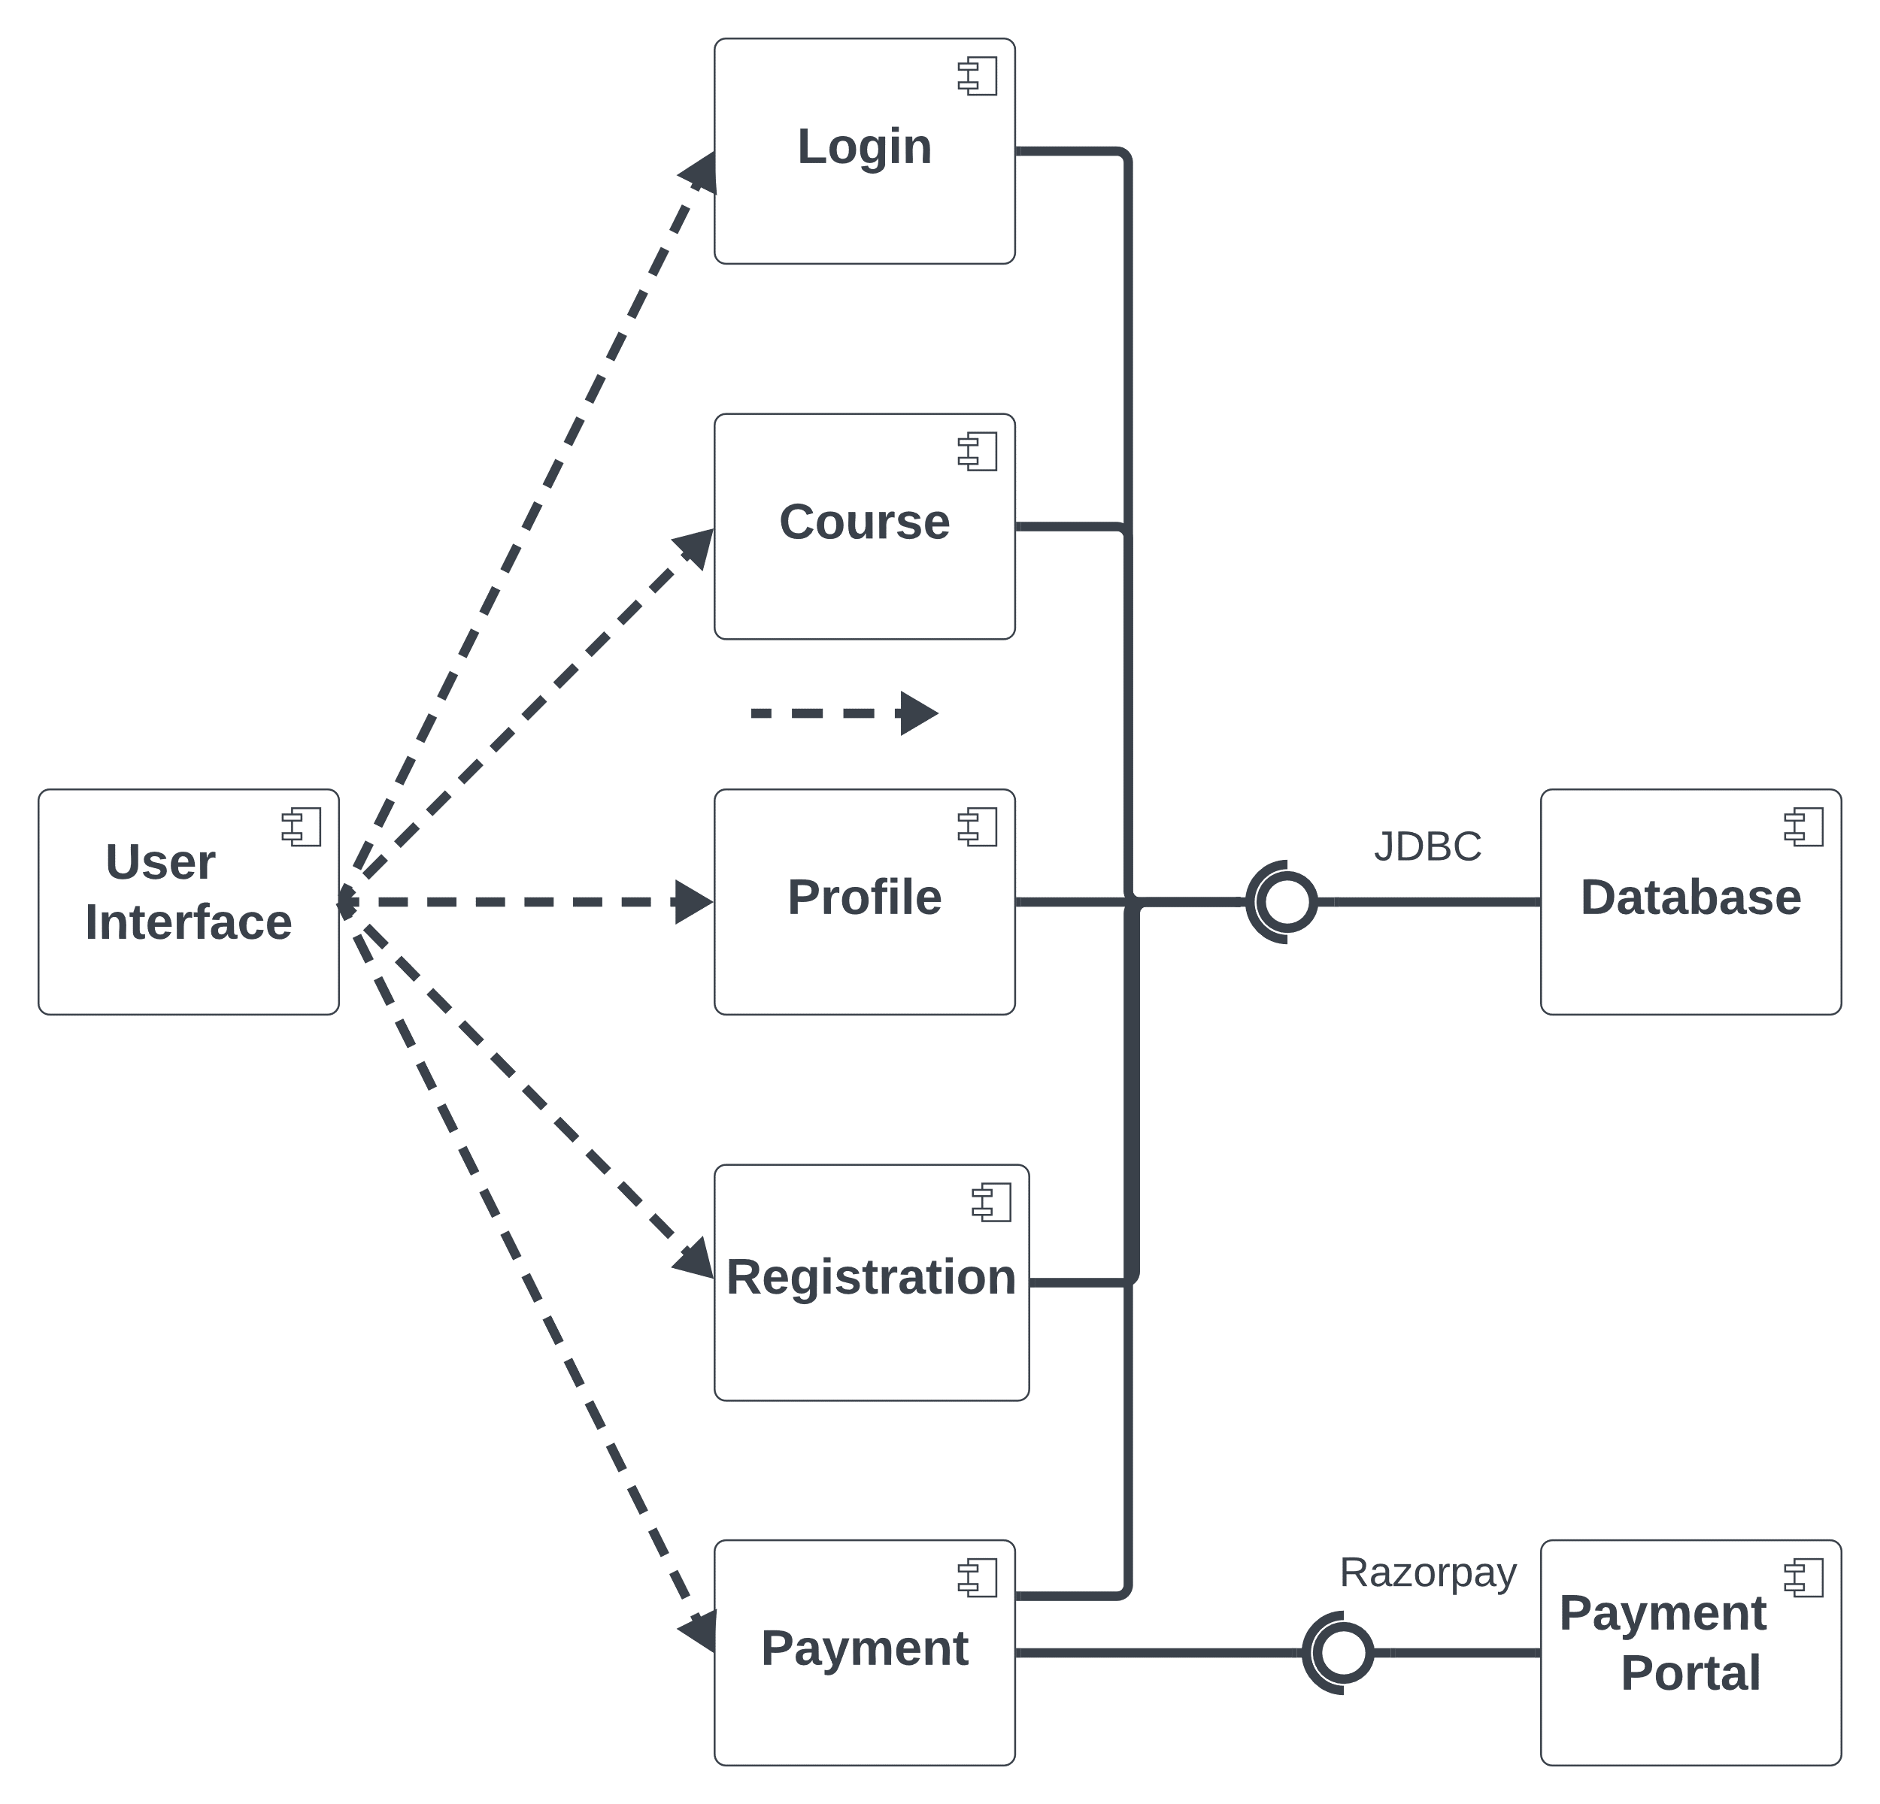

Figure 11: Component Diagram

### 3.3.9. Deployment Diagram

A deployment diagram in the Unified Modeling Language (UML) is a type of diagram that illustrates the physical hardware components (nodes) and the software components (artifacts) of a system, showcasing their interconnections and deployment configurations. This diagram provides a visual representation of how software components are deployed on hardware nodes in a system's environment.

Key Components of a Deployment Diagram:

Nodes:

Represent physical hardware devices or computing resources where software components are deployed.

Nodes can include servers, PCs, mobile devices, routers, or any hardware device relevant to the system's architecture.

Displayed as boxes with the node's name written inside.

Artifacts:

Represent software components or modules that are deployed on the nodes.

Examples include executable files, libraries, databases, configuration files, etc.

Shown as rectangles with the artifact's name written inside.

Deployment Relationships:

Lines with arrows indicating the deployment relationships between nodes and artifacts.

Show how artifacts are allocated or deployed on specific nodes.

May include associations, dependencies, or connections between nodes and artifacts.

Association Links:

Represent communication paths or connectivity between nodes.

Displayed as lines connecting nodes, denoting the communication channels or network connections between hardware devices.

Purpose of Deployment Diagrams:

System Deployment Visualization:

Deployment diagrams provide an overview of how software components are distributed and deployed across physical hardware nodes in a system's environment.

Hardware and Software Configuration:

They show the mapping of software components to hardware nodes, aiding in understanding the system's configuration and deployment structure.

System Maintenance and Upgrades:

Deployment diagrams assist in planning system maintenance, upgrades, or scaling by visualizing the relationships between hardware and software components.

Deployment diagrams effectively showcase the physical deployment of software components onto hardware nodes, providing insights into the system's configuration, allocation of resources, and interactions between different components within the deployment environment.

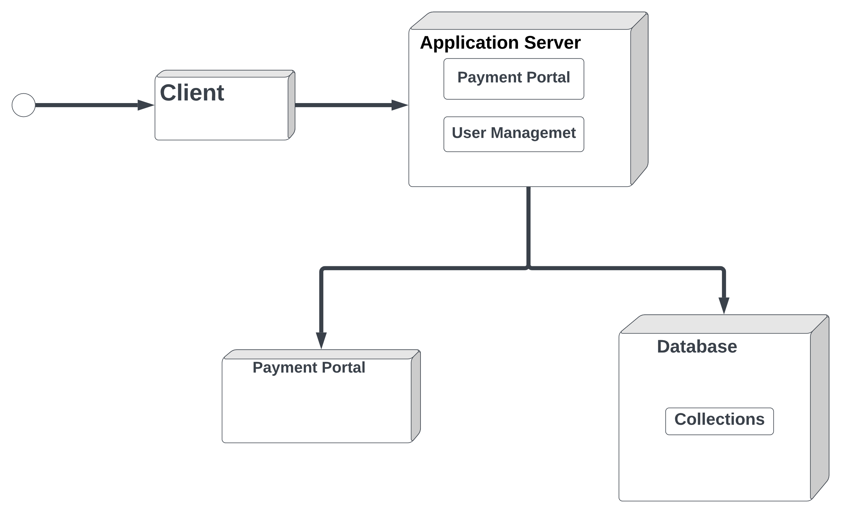

Figure 12: Deployment Diagram

## 3.4. User Interface Design

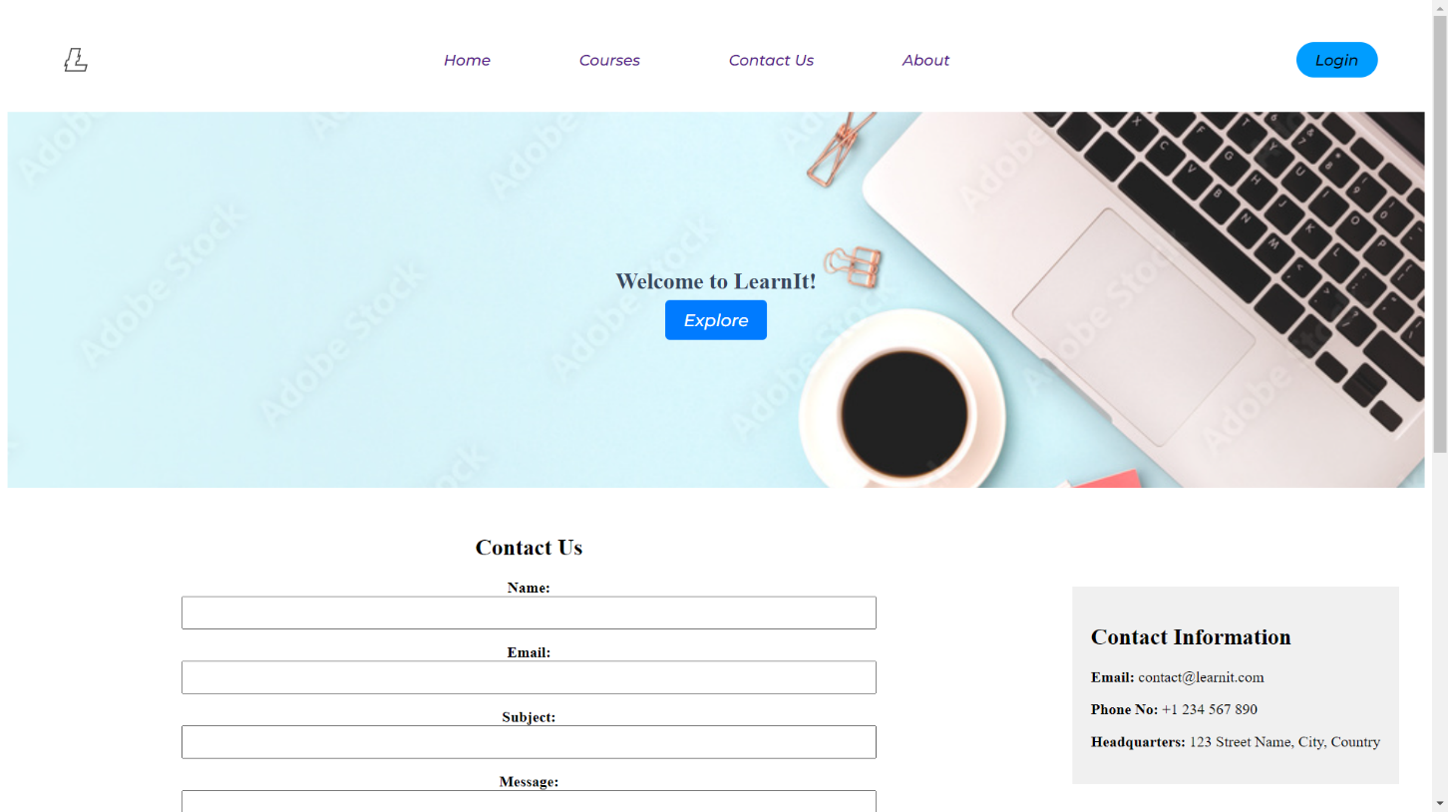

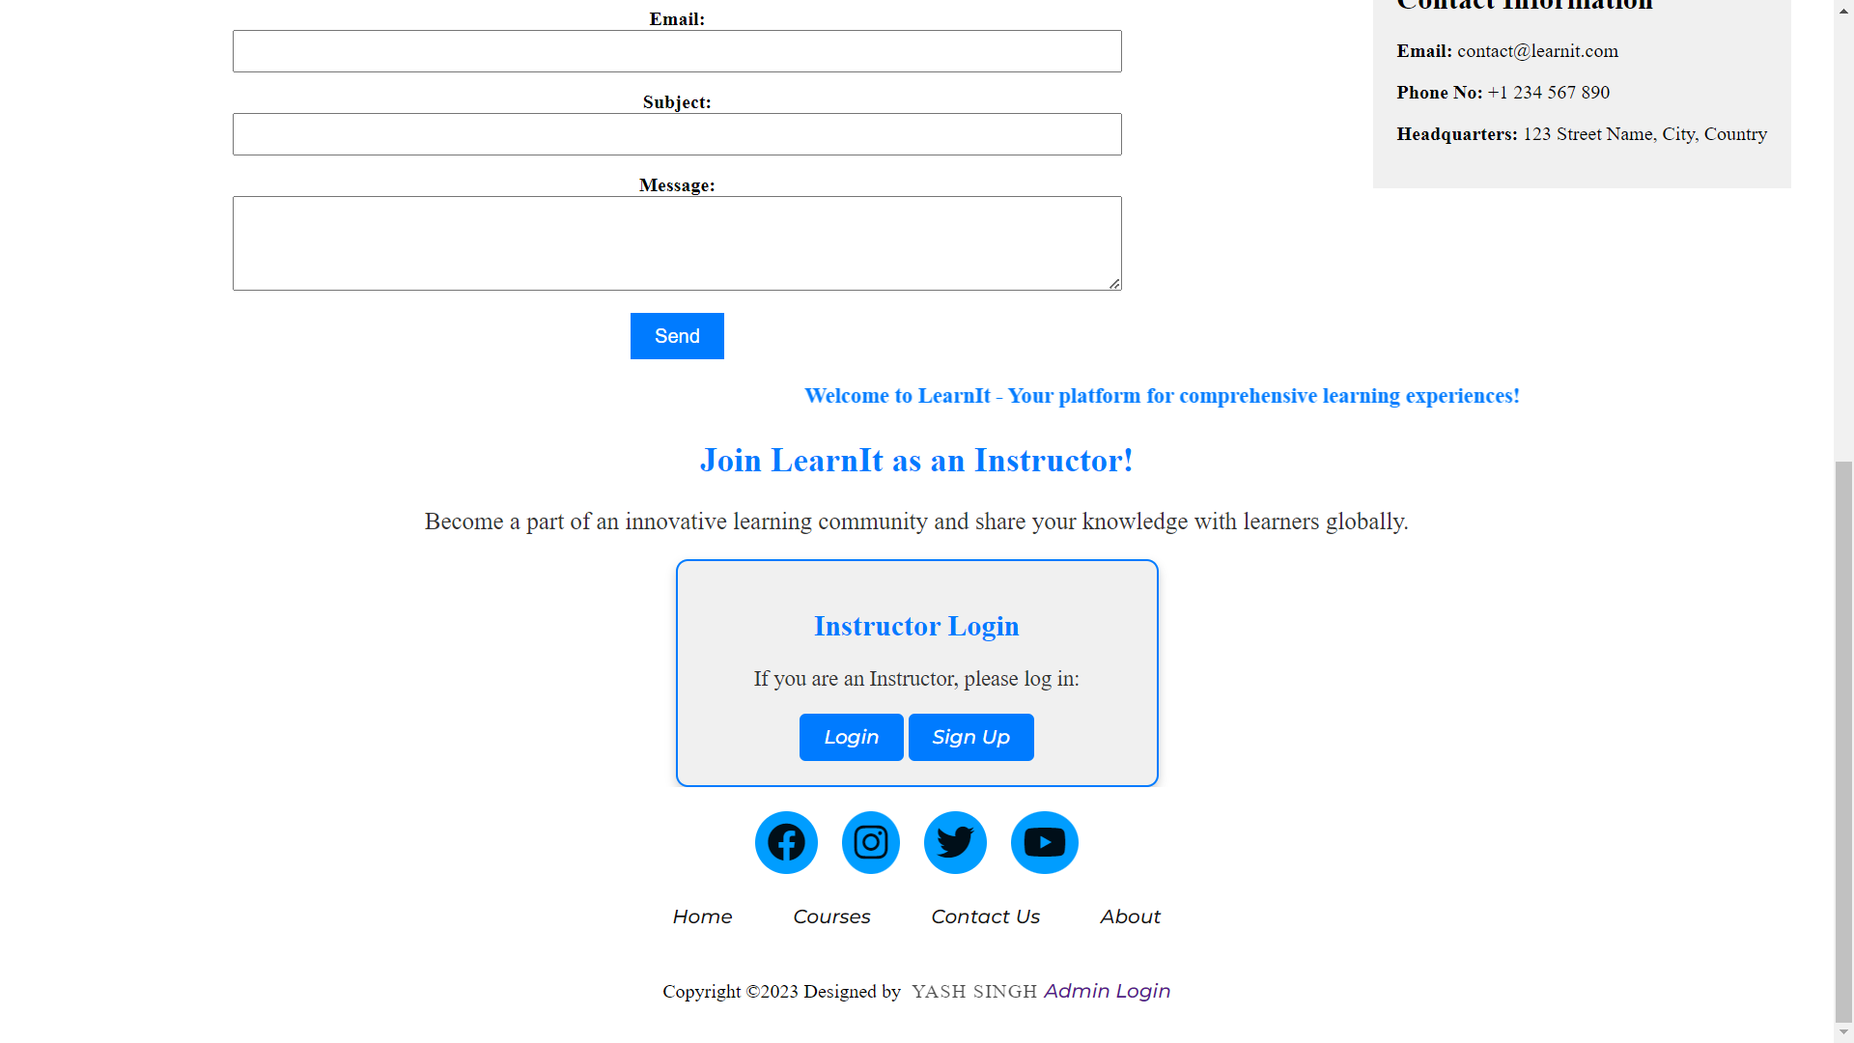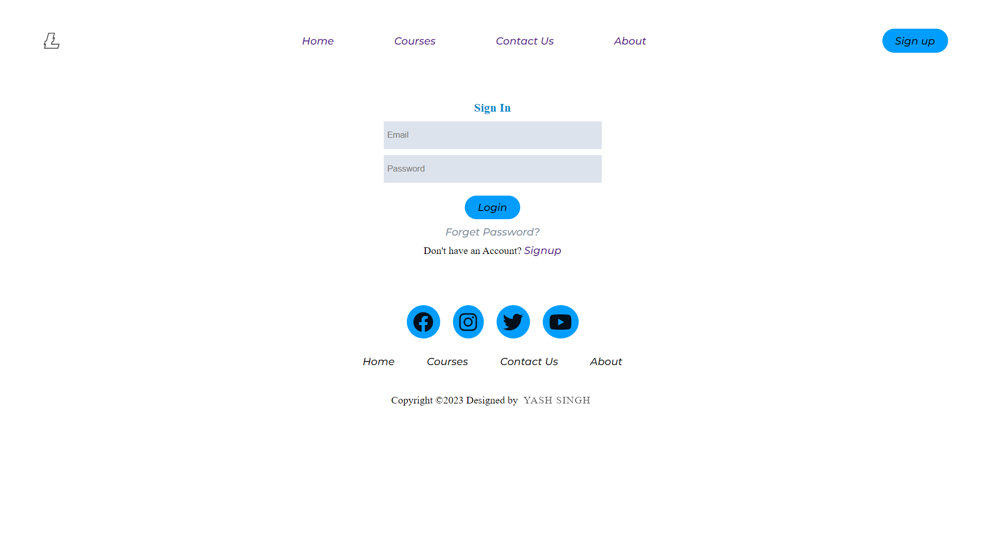

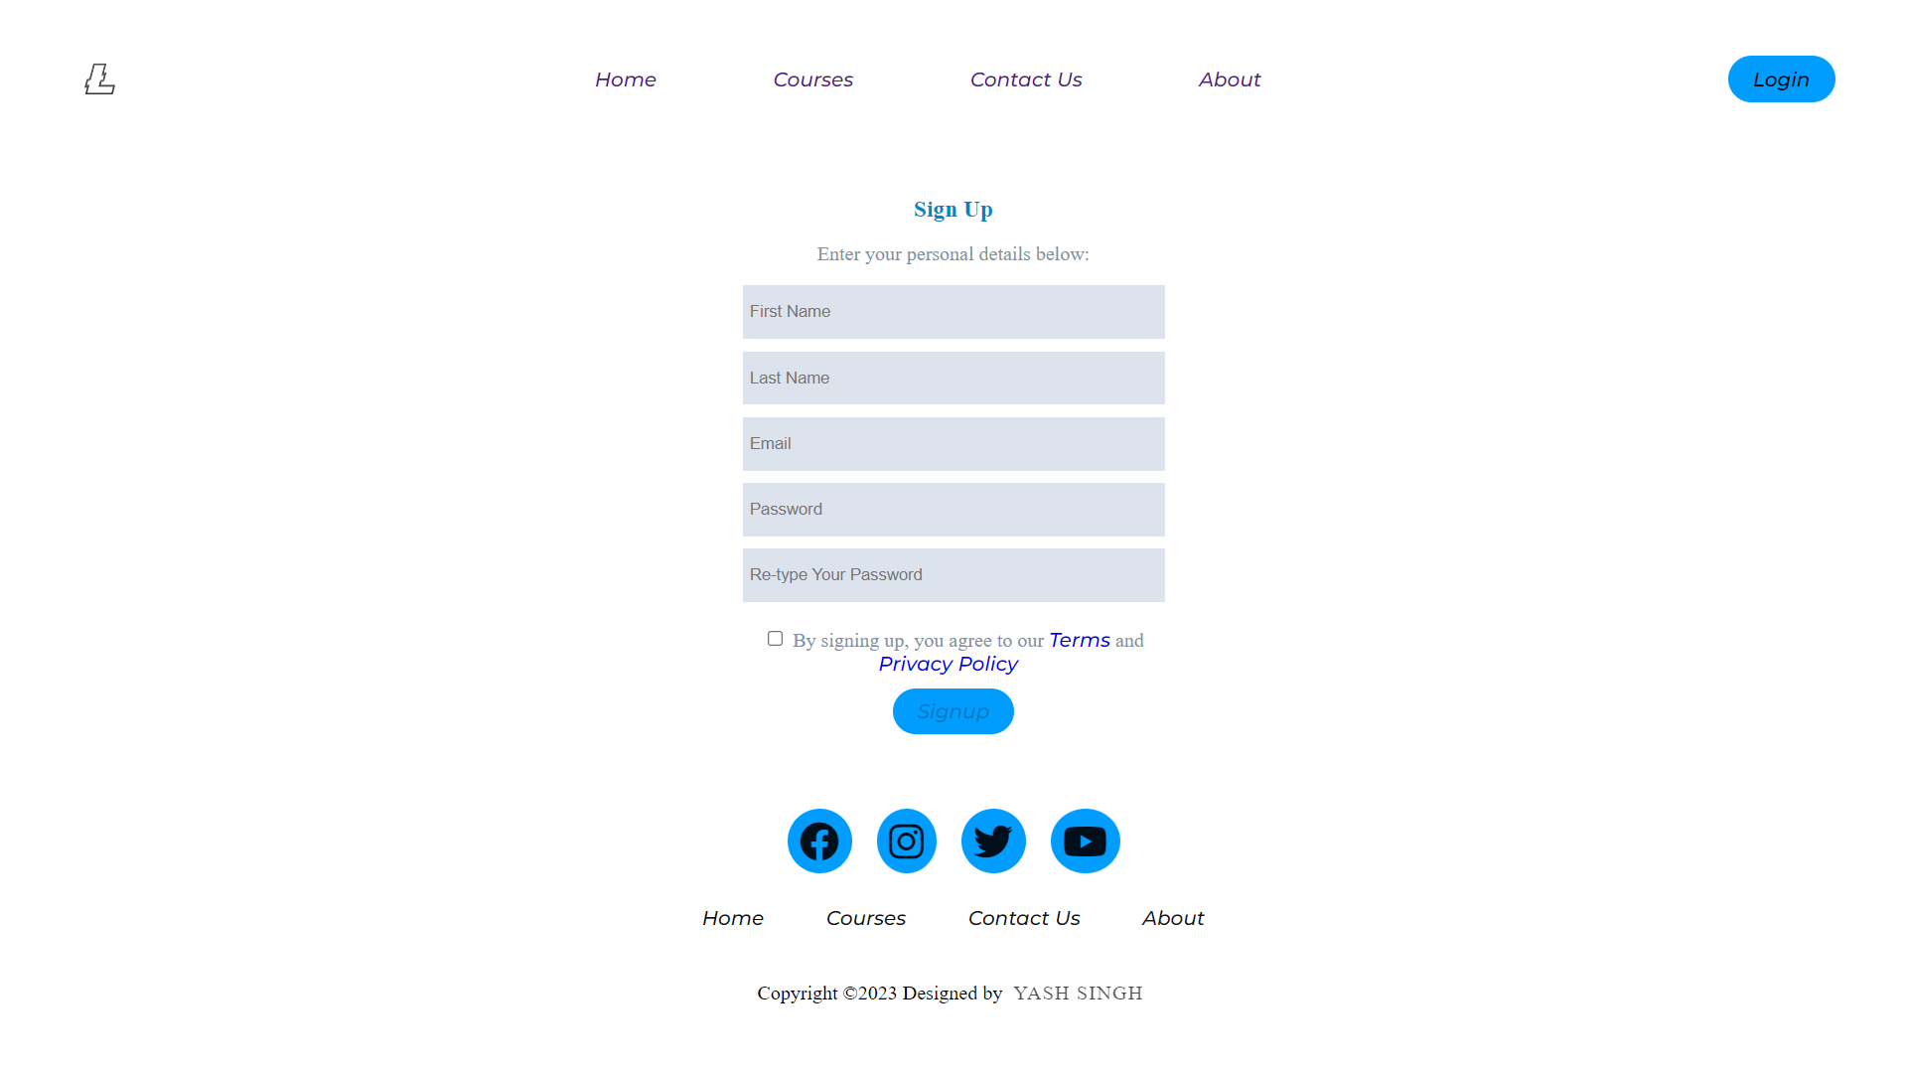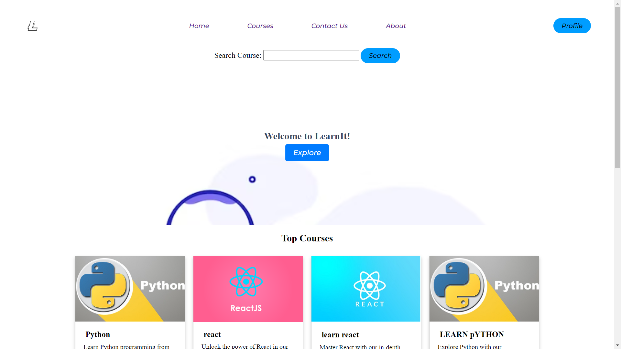

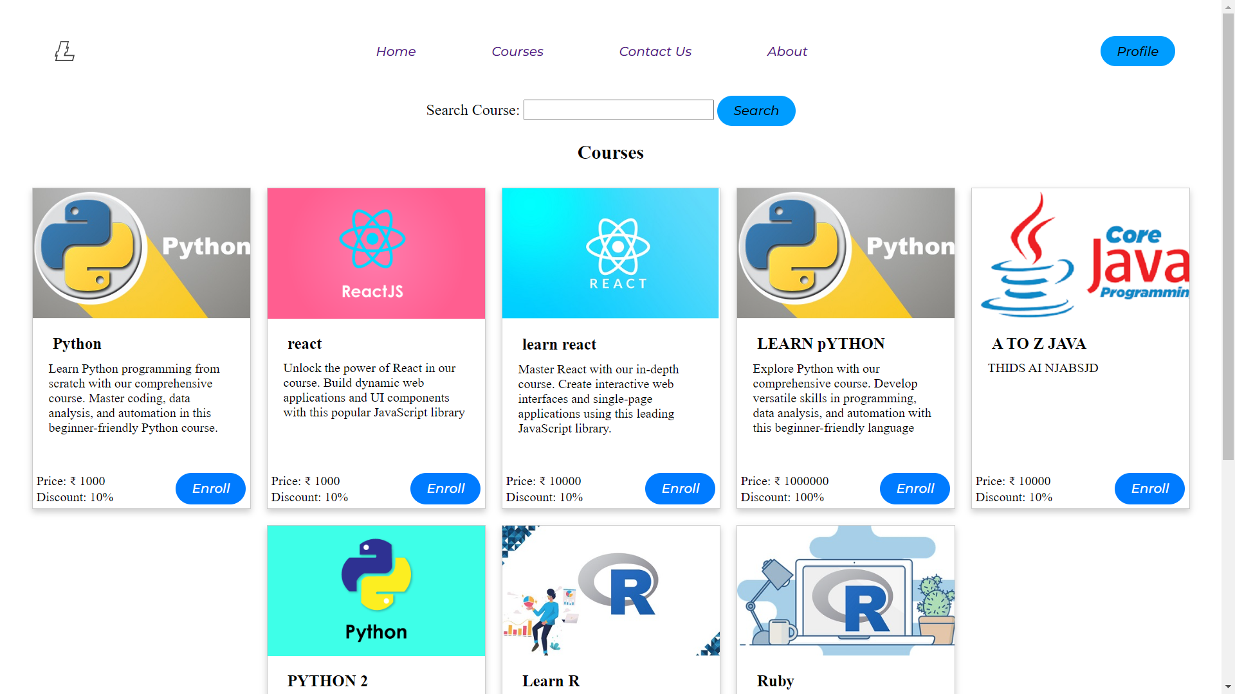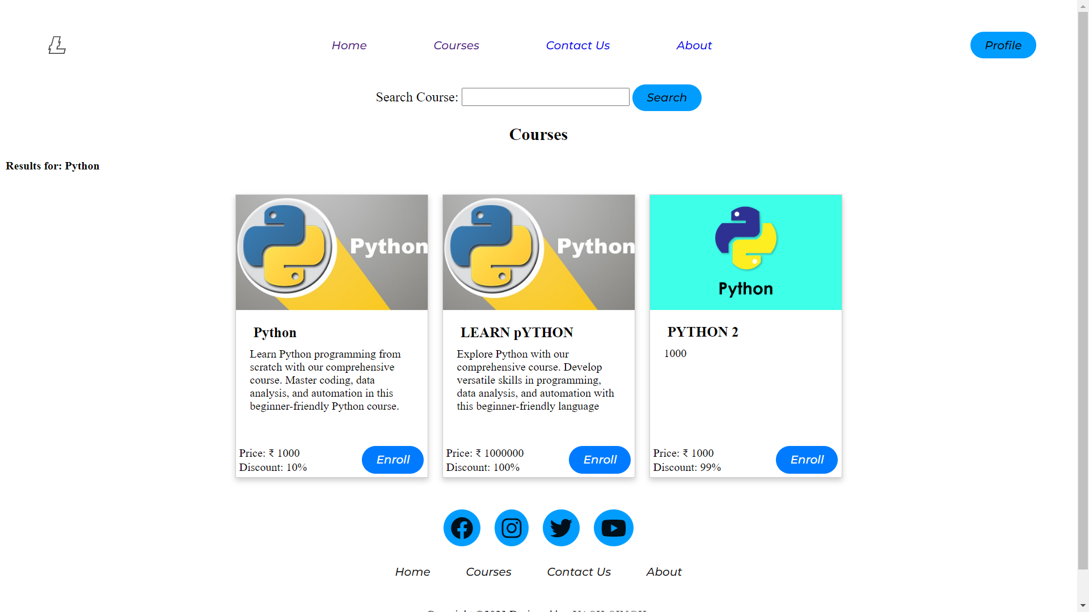

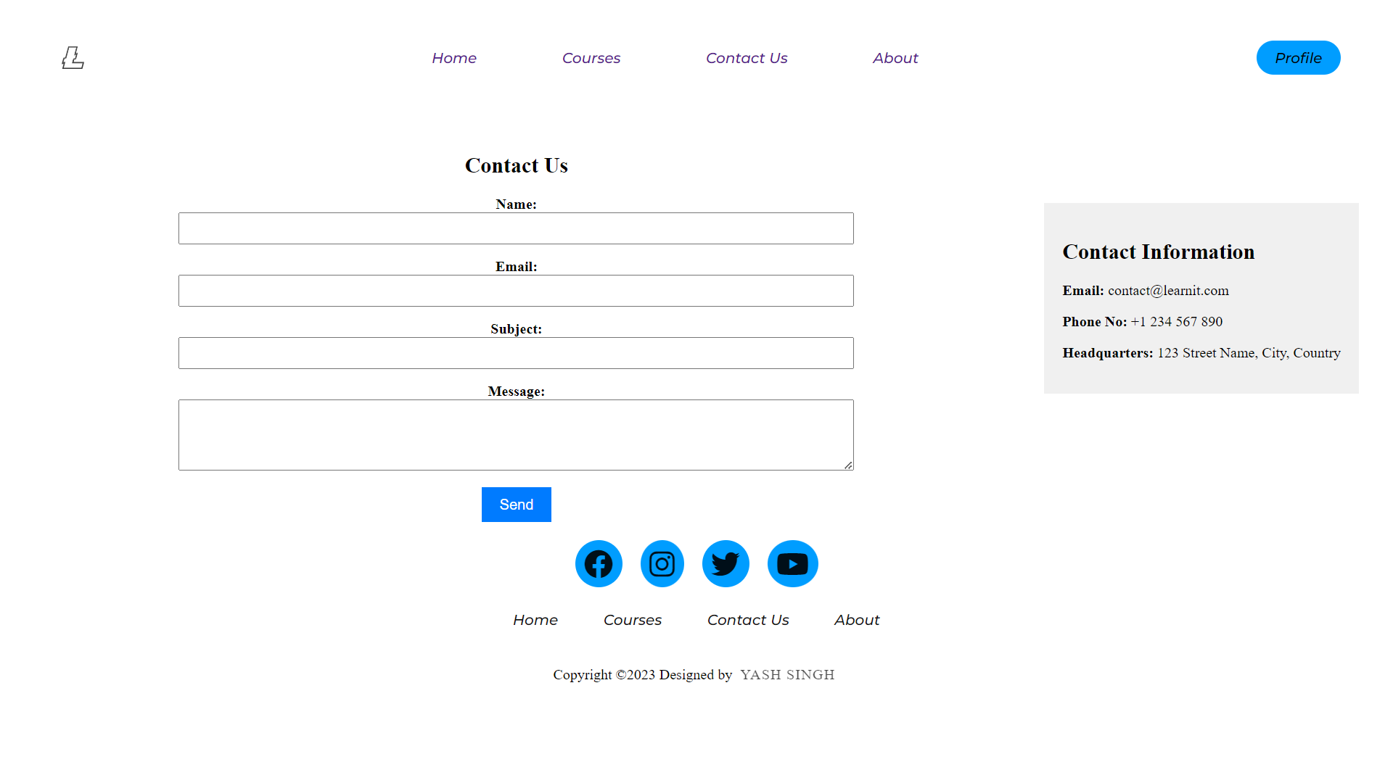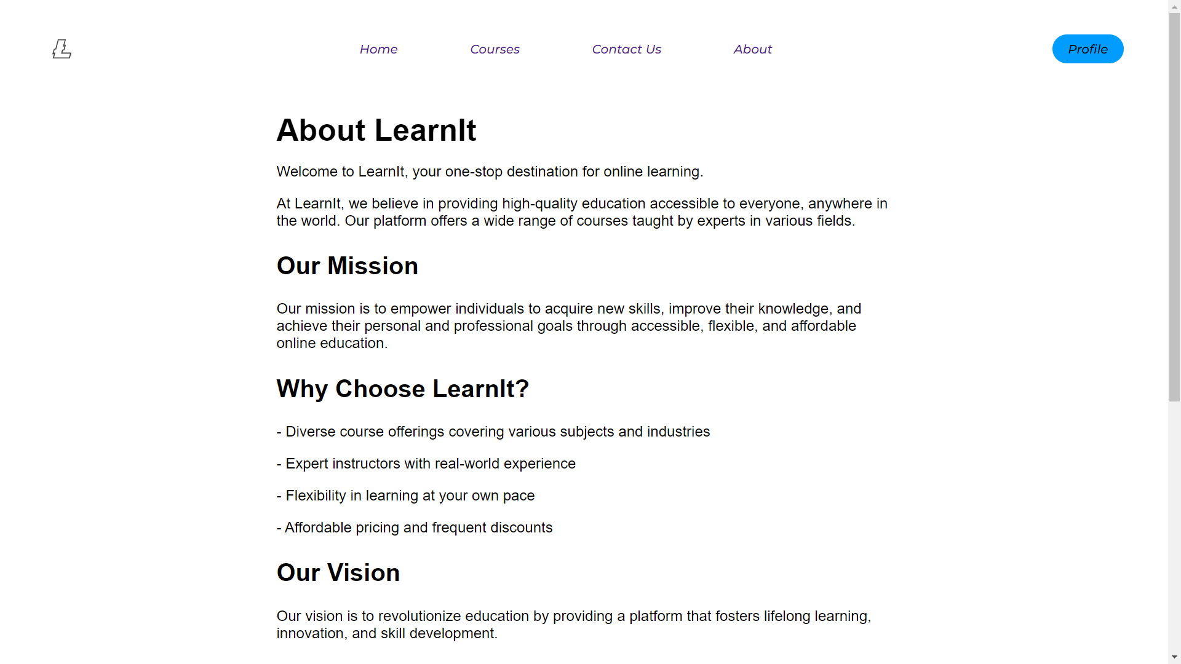

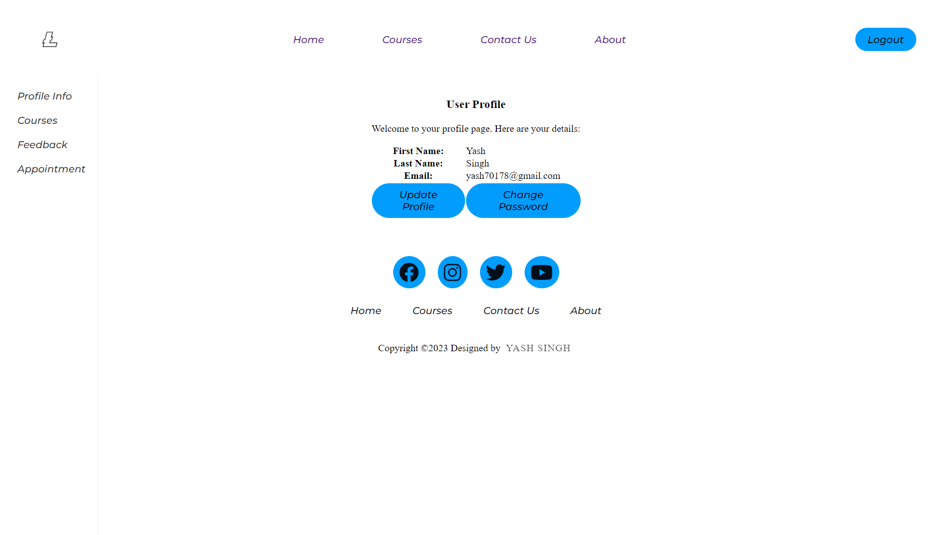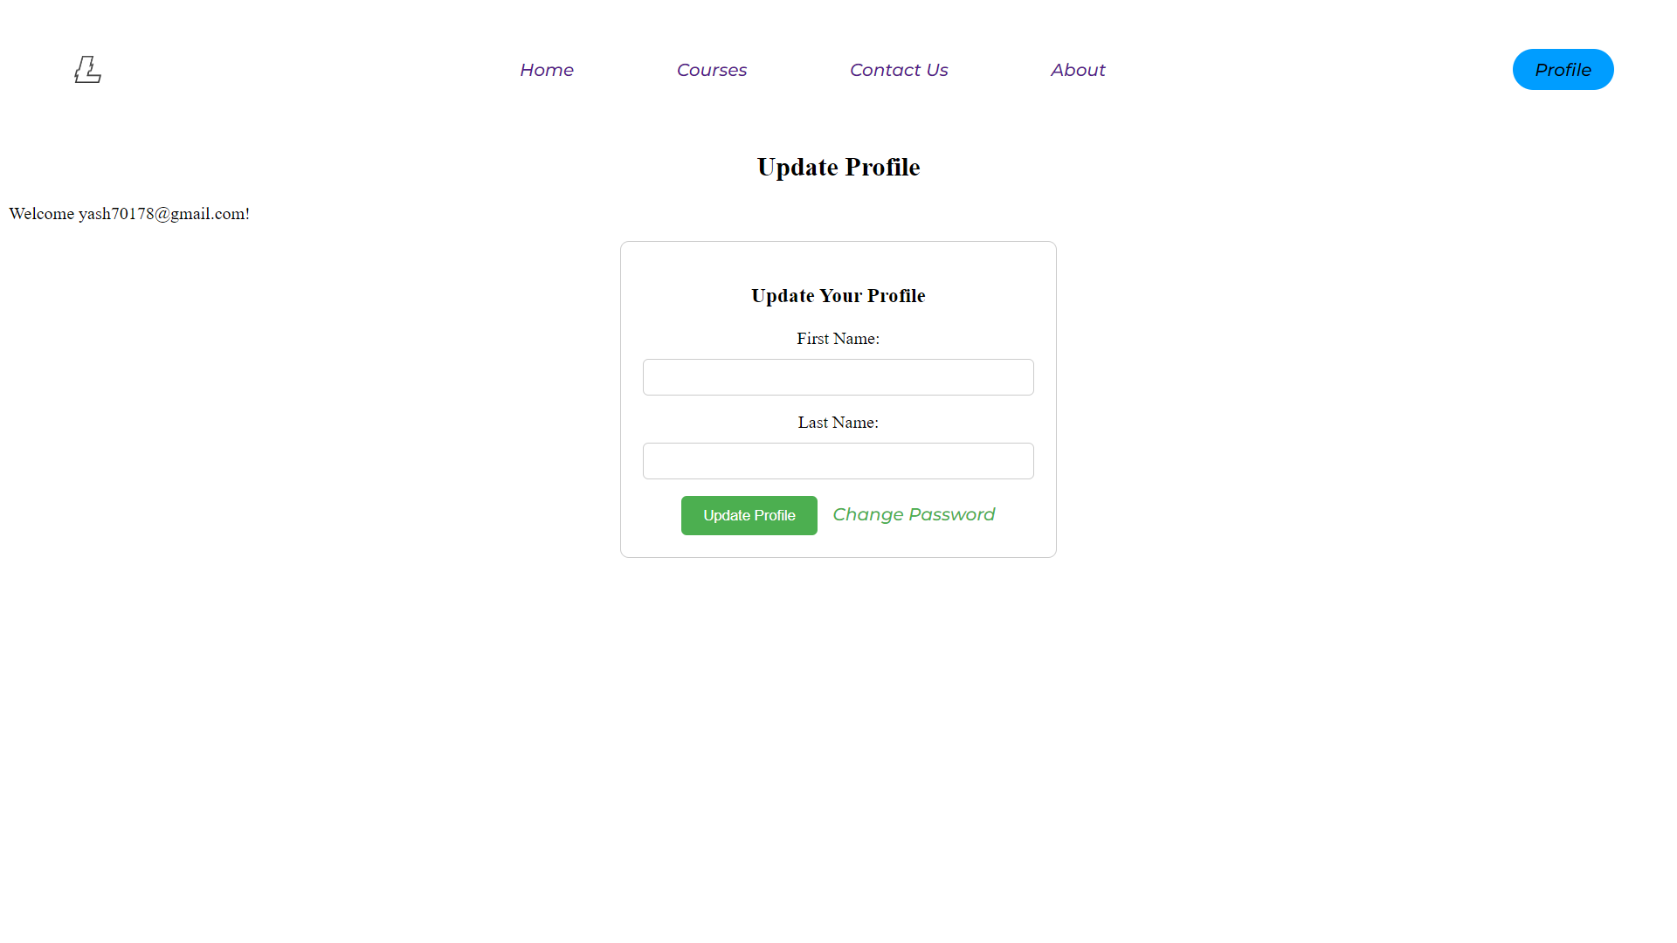

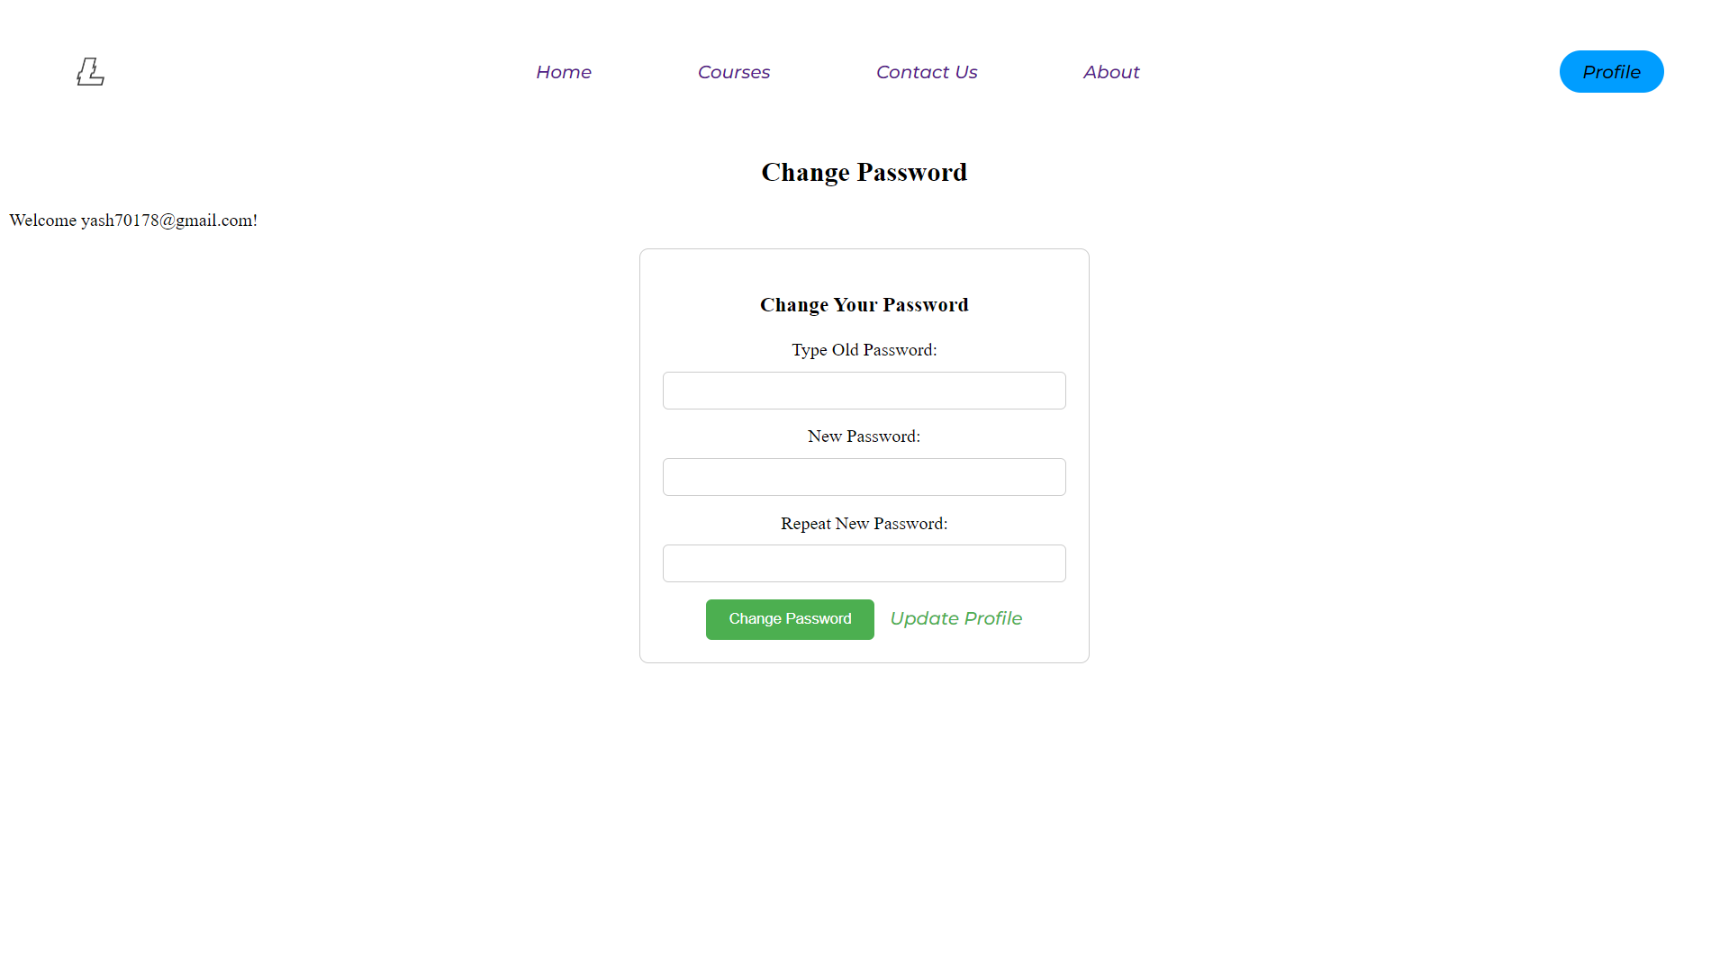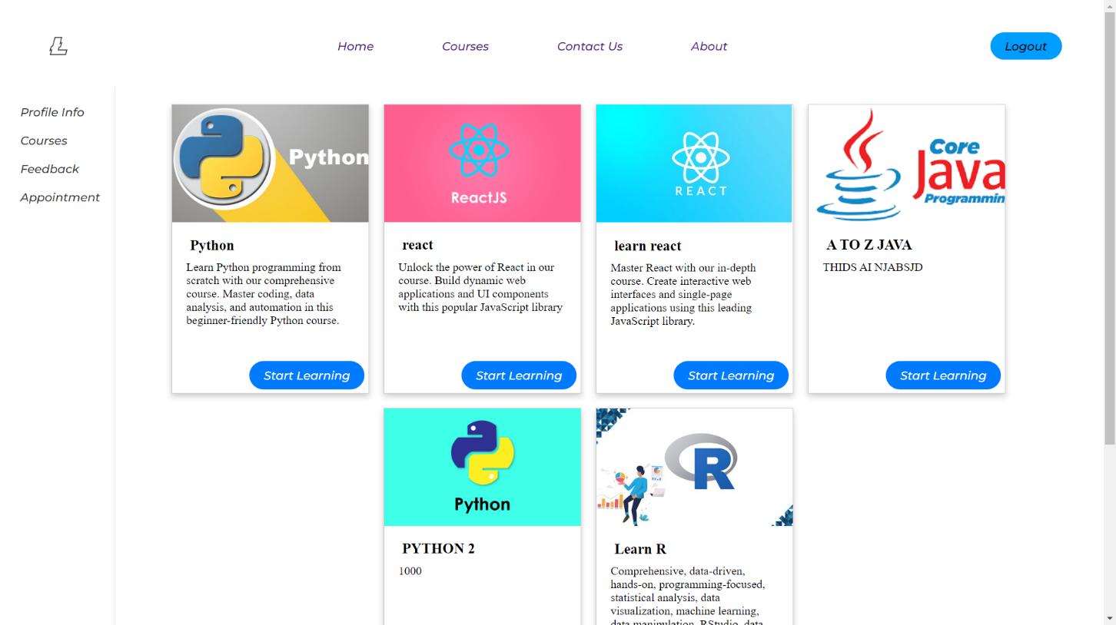

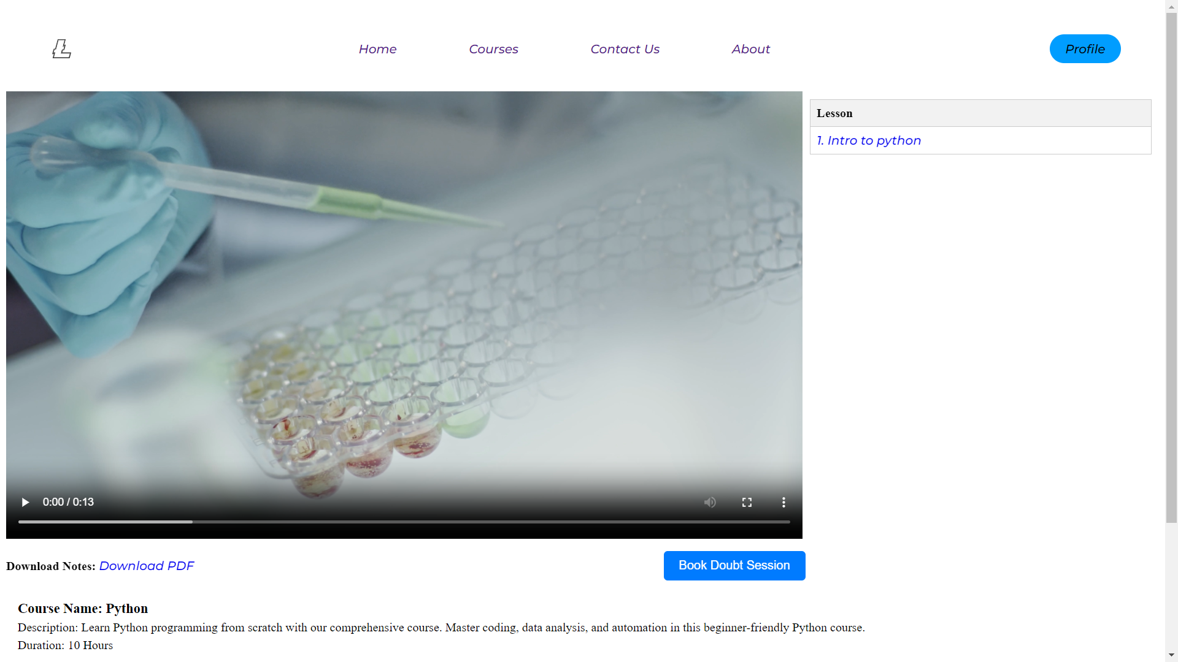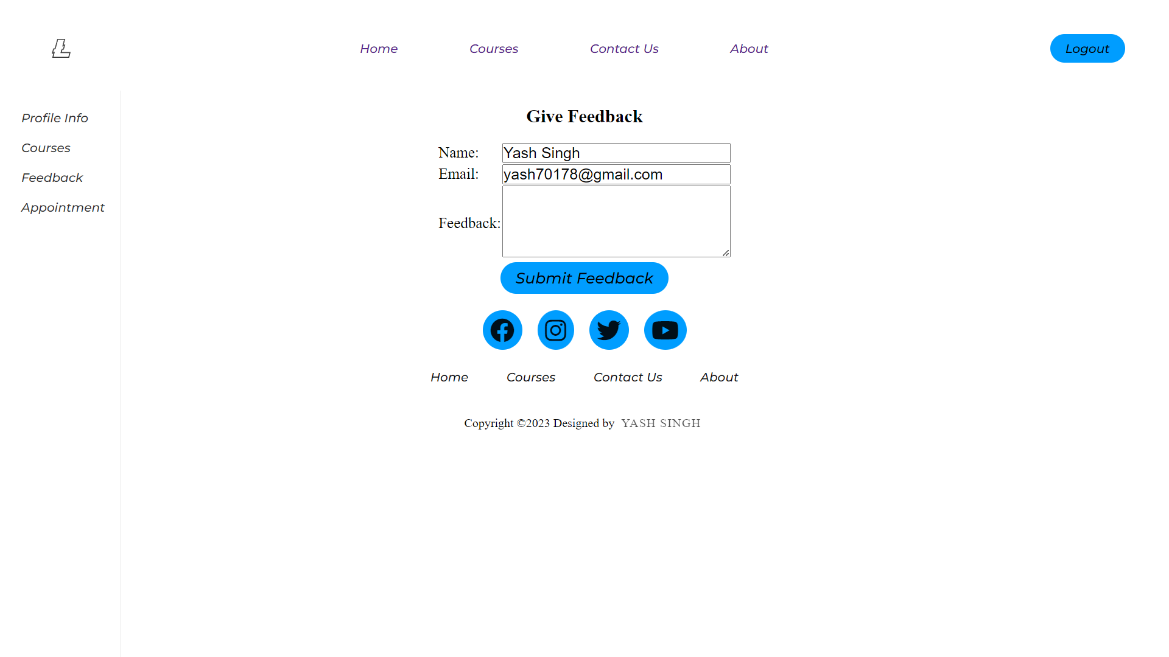

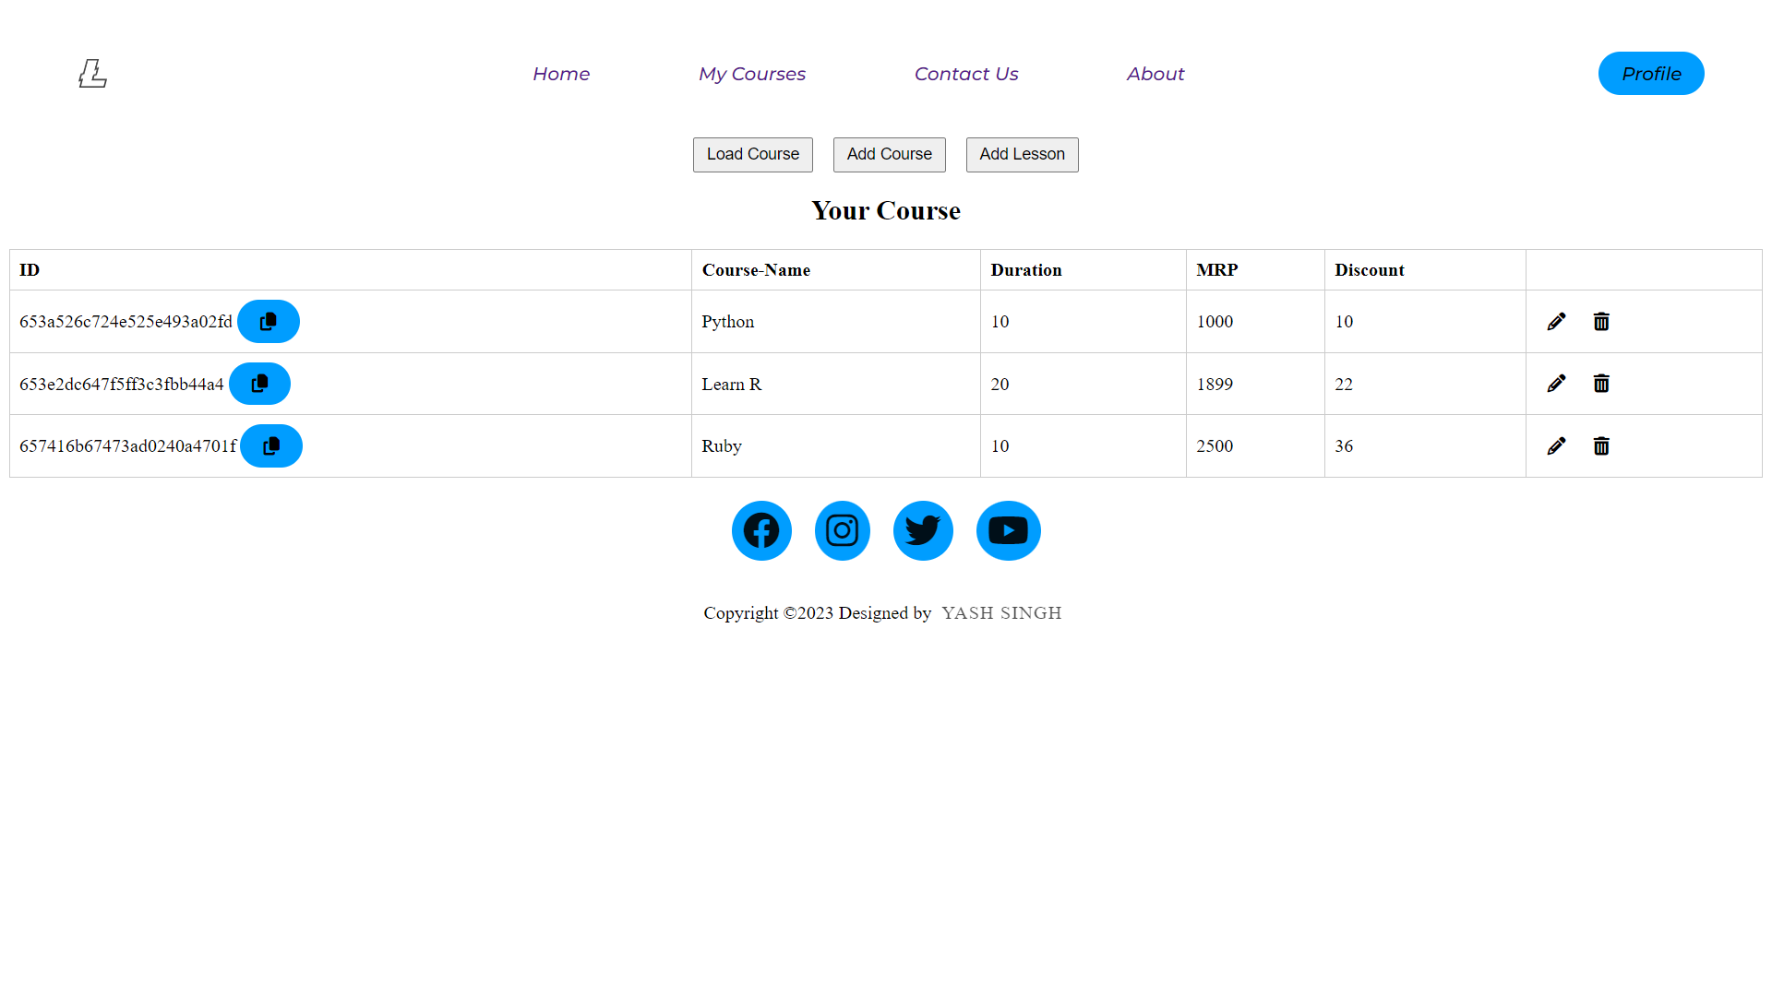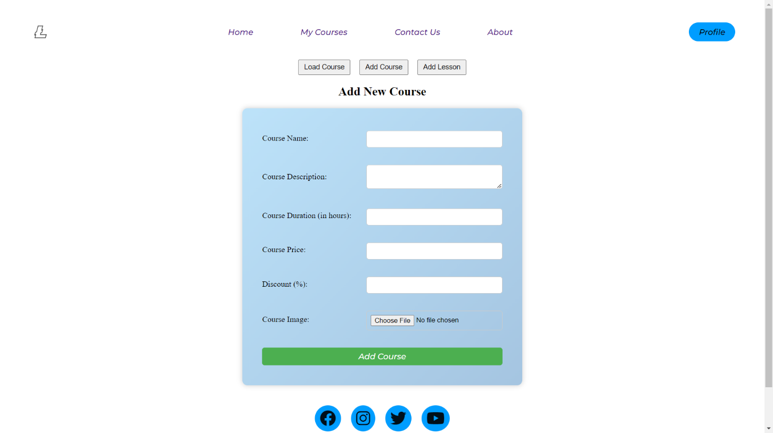

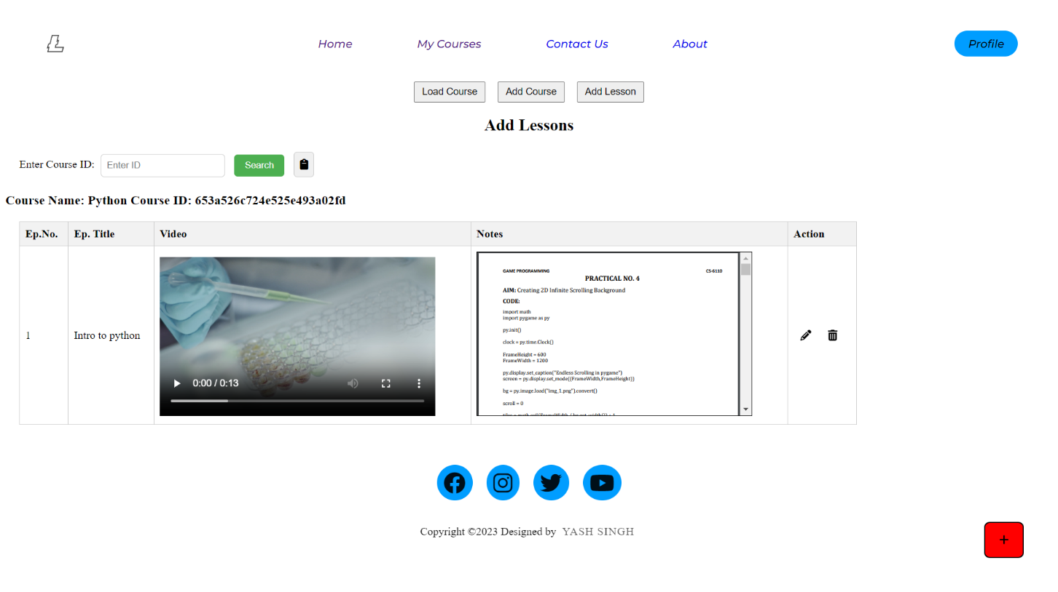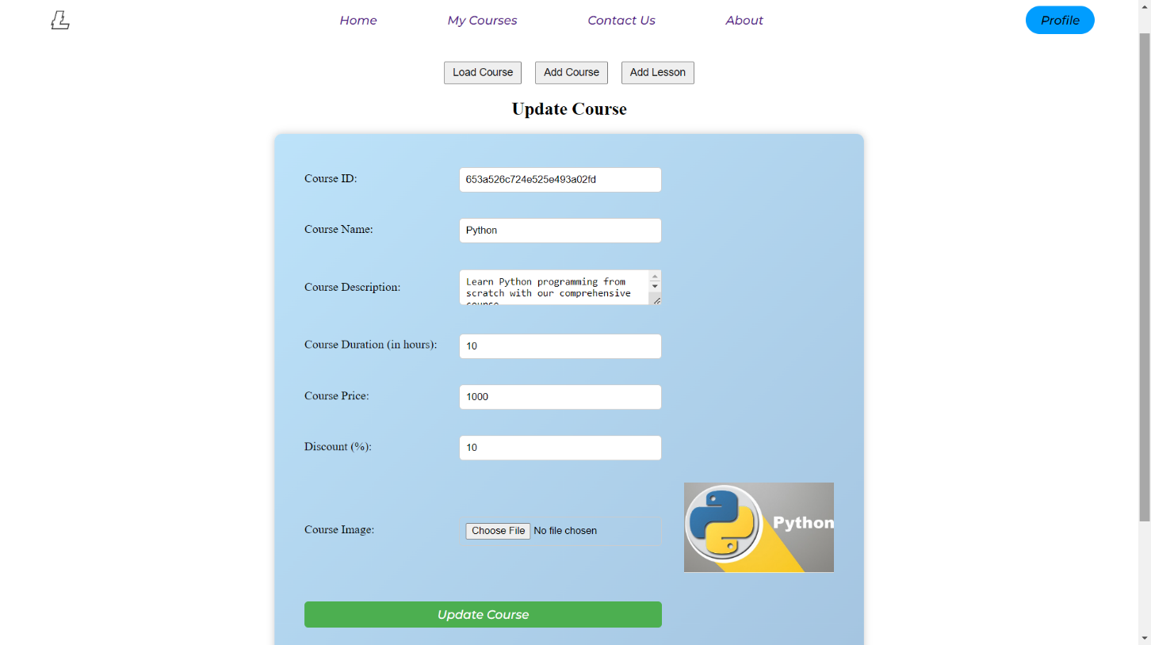

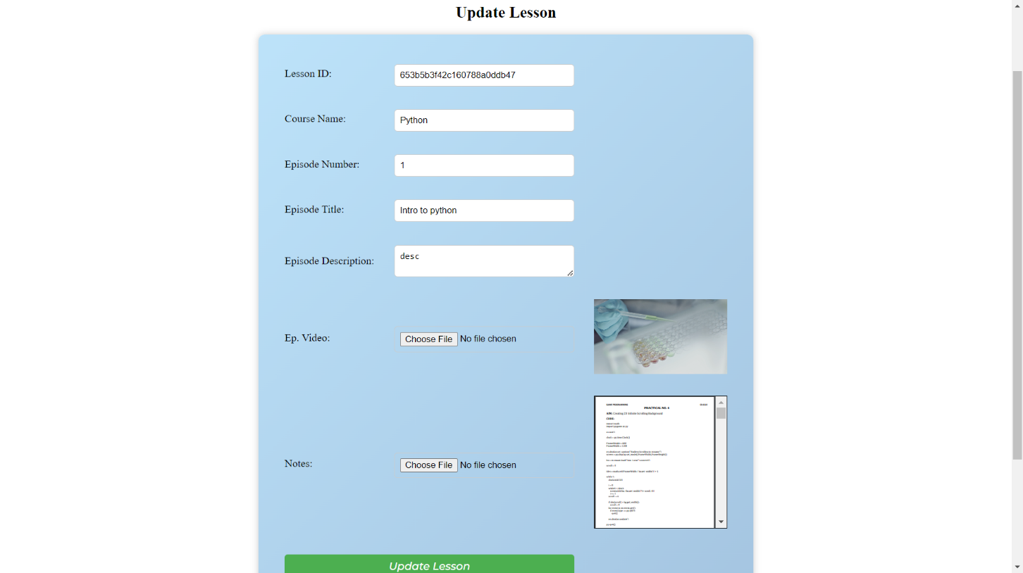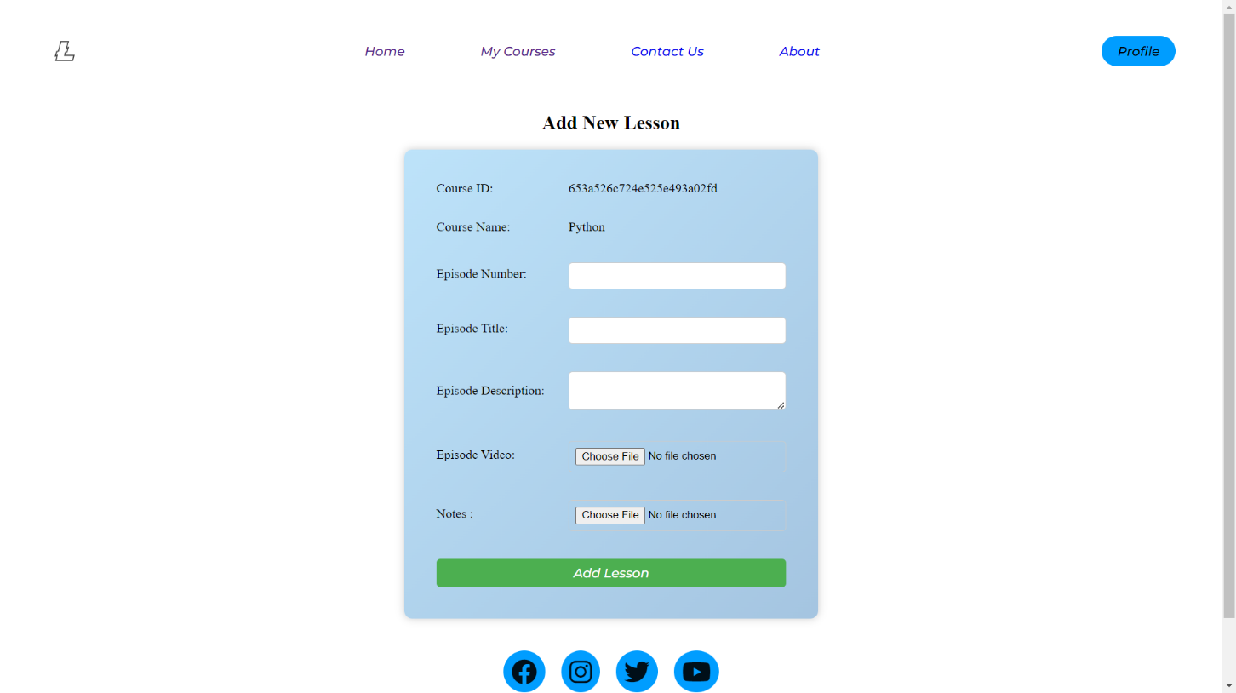

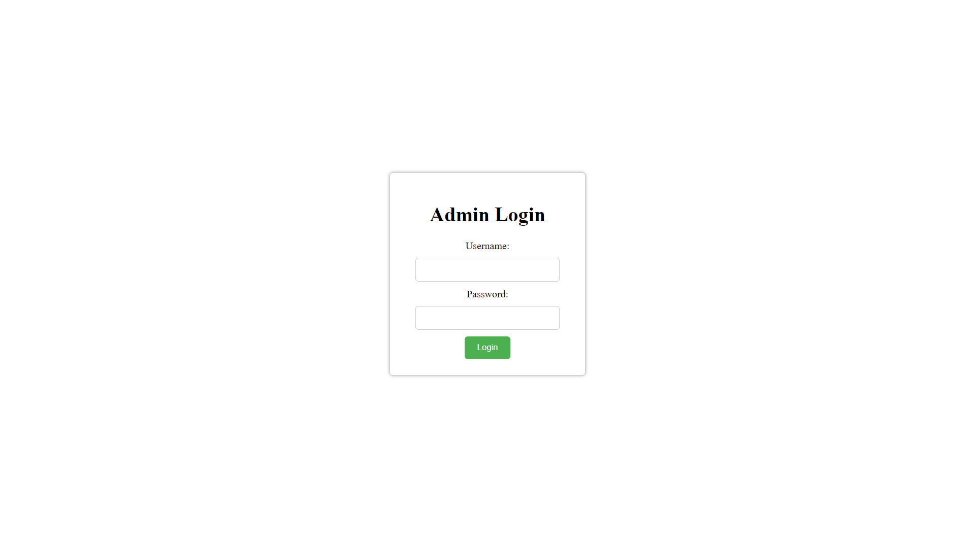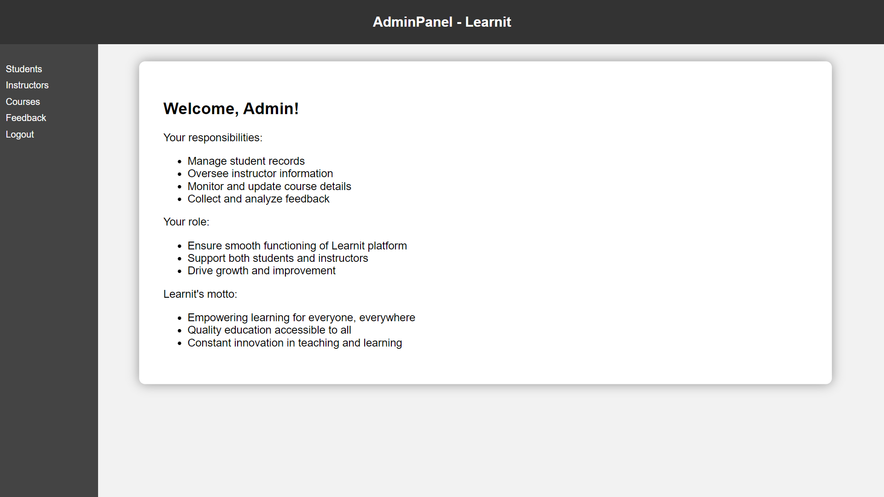

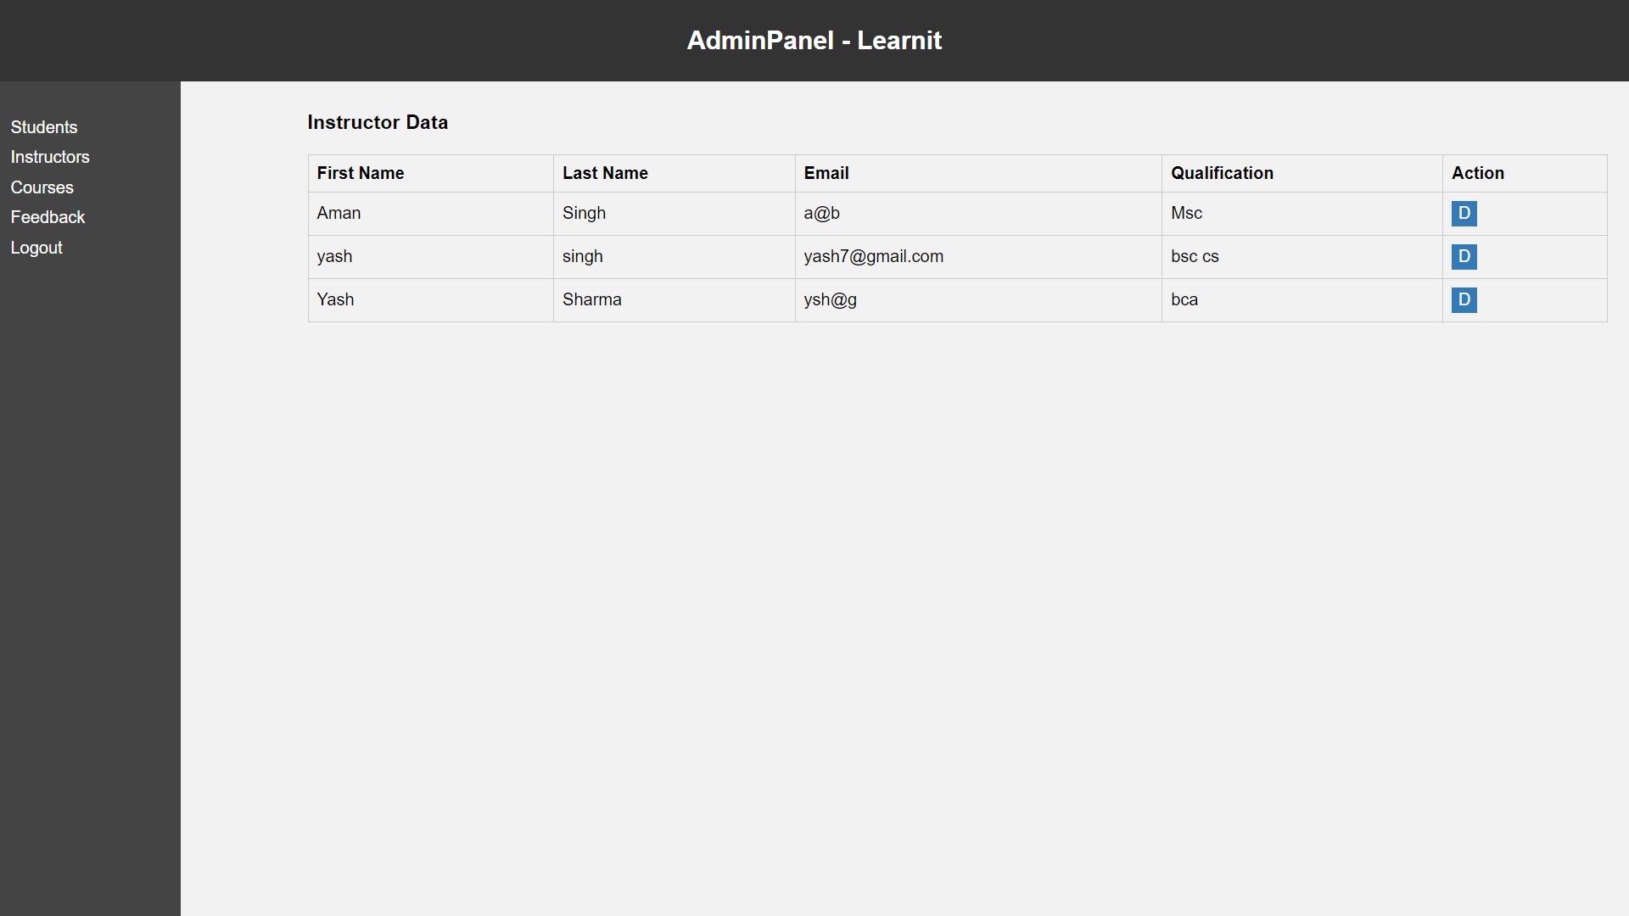

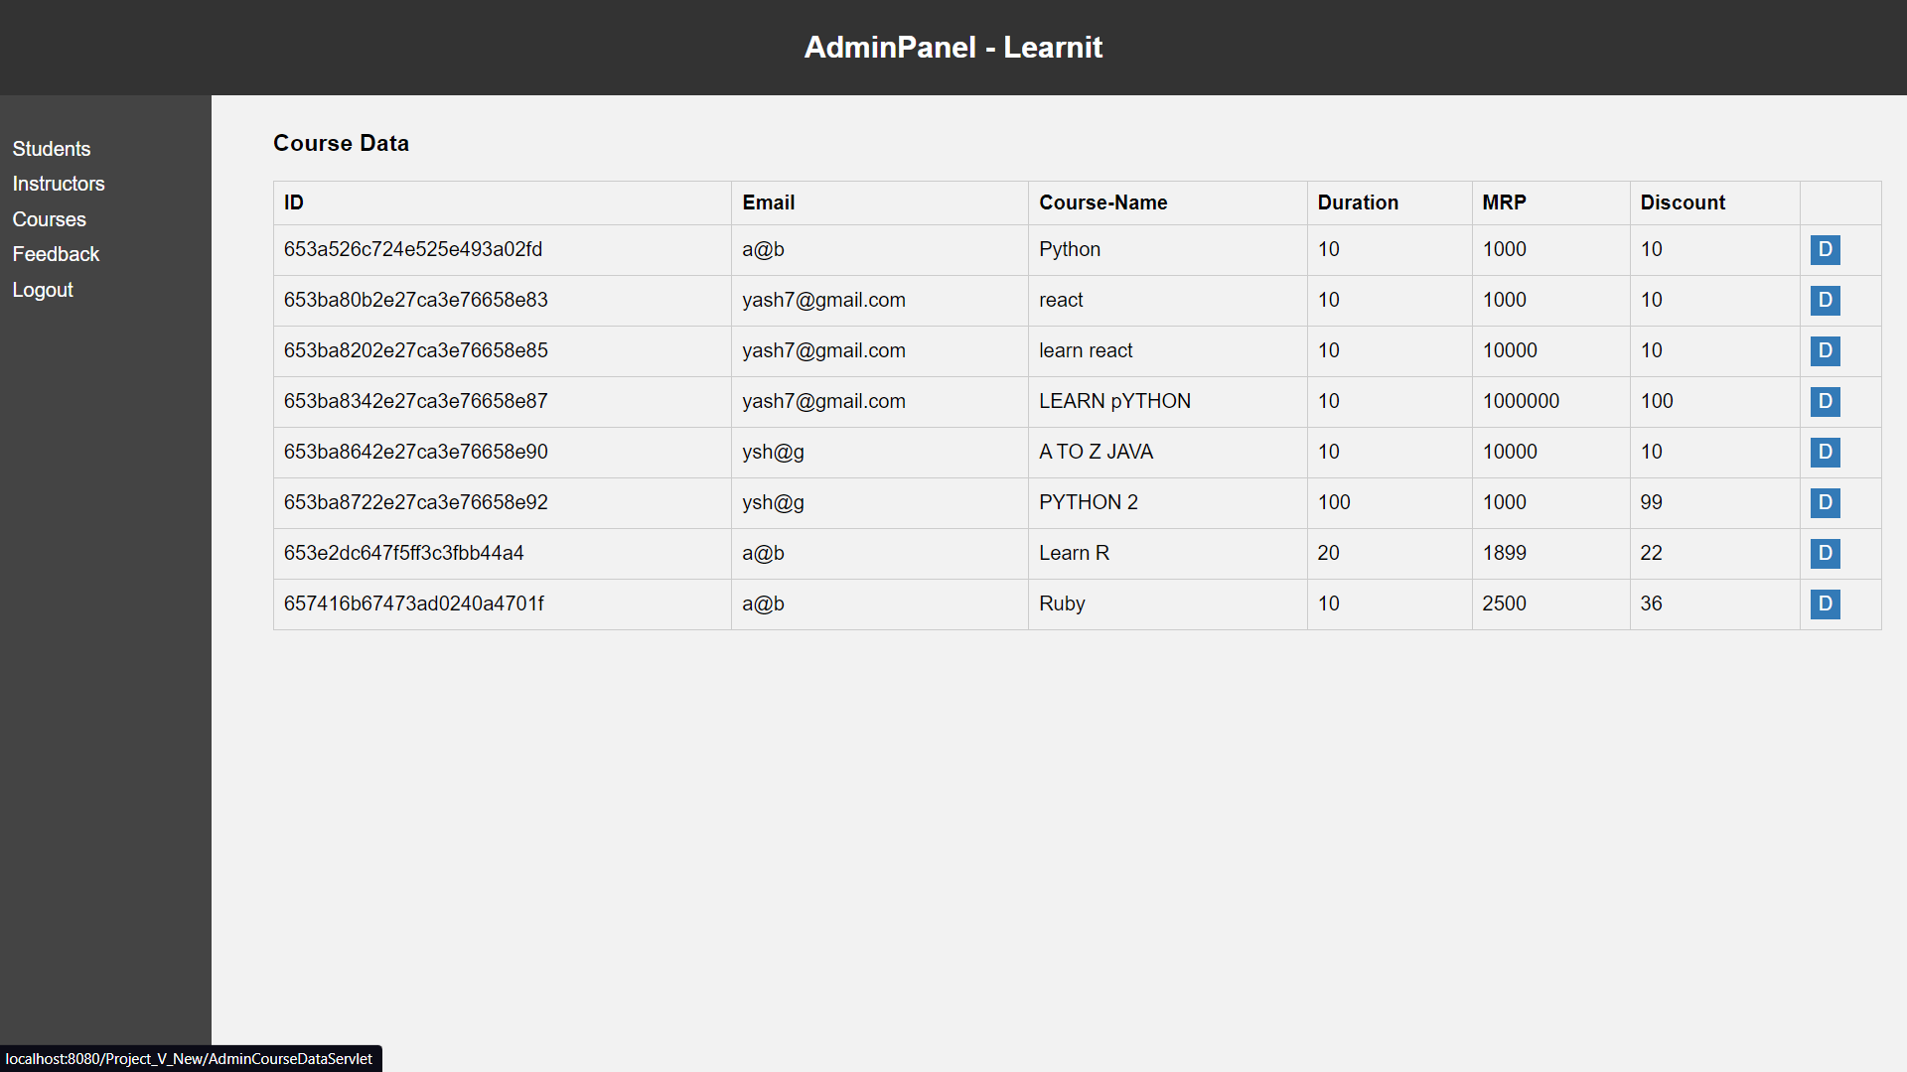

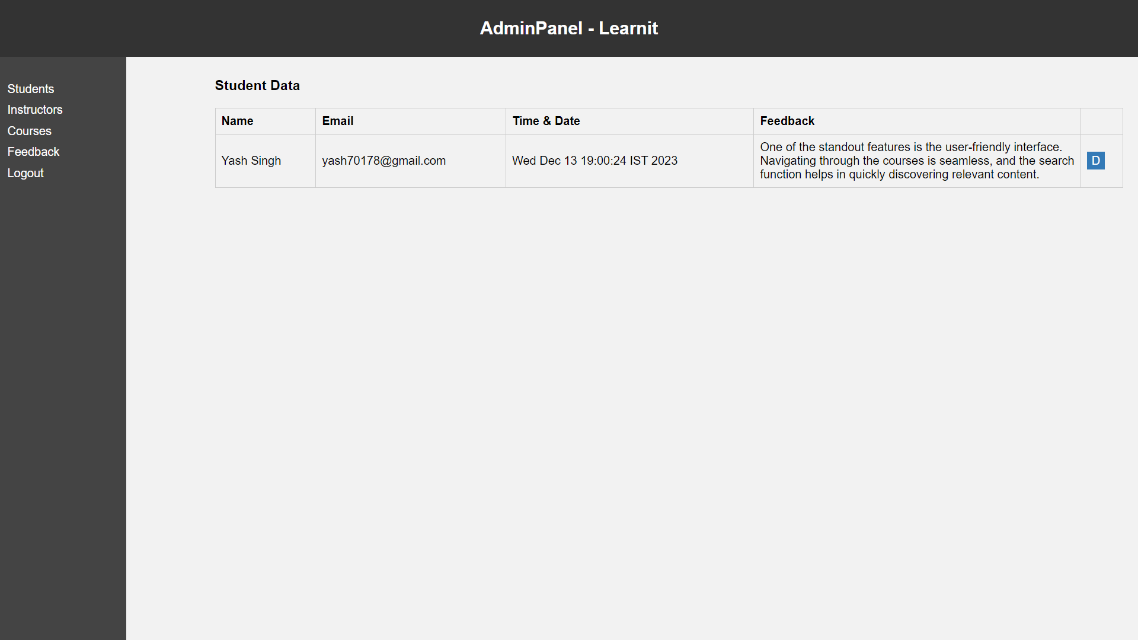

## 3.5. Test Cases Design

### 3.5.1. Test Case Development Process

The test case development process followed a structured approach involving:

* **Requirement Analysis**: Derivation from Detailed Requirements: Test cases were meticulously developed based on the comprehensive requirements outlined in the project specifications. Each functional aspect, including user management, course creation, content delivery, and admin portal functionalities, was analyzed to define corresponding test cases.
* **Identification of Scenarios**: Various user scenarios, including user registration, course enrollment, video lecture playback, and admin dashboard functionalities, were identified and translated into test cases.
  + User Registration: Test cases focusing on the registration process, ensuring validation of user input, successful account creation, and error handling for invalid entries.
  + Course Enrollment: Test cases covering the enrollment process, verifying users' ability to explore courses, select desired courses, and complete enrollment successfully.
  + Video Lecture Playback: Test scenarios verifying the functionality of video playback within course modules, ensuring smooth streaming, pause/play controls, and compatibility across devices.
  + Admin Dashboard Functionalities: Test cases validating administrative actions such as user management, content moderation, and system monitoring within the admin portal.
* Test Case Documentation
  + Structured Test Case Documentation: Each identified scenario was translated into detailed test cases, comprising clear steps, expected outcomes, preconditions, and post-conditions.
  + Validation Criteria: Test cases were defined with specific validation criteria to ascertain the expected behavior of the system, enabling testers to verify functionality and report any deviations from expected results.

### 3.5.2. Test Case Structure

The structure of test cases plays a pivotal role in ensuring systematic and efficient testing procedures within a software development lifecycle. A well-defined test case structure provides clarity, guiding testers with precise steps, expected outcomes, and validation criteria.

Each test case followed a defined structure for clarity and comprehensiveness:

* **Test Case Name/ID**: TC001 - User Registration Validation
* **Description**: Validates the user registration process by entering valid and invalid inputs in the registration form.
* **Preconditions**: The user registration page is accessible and functional.
* **Test Steps**:

1. Enter valid user details (name, email, password).
2. Enter invalid email format and attempt registration.
3. Verify error message for invalid email format.
4. Repeat steps with invalid password length and check error message.

* **Expected Results**: Successful registration with valid inputs and appropriate error messages for invalid inputs.
* **Actual Results**: Pass/Fail status and any observations made during testing.
* **Status and Remarks**: Passed - Valid inputs registered successfully. Failed - Error message not displayed for invalid email format.

**Example:** -

|  |  |  |  |  |  |  |
| --- | --- | --- | --- | --- | --- | --- |
| Test Case ID | Description | Preconditions | Test Steps | Expected Results | Actual Results | Status |
| TC001 | User Registration Validation | User registration page should be accessible | 1. Enter valid user details | Successful registration | Pass | Passed |

Table 2: Test Case Structure Example

### 3.5.3. Test Case Coverage

**Test Cases:**

|  |  |  |  |  |
| --- | --- | --- | --- | --- |
| Test Case ID | Description | Preconditions | Test Steps | Expected Results |
| TC001 | Valid Login Credentials | User account exists with valid login credentials. | Enter valid username and password. Click login. | User successfully logs in and accesses the dashboard. |
| TC002 | Invalid Login Credentials | User account exists with invalid login credentials. | Enter invalid username or password. Click login. | System displays an error message for incorrect credentials. |
| TC003 | Enrolling in a Course | Course selection available for enrollment. | Select a course and click "Enroll". | User is successfully enrolled in the selected course. |
| TC004 | Course Enrollment Limit | Course has reached its enrollment capacity. | Attempt to enroll in a full course. | User receives a message indicating the course is full. |
| TC005 | Video Playback | Course with available video lectures. | Click on a video lecture to play. | Video starts playing smoothly without interruptions. |
| TC006 | Video Quality Settings | Video playback screen with quality settings. | Change video quality settings during playback. | Video quality adjusts according to selected settings. |
| TC007 | User Account Management (Admin) | Admin access to user management dashboard. | Suspend or delete a user account. | Selected user account is suspended or deleted as per action. |
| TC008 | Content Moderation (Admin) | Admin access to content moderation dashboard. | Review and moderate user-generated content. | Admin approves or rejects content submissions appropriately. |
| TC009 | Successful Payment Process | Course selected for purchase. | Initiate course purchase and complete payment. | User receives confirmation of successful payment. |
| TC010 | Payment Gateway Error Handling | Payment gateway available for testing errors. | Simulate a payment failure from the gateway. | User receives an error message indicating payment failure. |
| TC011 | Submitting Feedback | Logged in into the Account | Provide feedback. | System records user feedback. |
| TC012 | Feedback Validation | Feedback submission form with invalid details. | Submit incomplete or invalid feedback. | System prompts the user to provide valid feedback details. |
| TC013 | Updating Profile Information | User profile with editable fields. | Edit user profile details (name, email, etc.). | Changes are saved and reflected correctly in the profile. |
| TC014 | Password Change | User logged in with an existing password. | Change the user password. | Password is updated successfully and allows login. |
| TC015 | Search Functionality | Course catalog with search bar. | Search for a course using specific keywords. | Relevant courses matching the search query are displayed. |
| TC016 | Error Page Display | Access an invalid or non-existent URL. | Apply sorting options to view courses (e.g., by date). | Courses are arranged according to the selected criteria. |
| TC017 | Input Validation | Input fields with validation requirements. | Access an invalid URL or a non-existent page. | User is directed to an error page with a clear message. |
| TC018 | Accessing Downloadable Materials | Enrolled in a course offering downloadable resources. | Access course materials section and download provided files. | Downloaded files are accessible and correctly downloaded. |
| TC019 | Navigation Functionality | User logged in and navigating across different pages. | Click on various navigation links (Home, Profile, Courses, etc.) | User smoothly navigates between different pages. |
| TC020 | Instructors' Course Creation | Instructors logged in with course creation privileges. | Create a new course with relevant details and multimedia content. | Newly created course is visible and accessible to users. |
| TC021 | Course Editing and Updating | Instructors with existing courses to edit. | Edit course details (title, description, etc.) and save changes. | Changes made are reflected and saved successfully. |
| TC022 | One-on-One Doubt Session Booking | User enrolled in a course with doubt session availability. | Book a doubt-clearing session with the instructor. | Doubt session is scheduled and confirmed with the instructor. |
| TC023 | User Account Creation | User accessing the platform for the first time. | Register by filling in mandatory fields and submitting details. | New user account is created and ready for login. |
| TC024 | Accessibility Testing | User with accessibility needs accessing the platform. | Navigate and interact using screen readers or keyboard only. | Platform functions effectively with accessibility tools. |
| TC025 | Mobile Responsiveness Testing | Accessing the platform from mobile devices. | Browse courses and access features through mobile web browsers. | Platform features are easily accessible and responsive. |
| TC026 | Session Timeout Handling | User session active for an extended period without activity. | Wait for session timeout duration to elapse. | User is logged out and prompted to reauthenticate. |
| TC027 | Multi-browser Compatibility | Accessing the platform using different web browsers. | Login and navigate through the platform in various browsers. | Platform functions consistently across different browsers. |
| TC028 | Inactivity Alert | User inactivity for a specified time while logged in. | Remain inactive for the specified duration. | Alert or prompt notifies the user about session inactivity. |
| TC029 | Language Localization | Platform accessed in different language preferences. | Change language settings and verify translated content. | Platform elements and content are correctly translated. |
| TC030 | Social Media Integration | Sharing course details on social media platforms. | Click on social media sharing icons within course details. | Course information is successfully shared on social media. |
| TC031 | Concurrent User Load Testing | Simulate multiple users accessing the platform simultaneously. | Access the platform with multiple user accounts simultaneously. | Platform remains responsive and functions under simultaneous user load. |
| TC032 | Browser Compatibility | Accessing the platform using different browser versions. | Login and navigate through the platform in various browser versions. | Platform functions consistently across different browser versions. |

Table 3: Test Cases

* **Functional Coverage**: Test cases were designed to cover a wide range of functionalities outlined in the project's requirements document. These functionalities included user management (authentication, profile management), course-related operations (creation, enrollment), content delivery (video lectures, downloadable materials), and admin portal functionalities (user management, content moderation). Each functional area was thoroughly tested to ensure proper functioning and adherence to the specified requirements.
* **Module/Component Coverage**: The testing process encompassed major modules/components of the e-learning platform. This included User Management, where test cases focused on registration, authentication, and profile management. Course Management testing ensured proper creation, editing, enrollment, and access to courses. Content Delivery was thoroughly examined, ensuring smooth video playback and accessibility of downloadable materials. The Admin Dashboard was rigorously tested for functionalities like user account management and content moderation.
* **User Story Coverage**: Test cases were aligned with user stories gathered during the development phase. Each user story represented a specific user scenario or requirement. Test cases were meticulously crafted to cover these user stories, ensuring end-to-end testing of various user journeys and scenarios. For instance, scenarios like user account creation, course enrollment, content access, and admin-level actions were thoroughly tested to validate user stories and ensure seamless functionality across different user interactions.
* **Boundary and Error Case Coverage**: In addition to functional testing, boundary cases, and error scenarios were covered extensively. This included testing for limits such as maximum course enrollment, boundary conditions for data input (such as character limits for text fields), and error handling (incorrect credentials, expired sessions). Robust testing of these scenarios aimed to ensure system stability, data integrity, and appropriate error handling mechanisms in various conditions.
* **Integration and Compatibility Coverage**: Test cases also covered integration aspects, ensuring smooth interactions between different modules and components. Compatibility testing involved verifying the platform's performance across different browsers, devices, and operating systems, ensuring optimal functionality and user experience across diverse environments.

Overall, the test cases were structured to ensure comprehensive coverage of functionalities, modules, user stories, boundary cases, integration aspects, and compatibility checks, thus validating the system's robustness, reliability, and adherence to requirements.

### 3.5.4. Test Data and Environment Setup

* **Test Data Generation**: Synthetic data was systematically created to emulate various user scenarios and interactions within the e-learning platform. This included generating diversified user profiles, both for instructors and learners, encompassing valid, invalid, and edge-case inputs. The test data encompassed a range of scenarios such as different user roles, varying course enrollments, diverse content types, and user interactions with the platform's features. By incorporating synthetic data, the test cases were able to cover a broad spectrum of potential usage scenarios, ensuring the robustness and reliability of the platform.
* **Testing Environment**: The testing environment was meticulously set up to mirror the production environment as closely as possible. This involved replicating hardware specifications, software configurations, network settings, and database structures to match those in the actual production setup. The test environment was configured with the same versions of operating systems, browsers, server software, and other dependencies used in the live deployment. By aligning the testing environment with the production environment, it ensured accurate testing conditions and provided a realistic assessment of the system's behavior, performance, and compatibility across different components and user interactions.
* **Security and Privacy Considerations**: Additionally, the test environment was designed with stringent security measures to safeguard sensitive user information and ensure compliance with privacy regulations. This included data encryption, access controls, and adherence to data protection standards to guarantee the confidentiality, integrity, and availability of user data throughout testing processes.

# CHAPTER 4: IMPLEMENTATION AND TESTING

## 4.1. Source Code

### 4.1.1. Login Module

**package** com.learnit.controller;

**import** java.io.IOException;

**import** javax.servlet.RequestDispatcher;

**import** javax.servlet.ServletException;

**import** javax.servlet.annotation.WebServlet;

**import** javax.servlet.http.HttpServlet;

**import** javax.servlet.http.HttpServletRequest;

**import** javax.servlet.http.HttpServletResponse;

**import** javax.servlet.http.HttpSession;

**import** org.bson.Document;

**import** com.learnit.db.DBConnect;

**import** com.mongodb.client.FindIterable;

@WebServlet("/StdLogin")

**public** **class** StdLogin **extends** HttpServlet {

**private** **static** **final** **long** ***serialVersionUID*** = 1L;

**public** StdLogin() {

**super**();

}

**protected** **void** doGet(HttpServletRequest request, HttpServletResponse response)

**throws** ServletException, IOException {

}

**protected** **void** doPost(HttpServletRequest request, HttpServletResponse response)

**throws** ServletException, IOException {

**try** {

String email = request.getParameter("email");

String password = request.getParameter("password");

DBConnect dbConnect = **new** DBConnect();

**boolean** loginSuccess = dbConnect.sLogin(email, password);

FindIterable<Document> courseData = dbConnect.retrieveCourseData();

**if** (courseData == **null**) {

System.***out***.println("no course data retrived");

} **else** {

System.***out***.println("data found" + courseData);

}

**if** (loginSuccess) {

// Assuming the user is successfully authenticated

HttpSession session = request.getSession();

session.setAttribute("userEmail", email); // Store user's email in the session

// Store the user data in a request attribute to make it available in the JSP page

request.setAttribute("courseData", courseData);

System.***out***.println("loginsuccessfull");

RequestDispatcher dispatcher = request.getRequestDispatcher("home.jsp");

dispatcher.forward(request, response);

} **else** {

System.***out***.println("incorrect password");

response.sendRedirect("login.html");

}

} **catch** (Exception e) {

// Handle the exception, for example, log the error and show an error page to the user.

System.***out***.println("Error occurred: " + e);

response.sendRedirect("error.html");

}

}

}

### 4.1.2. Course Upload Module

**package** com.learnit.controller;

**import** java.io.File;

**import** java.io.IOException;

**import** java.util.Collection;

**import** javax.servlet.ServletException;

**import** javax.servlet.annotation.MultipartConfig;

**import** javax.servlet.annotation.WebServlet;

**import** javax.servlet.http.HttpServlet;

**import** javax.servlet.http.HttpServletRequest;

**import** javax.servlet.http.HttpServletResponse;

**import** javax.servlet.http.HttpSession;

**import** javax.servlet.http.Part;

**import** com.learnit.db.DBConnect;

@WebServlet("/UploadCourse")

@MultipartConfig(location = "D:\\UploadedCourseFiles", fileSizeThreshold = 1024 * 1024 * 1024, // close to 1024MB

maxFileSize = -1, // No maximum file size limit

maxRequestSize = -1 // No maximum request size limit

)

**public** **class** UploadCourse **extends** HttpServlet {

**private** **static** **final** **long** ***serialVersionUID*** = 1L;

**public** UploadCourse() {

**super**();

}

**protected** **void** doPost(HttpServletRequest request, HttpServletResponse response)

**throws** ServletException, IOException {

// Get the session

HttpSession session = request.getSession();

// Retrieve the user's email from the session

String userEmail = (String) session.getAttribute("userEmail");

// Retrieve course data

String courseName = request.getParameter("playlistName");

String courseDescription = request.getParameter("courseDescription");

String courseDuration = request.getParameter("courseDuration");

String coursePrice = request.getParameter("coursePrice");

String discount = request.getParameter("discount");

String locationValue = "C:\\Users\\Yash\\eclipse-workspace\\Project_V_New\\src\\main\\webapp\\UploadedCourseFiles\\CourseImg";

String message = "";

**try** {

String folderPath = locationValue + File.***separator*** + userEmail + "_" + courseName;

File folder = **new** File(folderPath);

**if** (!folder.exists()) {

folder.mkdirs(); // Create the folder if it doesn't exist

}

// Get the course image Part

Part courseImagePart = request.getPart("courseImage");

String courseImageFileName = getFileName(courseImagePart);

**if** (courseImageFileName != **null**) {

String fileExtension = courseImageFileName.substring(courseImageFileName.lastIndexOf('.'));

courseImageFileName = userEmail + "_" + courseName + "_image" + fileExtension;

String relativePath = "UploadedCourseFiles\\CourseImg" + File.***separator*** + userEmail + "_" + courseName

+ File.***separator*** + courseImageFileName;

String imagePath = folderPath + File.***separator*** + courseImageFileName;

courseImagePart.write(imagePath);

// Your DBConnect code here to store the course data and image path in the

// database

DBConnect dbConnect = **new** DBConnect();

dbConnect.UploadCourse(userEmail, courseName, courseDescription, courseDuration, coursePrice, discount,

relativePath);

}

message = "Files have been uploaded successfully";

} **catch** (Exception e) {

message = "File upload failed: " + e.getMessage();

}

response.sendRedirect("Upcourses.jsp");

//request.setAttribute("message", message);

//request.getRequestDispatcher("message.jsp").forward(request, response);

}

**private** String getFileName(Part part) {

String contentDisposition = part.getHeader("content-disposition");

**if** (!contentDisposition.contains("filename=")) {

**return** **null**;

}

**int** beginIndex = contentDisposition.indexOf("filename=") + 10;

**int** endIndex = contentDisposition.length() - 1;

**return** contentDisposition.substring(beginIndex, endIndex);

}

}

### 4.1.3. Course Access Module

**package** com.learnit.controller;

**import** java.io.IOException;

**import** javax.servlet.RequestDispatcher;

**import** javax.servlet.ServletException;

**import** javax.servlet.annotation.WebServlet;

**import** javax.servlet.http.HttpServlet;

**import** javax.servlet.http.HttpServletRequest;

**import** javax.servlet.http.HttpServletResponse;

**import** org.bson.Document;

**import** com.learnit.db.DBConnect;

**import** com.mongodb.client.FindIterable;

@WebServlet("/WatchCourseServlet")

**public** **class** WatchCourseServlet **extends** HttpServlet {

**private** **static** **final** **long** ***serialVersionUID*** = 1L;

**public** WatchCourseServlet() {

**super**();

}

**protected** **void** doGet(HttpServletRequest request, HttpServletResponse response) **throws** ServletException, IOException {

}

**protected** **void** doPost(HttpServletRequest request, HttpServletResponse response) **throws** ServletException, IOException {

**try** {

String courseId = request.getParameter("course_id");

String email = request.getParameter("email");

DBConnect dbConnect = **new** DBConnect();

Document courseData = dbConnect.retrieveCourseDataById(courseId, email);

FindIterable<Document> lessonData = dbConnect.retriveLessonById(courseId);

**if** (courseData == **null** && lessonData == **null**) {

System.***out***.println("no course data & lesson data retrived");

} **else** {

System.***out***.println("course data found" + courseData + "lesson data found" + lessonData);

request.setAttribute("courseData", courseData);

request.setAttribute("lessonData", lessonData);

RequestDispatcher dispatcher = request.getRequestDispatcher("WatchCourse.jsp");

dispatcher.forward(request, response);

}

} **catch** (Exception e) {

// Handle the exception, for example, log the error and show an error page to the user.

System.***out***.println("Error occurred: " + e);

response.sendRedirect("error.jsp");

}

}

}

### 4.1.4. Payment Module

<%@ page language=*"java"* contentType=*"text/html; charset=UTF-8"*

pageEncoding=*"UTF-8"*%>

<%@ page import=*"com.mongodb.client.FindIterable"* %>

<%@ page import=*"org.bson.Document"* %>

<%@ page import=*"com.mongodb.client.MongoCursor"* %>

<%@ page import=*"org.bson.types.ObjectId"* %>

<%@ page import=*"java.util.Random"* %>

<%@ page import=*"com.razorpay.RazorpayClient"* %>

<%@ page import=*"com.razorpay.Order"* %>

<%@ page import=*"org.json.JSONObject"* %>

<!DOCTYPE html>

<html>

<head>

<meta charset=*"UTF-8"*>

<script src=*"https://checkout.razorpay.com/v1/checkout.js"*></script>

<style>

*.checkout-info* {

background-color: *#f4f4f4*; /* Off white background color */

border: *1px solid #ccc*; /* Border for the box */

border-radius: *10px*; /* Rounded corners */

padding: *20px*; /* Add padding inside the box */

width: *60%*; /* Set the width of the box */

margin: *0 auto*; /* Center the box horizontally */

text-align: *center*; /* Center the content inside the box */

}

*.info* {

margin-bottom: *10px*; /* Add spacing between each label and its content */

text-align: *center*; /* Align labels and content to the center*/

}

</style>

<title>CheckOut</title>

</head>

<body>

<h1 align=*"center"*>Payment Page</h1>

<%

String userEmail = (String) session.getAttribute("userEmail");

// Access other user-specific data if needed

**if**(userEmail==**null**){

response.sendRedirect("login.html");

}

Document courseData = (Document) request.getAttribute("courseData");

Document stdData = (Document) request.getAttribute("stdData");

String customerEmail = (String) request.getAttribute("userEmail");

String coursePrice = (String) request.getAttribute("price");

**if** (courseData != **null** && stdData != **null**) {

ObjectId cId = courseData.getObjectId("_id");

String email = courseData.getString("instructorEmail");

String cName = courseData.getString("courseName");

String cDescription = courseData.getString("courseDescription");

String cDuration = courseData.getString("courseDuration");

String cPrice = courseData.getString("coursePrice");

String cDiscount = courseData.getString("discount");

String imagepath = courseData.getString("courseImage");

ObjectId stdId = stdData.getObjectId("_id");

String fName = stdData.getString("FirstName");

String LName = stdData.getString("LastName");

String Name = fName + "_" + LName;

**double** originalPrice = Double.parseDouble(cPrice);

**double** discountPercentage = Double.parseDouble(cDiscount);

**double** discountedPrice = originalPrice - (originalPrice * discountPercentage / 100);

String discountedPriceAsString = String.format("%.0f", discountedPrice);

**int** priceInRupeesInt = (**int**) discountedPrice; // Convert the double to an integer

String orderID = (String) request.getAttribute("orderId");

String razorpayOrderId = (String) request.getAttribute("razorpayOrderId");

%>

<script>

**var** amount = <%= priceInRupeesInt * 100 %>;

**var** cName = "<%= cName %>";

**var** Name = "<%= Name %>";

**var** customerEmail = "<%= customerEmail %>";

**var** razorpayOrderId = "<%= razorpayOrderId %>";

</script>

<div class=*"checkout-info"*>

<form>

<!-- Customer Information -->

<h2>Customer Information</h2>

<div class=*"info"*>

<label for=*"name"*>Name:</label>

<label><b><%= Name %></b></label>

<input type=*"hidden"* name=*"customerName"* value=*"*<%= Name %>*"*>

</div>

<div class=*"info"*>

<label for=*"email"*>Email:</label>

<label for=*"email"*><b><%= customerEmail %></b></label>

<input type=*"hidden"* name=*"customerEmail"* value=*"*<%= customerEmail %>*"*>

<input type=*"hidden"* name=*"stdId"* value=*"*<%= stdId %>*"*>

</div>

<!-- Course Information -->

<h2>Course Information</h2>

<div class=*"info"*>

<label for=*"cName"*>Course Name:</label>

<label for=*"cName"*><b><%= cName %></b></label>

<input type=*"hidden"* name=*"courseName"* value=*"*<%= cName %>*"*>

<input type=*"hidden"* name=*"cId"* value=*"*<%= cId %>*"*>

</div>

<div class=*"info"*>

<label for=*"cPrice"*>Price:</label>

<label for=*"cPrice"*><b>₹<%= discountedPriceAsString %></b></label>

<input type=*"hidden"* name=*"discountedPriceInString"* value=*"*<%= discountedPriceAsString %>*"*>

</div>

<!-- Order summary -->

<h2>Order Summary</h2>

<div class=*"info"*>

<label for=*"OID"*>Order ID:</label>

<label for=*"OID"*><b><%= orderID %></b></label>

<input type=*"hidden"* name=*"orderID"* value=*"*<%= orderID %>*"*>

</div>

<!-- Submit Button -->

<input type=*"submit"* id=*"rzp-button1"* value=*"Pay Now"* style="padding: *10px 20px*; font-size: *16px*; background-color: *#007bff*; color: *#fff*; border: *none*; border-radius: *5px*; cursor: *pointer*;">

</form>

</div>

<%

}

%>

<script>

**var** options = {

"key": "rzp_test_p35m7G8SlMZ8cs",

"amount": amount,

"currency": "INR",

"name": "LearnIt Corp.",

"description": "Course" + cName,

"image": "https://ibb.co/9YVHPT0",

"order_id": razorpayOrderId,

"callback_url": "PaymentSuccessServlet",

"prefill": {

"name": Name,

"email": customerEmail,

"contact": ""

},

"notes": {

"address": "Razorpay Corporate Office"

},

"theme": {

"color": "#3399cc"

}

};

**var** rzp1 = **new** Razorpay(options);

document.getElementById('rzp-button1').onclick = **function**(e){

rzp1.open();

e.preventDefault();

}

</script>

</body>

</html>

## 4.2. Testing Approach

### 4.2.1. Unit Testing

**Definition**:

Unit testing is a fundamental testing methodology that assesses individual components or units of the software to ensure their isolated functionalities work as intended. It verifies that each unit performs its specific task correctly and independently, contributing to the overall system functionality.

* User Management Module:

The User Management module undergoes rigorous unit testing to evaluate various functionalities crucial for user interaction and account management within the e-learning platform. This involves a suite of test cases encompassing:

* + User Registration Testing: Test cases focus on validating the user registration process, ensuring accurate user data input, storage, and verification. Scenarios include testing different input combinations (valid, invalid, edge cases) for user details like name, email, and password. It validates the creation of unique user accounts, email validations, and data persistence in the database.
  + Login Functionality Testing: Unit tests are designed to cover the login mechanism, verifying user authentication, session creation, and access control. It includes scenarios like successful logins with valid credentials, failed logins with incorrect details, handling of edge cases like password resets, and user session management.
  + Password Reset Testing: This set of tests ensures the correct functioning of the password reset feature, including scenarios where users request a password reset, receive reset links, and successfully reset their passwords. The testing evaluates email notifications, token-based authentication for password reset, and data integrity post-reset.
* Course Creation Module:

The Course Creation module is another critical component of the e-learning platform that undergoes comprehensive unit testing, validating functionalities associated with creating, modifying, and managing courses:

* + Course Creation Testing: Test cases are formulated to validate the process of course creation, ensuring accurate entry and storage of course details such as title, description, content, and multimedia components. It covers scenarios like successful creation of new courses, handling duplicate course titles, and boundary tests for input data length and formats.
* Course Editing and Deletion Testing: Unit tests are designed to examine the editing and deletion functionalities of courses. This includes verifying the ability to modify existing course details, update multimedia content, and accurately delete courses without compromising data integrity. Tests cover scenarios involving course content modifications, permission validations for editing, and successful deletion processes.

Unit testing forms a critical part of the software development lifecycle, ensuring the reliability, functionality, and accuracy of individual software components in isolation. By meticulously testing the User Management and Course Creation modules, the unit testing process contributes to the overall quality and robustness of the e-learning platform.

### 4.2.3. Integrated Testing

**Definition**: Integrated testing is a pivotal phase in the software testing process that aims to verify the seamless interaction and collaboration between different modules or components of the software. It focuses on ensuring that these modules, when integrated, function harmoniously as a unified system. For instance:

* User-Course Enrollment Interaction:

The integrated testing strategy involves assessing the interactions between the Users and Courses modules, specifically focusing on the enrollment process and its impact on user-course interactions.

* + Test scenarios where users enroll in courses and verify enrollment status.
  + Validate data flow between the Users and Courses modules.

**Enrollment Status and Data Consistency Checks**:

Test cases are formulated to examine and validate the enrollment status updates within the Users and Courses modules. This involves verifying that enrolled users reflect the correct course enrollments in their profiles and that the Courses module accurately updates the enrollment counts and user data.

* Content Delivery and User Access:

Integrated testing also scrutinizes the integration between the Content Delivery module and user access permissions to ensure users can access course content seamlessly:

* + Test scenarios ensuring users can access video lectures and downloadable materials after enrolling in courses.
  + Verify proper integration of content delivery with user permissions.

**Content Availability and Permission Checks**:

Test cases are developed to verify that enrolled users can access all available course content and that unauthorized users are restricted from accessing course materials. This includes checking content availability based on enrollment status and proper handling of user permissions.

### 4.2.3. Beta Testing

**Purpose**: Beta testing involves releasing a version of the e-learning platform to a limited audience for real-world testing before the official launch.

* Beta Test Plan:
  + Target Audience: Selecting a group of volunteer users representing diverse user demographics.
  + Duration: Beta testing to span 2-3 days for comprehensive feedback collection.
  + Goals: Gather feedback on usability, identify bugs, and assess overall user experience.
* Feedback Collection:
  + Conducting user interviews to delve deeper into user insights and preferences.
* Bug Documentation:
  + Making a document to record all the bugs.
* Iterative Improvement:
  + Iteratively releasing updates based on collected feedback to improve usability, fix reported bugs, and enhance user satisfaction before the official launch.

## 4.3. Test Cases Results

|  |  |  |  |  |  |  |
| --- | --- | --- | --- | --- | --- | --- |
| Test Case ID | Description | Preconditions | Test Steps | Expected Results | Actual Result | Status |
| TC001 | Valid Login Credentials | User account exists with valid login credentials. | Enter valid username and password. Click login. | User successfully logs in and accesses the dashboard. | Successful Login | Pass |
| TC002 | Invalid Login Credentials | User account exists with invalid login credentials. | Enter invalid username or password. Click login. | System displays an error message for incorrect credentials. | Failed Login | Pass |
| TC003 | Enrolling in a Course | Course selection available for enrollment. | Select a course and click "Enroll". | User is successfully enrolled in the selected course. | Enrolled Successfully | Pass |
| TC004 | Course Enrollment Limit | Course has reached its enrollment capacity. | Attempt to enroll in a full course. | User receives a message indicating the course is full. | Enrolled successfully | Fail |
| TC005 | Video Playback | Course with available video lectures. | Click on a video lecture to play. | Video starts playing smoothly without interruptions. | Video Plays | Pass |
| TC006 | Video Quality Settings | Video playback screen with quality settings. | Change video quality settings during playback. | Video quality adjusts according to selected settings. | Quality Adjusted | Pass |
| TC007 | User Account Management (Admin) | Admin access to user management dashboard. | Suspend or delete a user account. | Selected user account is suspended or deleted as per action. | Account Deleted | Pass |
| TC008 | Content Moderation (Admin) | Admin access to content moderation dashboard. | Review and moderate user-generated content. | Admin deletes improper content. | Content Deleted | Pass |
| TC009 | Successful Payment Process | Course selected for purchase. | Initiate course purchase and complete payment. | User receives confirmation of successful payment. | Payment Successful | Pass |
| TC010 | Payment Gateway Error Handling | Payment gateway available for testing errors. | Simulate a payment failure from the gateway. | User receives an error message indicating payment failure. | Payment Failed Notification | Pass |
| TC011 | Submitting Feedback | Logged in into the Account | Provide feedback. | System records user feedback. | Feedback Recorded | Pass |
| TC012 | Feedback Validation | Feedback submission form with invalid details. | Submit incomplete or invalid feedback. | System prompts the user to provide valid feedback details. | Feedback not submitted | Pass |
| TC013 | Updating Profile Information | User profile with editable fields. | Edit user profile details (name, email, etc.). | Changes are saved and reflected correctly in the profile. | Profile Information Changed | Pass |
| TC014 | Password Change | User logged in with an existing password. | Change the user password. | Password is updated successfully and allows login. | Password Changed | Pass |
| TC015 | Search Functionality | Course catalog with search bar. | Search for a course using specific keywords. | Relevant courses matching the search query are displayed. | Search Displays Relevant Results | Pass |
| TC016 | Error Page Display | Access an invalid or non-existent URL. | Access an invalid URL or a non-existent page. | User is directed to an error page with a clear message. | Error page loads | Pass |
| TC017 | Input Validation | Input fields with validation requirements. | Enter valid data according to the defined validation rules (e.g., if it's an email field, enter a valid email address). | Data is accepted without any validation errors. | Data Accepted | Pass |
| TC018 | Accessing Downloadable Materials | Enrolled in a course offering downloadable resources. | Access course materials section and download provided files. | Downloaded files are accessible and correctly downloaded. | Proper File Downloaded | Pass |
| TC019 | Navigation Functionality | User logged in and navigating across different pages. | Click on various navigation links (Home, Profile, Courses, etc.) | User smoothly navigates between different pages. | Navigation Works | Pass |
| TC020 | Instructors' Course Creation | Instructors logged in with course creation privileges. | Create a new course with relevant details and multimedia content. | Newly created course is visible and accessible to users. | Visible Course Created | Pass |
| TC021 | Course Editing and Updating | Instructors with existing courses to edit. | Edit course details (title, description, etc.) and save changes. | Changes made are reflected and saved successfully. | Changes made reflected | Pass |
| TC022 | One-on-One Doubt Session Booking | User enrolled in a course with doubt session availability. | Book a doubt-clearing session with the instructor. | Doubt session is scheduled and confirmed with the instructor. | Doubt Session Booked | Pass |
| TC023 | User Account Creation | User accessing the platform for the first time. | Register by filling in mandatory fields and submitting details. | New user account is created and ready for login. | Account Created | Pass |
| TC024 | Accessibility Testing | User with accessibility needs accessing the platform. | Navigate and interact using screen readers or keyboard only. | Platform functions effectively with accessibility tools. | Website is Accessible | Pass |
| TC025 | Mobile Responsiveness Testing | Accessing the platform from mobile devices. | Browse courses and access features through mobile web browsers. | Platform features are easily accessible and responsive. | Website Alignment Not Proper | Fail |
| TC026 | Session Timeout Handling | User session active for an extended period without activity. | Wait for session timeout duration to elapse. | User is logged out and prompted to reauthenticate. | User Logged Out | Pass |
| TC027 | Multi-browser Compatibility | Accessing the platform using different web browsers. | Login and navigate through the platform in various browsers. | Platform functions consistently across different browsers. | Works across different Browsers | Pass |
| TC028 | Inactivity Alert | User inactivity for a specified time while logged in. | Remain inactive for the specified duration. | Alert or prompt notifies the user about session inactivity. | No notification | Fail |
| TC029 | Language Localization | Platform accessed in different language preferences. | Change language settings and verify translated content. | Platform elements and content are correctly translated. | No change in Language | Fail |
| TC030 | Social Media Integration | Social Media platforms accessible through website. | Click on social media icons to access them. | Social Media Accounts Open. | Social Media Account Accessible | Pass |
| TC031 | Concurrent User Load Testing | Simulate multiple users accessing the platform simultaneously. | Access the platform with multiple user accounts simultaneously. | Platform remains responsive and functions under simultaneous user load. | Platform works with multiple users. | Pass |
| TC032 | Browser Compatibility | Accessing the platform using different browser versions. | Login and navigate through the platform in various browser versions. | Platform functions consistently across different browser versions. | Platform works across different browser version | Pass |

Table 4: Test Cases Result

# CHAPTER 5: CONCLUSION

## 5.1. Conclusion

In the culmination of our e-learning platform development, we reinforce our commitment to revolutionizing the educational landscape by placing the learner at the forefront. Our platform stands as a testament to user-centric learning, advocating for flexibility, accessibility, and quality educational experiences.

**Championing User-Focused Learning**:

Our platform is meticulously designed to cater to the diverse learning needs of users, offering self-paced courses that grant individuals the autonomy to learn at their own convenience. Through an array of multimedia-rich courses, downloadable resources, and a user-friendly interface, we prioritize delivering an engaging, interactive, and personalized learning journey.

**Empowering Learners and Instructors:**

At the core of our platform lies the empowerment of both learners and instructors. For learners, we provide an enriched educational environment fostering deep engagement, where they can access a wealth of resources, engage in interactive sessions, and benefit from personalized guidance. Simultaneously, our platform welcomes educators and subject matter experts, offering them a space to share their knowledge, expand their reach, and actively contribute to the growth of online education.

**Dynamic Evolution and Continuous Learning:**

Our platform's development isn't an endpoint; it's a dynamic, ongoing process. Through meticulous planning, resource allocation, and adaptability, we ensure a platform that evolves with the changing educational landscape. By embracing innovative technologies, user feedback, and emerging pedagogical methods, we remain committed to fostering a culture of continuous learning and knowledge exchange.

**Quality, Engagement, and Educational Revolution:**

Quality remains the cornerstone of our platform. We prioritize delivering high-quality content, seamless user experiences, and robust administrative tools through an intuitive admin portal. By amalgamating educational excellence with cutting-edge technology, our aim is to lead an educational revolution that transcends conventional boundaries, creating an ecosystem that inspires and propels lifelong learning.

In essence, our e-learning platform stands as a beacon of transformative education, championing user empowerment, embracing innovation, and fostering an inclusive environment where learning knows no bounds. Through collaboration, innovation, and a steadfast commitment to educational excellence, we envision a future where our platform continues to redefine and elevate the realms of online education.

## 5.2. Limitation of the System

* **No OTP for Registration**: Absence of OTP verification during registration may compromise platform security, potentially exposing user accounts to unauthorized access or fake registrations.
* **Lack of Personalized Learning Recommendations**: The absence of personalized learning recommendations diminishes user engagement and the tailored learning experience, hindering users from discovering relevant courses based on their interests or progress.
* **Missing Course Completion Tracking**: Without a course completion tracking system, users might face difficulties in tracking their progress or understanding which courses they've completed, impacting their learning journey's organization.
* **Absence of Quizzes**: The lack of quizzes or assessment tools limits the platform's ability to evaluate user comprehension and engagement, essential for reinforcing learning and knowledge retention.
* **Basic UI Design**: The rudimentary UI might hinder user experience, potentially affecting usability and navigation, resulting in a less engaging and intuitive learning environment.

These limitations hinder various aspects of the e-learning platform, impacting security, personalization, user progress tracking, engagement, and user interface experience. Addressing these limitations could significantly enhance the platform's usability and user satisfaction.

## 5.3. Future Scope of the Project

While our e-learning platform stands as a robust and innovative educational solution, there are areas for potential enhancements and future development to further elevate the user experience:

* **OTP for Registration**: Enhance security by introducing OTP verification during user sign-up, ensuring authenticated registrations.
* **Email Services**: Integrate an email system to disseminate receipts and course updates, improving user communication and engagement.
* **File Structure Enhancement**: Optimize the file structure to streamline navigation and content management, ensuring an organized and efficient system.
* **Interactive Features**: Plan to incorporate forums and live chat for user interaction, fostering a collaborative learning environment.
* **Learning Analytics Integration**: Utilize data-driven insights for personalized learning experiences, offering tailored recommendations and performance tracking.
* **Mobile Applications**: Develop mobile apps for wider accessibility, enabling users to access courses conveniently on-the-go.
* **Multilingual Support**: Implement multiple language options to cater to a diverse global audience, ensuring inclusivity and accessibility.

These improvements aim to bolster security, communication, usability, and engagement within the e-learning platform, ensuring a more enriched user experience.

# REFERENCES

* Java Documentation. (Accessed from: <https://docs.oracle.com/en/java/> )
* Payment Gateway Tutorial. (Accessed from: <https://www.youtube.com/watch?v=-Ke6JYqTM_s> )
* Invoice Generator GitHub Repository. (Available at: <https://github.com/bhaskarkh/PdfInvoiceCreator> )
* Learn Java Online. (Accessed from: <https://www.learnjavaonline.org/> )
* MongoDB Documentation. (Accessed from: <https://www.mongodb.com/docs/> )
* MongoDB Java Drivers Documentation. (Available at: <https://www.mongodb.com/docs/drivers/java-drivers/> )

# GLOSSARY

|  |  |
| --- | --- |
| **Term** | **Definition** |
| absence | failure to be present |
| absorption | the mental state of being preoccupied by something |
| accessibility | the attribute of being easy to meet or deal with |
| accessible | capable of being reached |
| accommodate | to make fit for or change to suit a new purpose |
| accommodates | to make fit for or change to suit a new purpose |
| accomplish | to achieve or complete successfully |
| accomplishments | the action of accomplishing something |
| according | (followed by `to') as reported or stated by |
| accuracy | the quality of being near to the true value |
| accurately | with few mistakes |
| acquisition | the act of contracting or assuming or acquiring possession of something |
| actions | something done usually as opposed to something said |
| activation | making active and effective (as a bomb) |
| actively | in an active manner |
| adaptability | the ability to change (or be changed) to fit changed circumstances |
| adaptive | having a capacity for adaptation |
| additionally | in addition by way of addition |
| adequate | having the requisite qualities or resources to meet a task |
| adherence | faithful support for a cause or political party or religion |
| adjusts | to adapt or conform oneself to new or different conditions |
| administrative | of or relating to or responsible for administration |
| administrators | someone who manages a government agency or department |
| aesthetically | in a tasteful way |
| aesthetics | (art) the branch of philosophy dealing with beauty and taste (emphasizing the evaluative criteria that are applied to art) |
| alert | engaged in or accustomed to close observation |
| align | to place in a line or arrange so as to be parallel or straight |
| aligned | brought into agreement or cooperation on the side of a faction party or cause |
| aligning | causing to fall into line or into position |
| alignment | the act of adjusting or aligning the parts of a device in relation to each other |
| aligns | to place in a line or arrange so as to be parallel or straight |
| all-encompassing | broad in scope or content |
| allocation | (computer science) the assignment of particular areas of a magnetic disk to particular data or instructions |
| amalgamation | the combination of two or more commercial companies |
| amassed | to collect or gather |
| ambit | an area in which something acts or operates or has power or control: 'the range of a supersonic jet' |
| analysts | a licensed practitioner of psychoanalysis |
| analytics | of a proposition that is necessarily true independent of fact or experience |
| analyze | to subject to psychoanalytic treatment |
| analyzed | examined carefully and methodically |
| anchored | a mechanical device that prevents a vessel from moving |
| annotations | the act of adding notes |
| anticipated | expected hopefully |
| apache | a parisian gangster |
| applicability | relevance by virtue of being applicable to the matter at hand |
| appropriately | in an appropriate manner |
| appropriateness | the quality of being specially suitable |
| array | an arrangement of aerials spaced to give desired directional characteristics |
| arrays | an arrangement of aerials spaced to give desired directional characteristics |
| arrow | a projectile with a straight thin shaft and an arrowhead on one end and stabilizing vanes on the other |
| arrowhead | the pointed head or striking tip of an arrow |
| arrows | a projectile with a straight thin shaft and an arrowhead on one end and stabilizing vanes on the other |
| articulated | consisting of segments held together by joints |
| artifacts | a man-made object taken as a whole |
| ascertain | to learn or discover with certainty |
| aspirations | the act of inhaling |
| aspire | to have an ambitious plan or a lofty goal |
| assortment | the act of distributing things into classes or categories of the same type |
| assurance | freedom from doubt |
| asynchronous | not synchronous |
| attributes | an abstraction belonging to or characteristic of an entity |
| audits | a methodical examination or review of a condition or situation |
| authenticated | established as genuine |
| authentication | validating the authenticity of something or someone |
| authorization | the act of conferring legality or sanction or formal warrant |
| automate | to make automatic control or operate automatically |
| automatically | in a reflex manner |
| automating | a cafeteria where food is served from machines |
| automation | the act of implementing the control of equipment with advanced technology |
| autonomy | immunity from arbitrary exercise of authority: political independence |
| availability | the quality of being at hand when needed |
| axis | the center around which something rotates |
| backbone | the part of a network that connects other networks together |
| beacon | a tower with a light that gives warning of shoals to passing ships |
| behavior | manner of acting or controlling yourself |
| behavioral | of or relating to behavior |
| behaviors | manner of acting or controlling yourself |
| beta | preliminary or testing stage of a software or hardware product |
| bidirectional | reactive or functioning or allowing movement in two usually opposite directions |
| blueprint | photographic print of plans or technical drawings etc. |
| boasting | speaking of yourself in superlatives |
| boasts | speaking of yourself in superlatives |
| bolster | a pillow that is often put across a bed underneath the regular pillows |
| boolean | of or relating to a combinatorial system devised by george boole that combines propositions with the logical operators and and or and if then and except and not |
| bottlenecks | the narrow part of a bottle near the top |
| boundary | the greatest possible degree of something |
| bounds | the line or plane indicating the limit or extent of something |
| brainstorming | a group problem-solving technique in which members spontaneously share ideas and solutions |
| breakdown | the act of disrupting an established order so it fails to continue |
| browse | the act of feeding by continual nibbling |
| browser | a program used to view html documents |
| browsers | a program used to view html documents |
| browsing | the act of feeding by continual nibbling |
| budgetary | of or relating to a budget |
| bugs | a minute life form (especially a disease-causing bacterium) |
| burdens | weight to be borne or conveyed |
| catalog | a book or pamphlet containing an enumeration of things |
| catalyzes | to change by catalysis or cause to catalyze |
| categorization | the act of distributing things into classes or categories of the same type |
| categorized | arranged into categories |
| cater | to supply food ready to eat |
| catering | providing food and services |
| championing | holding first place in a contest |
| chrome | another word for chromium when it is used in dyes or pigments |
| clarification | the act of removing solid particles from a liquid |
| clarity | the quality of clear water |
| coding | act of writing in code or cipher |
| cohesive | causing cohesion |
| collaborate | to work together on a common enterprise of project |
| collaborates | to work together on a common enterprise of project |
| collaboration | act of working jointly |
| collaborations | act of working jointly |
| collaborative | accomplished by collaboration |
| commence | to take the first step or steps in carrying out an action |
| compartment | a partitioned section chamber or separate room within a larger enclosed area |
| compartments | a partitioned section chamber or separate room within a larger enclosed area |
| compatibility | capability of existing or performing in harmonious or congenial combination |
| compatible | able to exist and perform in harmonious or agreeable combination |
| completeness | (logic) an attribute of a logical system that is so constituted that a contradiction arises if any proposition is introduced that cannot be derived from the axioms of the system |
| completion | a concluding action |
| complexity | the quality of being intricate and compounded |
| compliance | the act of submitting |
| comprehend | to get the meaning of something |
| comprehending | to get the meaning of something |
| comprehension | an ability to understand the meaning or importance of something (or the knowledge acquired as a result) |
| comprehensive | including all or everything |
| comprehensively | in an all-inclusive manner |
| comprehensiveness | the capacity to understand a broad range of topics |
| compromise | a middle way between two extremes |
| compromising | making or willing to make concessions or compromises |
| computational | of or involving computation or computers |
| computing | the procedure of calculating |
| concurrent | occurring or operating at the same time |
| conditional | imposing or depending on or containing a condition |
| conducive | tending to bring about |
| confidentiality | discretion in keeping secret information |
| configuration | any spatial attributes (especially as defined by outline) |
| configurations | any spatial attributes (especially as defined by outline) |
| configured | organized so as to give configuration to |
| confirmation | a sacrament admitting a baptized person to full participation in the church |
| connectivity | the property of being connected or the degree to which something has connections |
| connectors | an instrumentality that connects |
| consistency | a harmonious uniformity or agreement among things or parts |
| consistently | in a systematic or consistent manner |
| constrained | lacking spontaneity |
| constraints | the act of constraining |
| continual | occurring without interruption |
| continually | seemingly without interruption |
| continuously | at every point |
| convenience | a device or control that is very useful for a particular job |
| conveniently | in a convenient manner |
| conventional | following accepted customs and proprieties |
| converges | to come together so as to form a single product |
| coordination | the regulation of diverse elements into an integrated and harmonious operation |
| cornerstone | a stone at the outer corner of two intersecting masonry walls |
| correctness | conformity to fact or truth |
| corresponding | accompanying |
| corresponds | to exchange messages |
| coupled | connected by a link as railway cars or trailer trucks |
| coverage | the extent to which something is covered |
| craft | the skilled practice of a practical occupation |
| crafted | the skilled practice of a practical occupation |
| crafts | the skilled practice of a practical occupation |
| credentials | a document attesting to the truth of certain stated facts |
| culmination | a concluding action |
| curate | a person authorized to conduct religious worship |
| curiosity | something unusual -- perhaps worthy of collecting |
| cutting-edge | in accord with the most fashionable ideas or style |
| dashboard | instrument panel on an automobile or airplane containing dials and controls |
| dashboards | instrument panel on an automobile or airplane containing dials and controls |
| dashed | having gaps or spaces |
| database | an organized body of related information |
| databases | an organized body of related information |
| deadlines | the point in time at which something must be completed |
| dedicated | devoted to a cause or ideal or purpose |
| dedication | the act of binding yourself (intellectually or emotionally) to a course of action |
| deepen | become more intense |
| default | loss due to not showing up |
| deletion | the act of deleting something written or printed |
| deliverables | suitable for or ready for delivery |
| delve | turn up loosen or remove earth |
| demographics | of or relating to demography |
| dependency | a geographical area politically controlled by a distant country |
| dependent | addicted to a drug |
| depicted | represented graphically by sketch or design or lines |
| depicting | a representation by picture or portraiture |
| depicts | give a description of |
| deploy | place troops or weapons in battle formation |
| deployed | place troops or weapons in battle formation |
| deployment | the distribution of forces in preparation for battle or work |
| derivation | the act of deriving something or obtaining something from a source or origin |
| developers | photographic equipment consisting of a chemical solution for developing film |
| deviations | a turning aside (of your course or attention or concern) |
| dictate | a guiding principle |
| diminishes | decrease in size extent or range |
| directionality | the property of being directional or maintaining a direction |
| disengagement | to break off a military action with an enemy |
| disseminate | cause to become widely known |
| dissemination | the act of dispersing or diffusing something |
| diverges | move or draw apart |
| diverse | distinctly dissimilar or unlike |
| diversified | having variety of character or form or components |
| documentation | documentary validation |
| domain | the content of a particular field of knowledge |
| duplicate | being two identical |
| duration | continuance in time |
| durations | continuance in time |
| dynamic | (used of verbs (e.g. `to run') and participial adjectives (e.g. `running' in `running water')) expressing action rather than a state of being |
| ease | lessen pain or discomfort |
| eclipse | one celestial body obscures another |
| ecosystem | a system formed by the interaction of a community of organisms with their physical environment |
| educators | someone who educates young people |
| effectiveness | capacity to produce strong physiological or chemical effects |
| efficiency | skillfulness in avoiding wasted time and effort |
| efficiently | with efficiency |
| effortlessly | without effort or apparent effort |
| elapse | pass by |
| elevate | raise in rank or condition |
| elicit | derive by reason |
| elicitation | stimulation that calls up or draws forth a particular class of behaviors |
| eliciting | derive by reason |
| embarked | set out on an enterprise or subject of study |
| embedded | inserted as an integral part of a surrounding whole |
| embody | represent as of a character on stage |
| embracing | the act of clasping another person in the arms (as in greeting or affection) |
| empathy | understanding and entering into another's feelings |
| emphasizes | to stress single out as important |
| empower | give or delegate power or authority to |
| empowering | give or delegate power or authority to |
| empowerment | the act of conferring legality or sanction or formal warrant |
| empowers | give or delegate power or authority to |
| emulate | compete with successfully |
| encloses | introduce |
| encompass | include in scope |
| encompassed | include in scope |
| encompassing | closely encircling |
| encryption | the activity of converting data or information into code |
| endeavor | earnest and conscientious activity intended to do or accomplish something |
| endeavors | earnest and conscientious activity intended to do or accomplish something |
| endpoint | a place where something ends or is complete |
| end-to-end | from first to last |
| engagement | employment for performers or performing groups that lasts for a limited period of time |
| engineered | a person who uses scientific knowledge to solve practical problems |
| enhancement | an improvement that makes something more agreeable |
| enhancements | an improvement that makes something more agreeable |
| enrich | make better or improve in quality |
| enriched | make better or improve in quality |
| enriching | make better or improve in quality |
| enroll | register formally as a participant or member |
| enrolled | register formally as a participant or member |
| enrolling | register formally as a participant or member |
| enrollment | the act of enrolling |
| enrollments | the act of enrolling |
| entity | that which is perceived or known or inferred to have its own distinct existence (living or nonliving) |
| envision | imagine |
| envisioned | seen in the mind as a mental image |
| equipped | carrying weapons |
| equips | provide with abilities or understanding |
| essence | a toiletry that emits and diffuses a fragrant odor |
| ethernet | a type of network technology for local area networks |
| ethos | (anthropology) the distinctive spirit of a culture or an era |
| evolution | a process in which something passes by degrees to a different stage (especially a more advanced or mature stage) |
| evolves | undergo development or evolution |
| exceeding | far beyond what is usual in magnitude or degree |
| excel | distinguish oneself |
| excellence | the quality of excelling |
| exceptional | surpassing what is common or usual or expected |
| executable | capable of being done with means at hand and circumstances as they are |
| executed | put to death as punishment |
| executing | putting a condemned person to death |
| execution | the act of performing |
| expansive | friendly and open and willing to talk |
| expertise | skillfulness by virtue of possessing special knowledge |
| expired | having come to an end or become void after passage of a period of time |
| explicit | precisely and clearly expressed or readily observable |
| explicitly | in an explicit manner |
| extensive | broad in scope or content |
| extensively | in a widespread way |
| facet | a distinct feature or element in a problem |
| facilitate | make easier |
| facilitates | make easier |
| fake | fraudulent |
| faqs | a list of questions that are frequently asked (about a given topic) along with their answers |
| faster | more quickly |
| feasibility | the quality of being doable |
| filtering | device that removes something from whatever passes through it |
| filters | device that removes something from whatever passes through it |
| flexibility | the quality of being adaptable or variable |
| forefront | the position of greatest importance or advancement |
| format | the general appearance of a publication |
| formats | the general appearance of a publication |
| formulated | devised |
| forums | a public facility to meet for open discussion |
| foster | providing or receiving nurture or parental care though not related by blood or legal ties |
| fostering | helping someone grow up to be an accepted member of the community |
| fosters | providing or receiving nurture or parental care though not related by blood or legal ties |
| foundation | the act of starting something for the first time |
| fragments | a broken piece of a brittle artifact |
| framework | a structure supporting or containing something |
| frameworks | a structure supporting or containing something |
| frictionless | lacking all friction |
| functional | designed for or capable of a particular function or use |
| functionality | capable of serving a purpose well |
| fusion | the act of fusing (or melting) together |
| garnered | a storehouse for threshed grain or animal feed |
| gateway | an entrance that can be closed by a gate |
| gateways | an entrance that can be closed by a gate |
| generalization | (psychology) transfer of a response learned to one stimulus to a similar stimulus |
| generator | engine that converts mechanical energy into electrical energy by electromagnetic induction |
| geographical | determined by geography |
| glossary | an alphabetical list of technical terms in some specialized field of knowledge |
| graphical | written or drawn or engraved |
| graphics | the drawings and photographs in the layout of a book |
| grasping | immoderately desirous of acquiring e.g. wealth |
| groundbreaking | being or producing something like nothing done or experienced or created before |
| groundwork | preliminary preparation as a basis or foundation |
| guidance | the act of setting and holding a course |
| guideline | a rule or principle that provides guidance to appropriate behavior |
| guidelines | a rule or principle that provides guidance to appropriate behavior |
| hampers | a basket usually with a cover |
| hardwares | in computer science the mechanical magnetic electronic and electrical components making up a computer system |
| harmonious | existing together in harmony |
| harmoniously | in a harmonious manner |
| high-level | occurring at or from a relative high altitude |
| hinder | located at or near the back of an animal |
| hindering | preventing movement |
| holistic | emphasizing the organic or functional relation between parts and the whole |
| horizontal | parallel to or in the plane of the horizon or a base line |
| icons | a conventional religious painting in oil on a small wooden panel |
| identification | the act of designating or identifying something |
| impediment | any structure that makes progress difficult |
| implement | instrumentation (a piece of equipment or tool) used to effect an end |
| implementation | the act of implementing (providing a practical means for accomplishing something) |
| implemented | forced or compelled or put in force |
| implementing | instrumentation (a piece of equipment or tool) used to effect an end |
| implicit | being without doubt or reserve |
| inability | lacking the power to perform |
| inactive | not active physically or mentally |
| inactivity | being inactive |
| inclusive | including much or everything |
| incomplete | not complete or total |
| incorporate | formed or united into a whole |
| incorporates | formed or united into a whole |
| incorrect | characterized by errors |
| independently | on your own |
| individualized | made for or directed or adjusted to a particular individual |
| ineffective | lacking the ability or skill to perform effectively |
| infrastructure | the stock of basic facilities and capital equipment needed for the functioning of a country or area |
| inheritance | hereditary succession to a title or an office or property |
| inherits | obtain from someone after their death |
| inhibits | to put down by force or authority |
| initiate | people who have been introduced to the mysteries of some field or activity |
| initiates | people who have been introduced to the mysteries of some field or activity |
| innovate | bring something new to an environment |
| innovation | the act of starting something for the first time |
| innovative | being or producing something like nothing done or experienced or created before |
| input | a component of production |
| inputs | a component of production |
| installation | the act of installing something |
| instant | demanding attention |
| integrate | make into a whole or make part of a whole |
| integrated | not segregated |
| integrating | the action of incorporating a racial or religious group into a community |
| integration | an operation used in the calculus whereby the integral of a function is determined |
| integrity | moral soundness |
| intelligently | in an intelligent manner |
| interact | act together or towards others or with others |
| interacting | act together or towards others or with others |
| interaction | a mutual or reciprocal action |
| interactions | a mutual or reciprocal action |
| interactive | used especially of drugs or muscles that work together so the total effect is greater than the sum of the two (or more) |
| interconnections | (computer science) the act of interconnecting (wires or computers or theories etc.) |
| interface | (chemistry) a surface forming a common boundary between two things (two objects or liquids or chemical phases) |
| interfaces | (chemistry) a surface forming a common boundary between two things (two objects or liquids or chemical phases) |
| interoperability | (computer science) the ability to exchange and use information (usually in a large heterogeneous network made up of several local area networks) |
| interruptions | an act of delaying or interrupting the continuity |
| intricate | having many complexly arranged elements |
| intuitive | obtained through intuition rather than from reasoning or observation |
| invalid | no longer valid |
| invoice | an itemized statement of money owed for goods shipped or services rendered |
| isolated | remote and separate physically or socially |
| isolation | the act of isolating something |
| iterative | marked by iteration |
| java | a beverage consisting of an infusion of ground coffee beans |
| javas | a beverage consisting of an infusion of ground coffee beans |
| justification | the act of defending or explaining or making excuses for by reasoning |
| keywords | a significant word used in indexing or cataloging |
| lanes | a narrow way or road |
| layout | the act of laying out as by making plans for something |
| learner | works for an expert to learn a trade |
| learners | works for an expert to learn a trade |
| leveraging | investing with borrowed money as a way to amplify potential gains (at the risk of greater losses) |
| lifeline | line thrown from a vessel that people can cling to in order to save themselves from drowning |
| lifelines | line thrown from a vessel that people can cling to in order to save themselves from drowning |
| lifelong | continuing through life |
| limitation | an act of limiting or restricting (as by regulation) |
| limitations | an act of limiting or restricting (as by regulation) |
| localization | a determination of the place where something is |
| logic | reasoned and reasonable judgment |
| logs | measuring instrument that consists of a float that trails from a ship by a knotted line in order to measure the ship's speed through the water |
| looping | (computer science) executing the same set of instructions a given number of times or until a specified result is obtained |
| loops | a flight maneuver |
| maintenance | activity involved in maintaining something in good working order |
| makeover | a complete reconstruction and renovation of something |
| mandatory | required by rule |
| manual | doing or requiring physical work |
| maximize | to make as big or large as possible |
| mechanism | the technical aspects of doing something |
| mechanisms | the technical aspects of doing something |
| mere | being nothing more than specified |
| merely | and nothing more |
| merge | join or combine |
| methodology | the system of methods followed in a particular discipline |
| meticulous | marked by precise accordance with details |
| meticulously | in a meticulous manner |
| metrics | the study of poetic meter and the art of versification |
| milestones | stone post at side of a road to show distances |
| minimalist | advocating minimal reforms as in government or politics |
| modeled | resembling sculpture |
| moderate | not extreme |
| moderating | lessening in intensity or strength |
| moderation | the action of lessening in severity or intensity |
| modifications | the act of making something different (as e.g. the size of a garment) |
| module | a self-contained component (unit or item) that is used in combination with other components |
| modules | a self-contained component (unit or item) that is used in combination with other components |
| monetization | establishing something (e.g. gold or silver) as the legal tender of a country |
| moreover | in addition |
| multifaceted | having many aspects |
| multilingual | using or knowing more than one language |
| multimedia | transmission that combine media of communication (text and graphics and sound etc.) |
| multiplicity | the property of being multiple |
| mutual | concerning each of two or more persons or things |
| navigate | travel on water propelled by wind or by other means |
| navigates | travel on water propelled by wind or by other means |
| navigation | the work of a sailor |
| newly | very recently |
| node | (computer science) any computer that is hooked up to a computer network |
| nodes | (computer science) any computer that is hooked up to a computer network |
| notifications | an accusation of crime made by a grand jury on its own initiative |
| notifies | inform (somebody) of something |
| novices | someone new to a field or activity |
| occurrences | an event that happens |
| offerings | the act of contributing to the funds of a church or charity |
| one-on-one | (of two persons) in direct encounter |
| one-to-one | used of relations such that each member of one set is associated with one member of a second set |
| ongoing | currently happening |
| optimal | most desirable possible under a restriction expressed or implied |
| optimize | act as an optimist and take a sunny view of the world |
| optimized | act as an optimist and take a sunny view of the world |
| optimizing | act as an optimist and take a sunny view of the world |
| optional | possible but not necessary |
| oval | rounded like an egg |
| ovals | rounded like an egg |
| overarching | form an arch over |
| overheating | excessive heating |
| overlaps | a flap that lies over another part |
| overloading | an excessive burden |
| oversee | watch and direct |
| overseeing | watch and direct |
| oversight | a mistake resulting from inattention |
| overview | a general summary of a subject |
| paradigms | a standard or typical example |
| parallel | being everywhere equidistant and not intersecting |
| paramount | having superior power and influence |
| participation | the act of sharing in the activities of a group |
| partitions | the act of dividing or partitioning |
| partnerships | a contract between two or more persons who agree to pool talent and money and share profits or losses |
| patches | a piece of soft material that covers and protects an injured part of the body |
| paves | cover with a material such as stone or concrete to make suitable for vehicle traffic |
| peak | a brim that projects to the front to shade the eyes |
| pedagogical | of or relating to pedagogy |
| peers | a person who is of equal standing with another in a group |
| pending | awaiting conclusion or confirmation |
| peripherals | on or near an edge or constituting an outer boundary |
| persistence | the act of persisting or persevering |
| personalize | make personal or more personal |
| personalized | made for or directed or adjusted to a particular individual |
| personnel | the department responsible for hiring and training and placing employees and for setting policies for personnel management |
| pertain | be a part or attribute of |
| pillar | (architecture) a tall vertical cylindrical structure standing upright and used to support a structure |
| pivotal | being of crucial importance |
| placement | contact established between applicants and prospective employees |
| playback | the act of reproducing recorded sound |
| plethora | extreme excess |
| pointers | a strong slender smooth-haired dog of spanish origin having a white coat with brown or black patches |
| portal | a grand and imposing entrance (often extended metaphorically) |
| portrays | portray in words |
| potentially | with a possibility of becoming actual |
| precise | (of ideas images representations expressions) characterized by perfect conformity to fact or truth |
| preconditions | a condition that is a prerequisite |
| preferences | grant of favor or advantage to one over another (especially to a country or countries in matters of international trade such as levying duties) |
| prerequisites | required as a prior condition or course of study |
| prides | unreasonable and inordinate self-esteem (personified as one of the deadly sins) |
| prioritize | assign a priority to |
| prioritizes | assign a priority to |
| privileges | a special advantage or immunity or benefit not enjoyed by all |
| probing | diligent and thorough in inquiry or investigation |
| processor | (computer science) the part of a computer (a microprocessor chip) that does most of the data processing |
| processors | (computer science) the part of a computer (a microprocessor chip) that does most of the data processing |
| productivity | the quality of being productive or having the power to produce |
| proficiency | the quality of having great facility and competence |
| proficient | having or showing knowledge and skill and aptitude |
| profitability | the quality of affording gain or benefit or profit |
| prompt | performed with little or no delay |
| prompted | performed with little or no delay |
| promptly | in a punctual manner |
| prompts | performed with little or no delay |
| propels | cause to move forward with force |
| prospective | of or concerned with or related to the future |
| protocols | code of correct conduct |
| prudent | careful and sensible |
| pursuits | the act of pursuing in an effort to overtake or capture |
| query | an instance of questioning |
| querying | an instance of questioning |
| quest | the act of searching for something |
| rationale | (law) an explanation of the fundamental reasons (especially an explanation of the working of some device in terms of laws of nature) |
| realms | a knowledge domain that you are interested in or are communicating about |
| recipient | the semantic role of the animate entity that is passively involved in the happening denoted by the verb in the clause |
| rectangle | a parallelogram with four right angles |
| rectangles | a parallelogram with four right angles |
| redefine | give a new or different definition of (a word) |
| redefines | give a new or different definition of (a word) |
| redesigned | design anew make a new design for |
| referential | referring or pointing to something |
| refinement | the quality of excellence in thought and manners and taste |
| refining | the process of removing impurities (as from oil or metals or sugar etc.) |
| registration | the act of enrolling |
| registrations | the act of enrolling |
| regulate | check the emission of (sound) |
| reinforce | make stronger |
| relevance | the relation of something to the matter at hand |
| reliability | the quality of being dependable or reliable |
| reliance | certainty based on past experience |
| render | a substance similar to stucco but exclusively applied to masonry walls |
| rendering | the act of interpreting something as expressed in an artistic performance |
| repertoire | a collection of works (plays songs operas ballets) that an artist or company can perform and do perform for short intervals on a regular schedule |
| replaceable | capable of being replaced |
| repository | a facility where things can be deposited for storage or safekeeping |
| representation | an activity that stands as an equivalent of something or results in an equivalent |
| reset | device for resetting instruments or controls |
| resets | device for resetting instruments or controls |
| reside | to live in a certain place |
| resolution | finding a solution to a problem |
| resolutions | finding a solution to a problem |
| resonate | be received or understood |
| resonates | be received or understood |
| respective | considered individually |
| responsive | readily reacting or replying to people or events or stimuli |
| responsiveness | the quality of being responsive |
| restrict | make more specific |
| restricted | the lowest level of official classification for documents |
| retention | the act of retaining something |
| retrieval | the act of regaining or saving something lost (or in danger of becoming lost) |
| revamped | to patch up or renovate |
| revenue | the entire amount of income before any deductions are made |
| revolutionize | change radically |
| revolved | turned in a circle around an axis |
| rigorous | demanding strict attention to rules and procedures |
| rigorously | in a rigorous manner |
| robust | rough and crude |
| robustness | the characteristic of being strong enough to withstand intellectual challenge |
| rooted | absolutely still |
| rounded | curving and somewhat round in shape rather than jagged |
| routers | a power tool with a shaped cutter |
| rudimentary | being in the earliest stages of development |
| safeguard | a precautionary measure warding off impending danger or damage or injury etc. |
| satisfaction | act of fulfilling a desire or need or appetite |
| scalability | the quality of being scalable |
| scalable | capable of being scaled |
| scaling | ascent by or as if by a ladder |
| scanners | a radio receiver that moves automatically across some selected range of frequencies looking for some signal or condition |
| scenario | a postulated sequence of possible events |
| scenarios | a postulated sequence of possible events |
| schema | a schematic or preliminary plan |
| schemas | a schematic or preliminary plan |
| scope | electronic equipment that provides visual images of varying electrical quantities |
| scrutinizes | examine carefully for accuracy with the intent of verification |
| scrutiny | the act of examining something closely usually for mistakes |
| seamless | perfectly consistent and coherent |
| seasoned | rendered competent through trial and experience |
| securely | in a secure manner |
| segment | one of several parts or pieces that fit with others to constitute a whole object |
| sender | set used to broadcast radio or tv signals |
| setup | an act that incriminates someone on a false charge |
| showcase | a glass container used to store and display items in a shop or museum or home |
| sierra | a spanish mackerel of western north america |
| signifies | denote or connote |
| simplified | made easy or uncomplicated |
| simulate | make a pretence of |
| simultaneous | occurring or operating at the same time |
| simultaneously | at the same instant |
| skilled | having or showing or requiring special skill |
| smoothly | with no problems or difficulties |
| snapshot | an informal photograph |
| sophisticated | ahead in development |
| span | the act of sitting or standing astride |
| spans | the act of sitting or standing astride |
| specialized | developed or designed for a special activity or function |
| specification | a restriction that is insisted upon as a condition for an agreement |
| specifications | a restriction that is insisted upon as a condition for an agreement |
| specified | clearly and explicitly stated |
| specify | select something or someone for a specific purpose |
| specifying | select something or someone for a specific purpose |
| spectrum | a broad range of related objects or values or qualities or ideas or activities |
| stability | the quality of being enduring and free from change or variation |
| stakeholder | someone entrusted to hold the stakes for two or more persons betting against one another |
| stakeholders | someone entrusted to hold the stakes for two or more persons betting against one another |
| standardize | cause to conform to standard or norm |
| standardized | capable of replacing or changing places with something else |
| static | showing little if any change |
| steadfast | firm and dependable especially in loyalty |
| stereotype | a conventional or formulaic conception or image |
| stimulating | making lively and cheerful |
| storage | depositing in a warehouse |
| strategic | highly important to or an integral part of a strategy or plan of action especially in war |
| streaming | (computer science) using or relating to a form of continuous tape transport |
| streamline | contour economically or efficiently |
| streamlined | made efficient by stripping off nonessentials |
| streamlines | contour economically or efficiently |
| stringent | demanding strict attention to rules and procedures |
| strives | to exert much effort or energy |
| structural | concerned with systematic structure in a particular field of study |
| subclass | (biology) a taxonomic category below a class and above an order |
| submission | the act of submitting |
| submissions | the act of submitting |
| subscription | the act of signing your name |
| sufficient | of a quantity that can fulfill a need or requirement but without being abundant |
| suite | apartment consisting of a series of connected rooms used as a living unit (as in a hotel) |
| superclass | (biology) a taxonomic class below a phylum and above a class |
| supplementary | added to complete or make up a deficiency |
| supportive | furnishing support or assistance |
| suspend | cause to be held in suspension in a fluid |
| suspended | supported or kept from sinking or falling by buoyancy and without apparent attachment like particles in a fluid |
| sustain | undergo as of injuries and illnesses |
| swift | moving very fast |
| swiftly | in a swift manner |
| synchronous | occurring or existing at the same time or having the same period or phase |
| syntax | the grammatical arrangement of words in sentences |
| synthetic | of a proposition whose truth value is determined by observation or facts |
| systematic | characterized by order and planning |
| systematically | in a systematic or consistent manner |
| tags | (sports) the act of touching a player in a game (which changes their status in the game) |
| tailored | (of clothing) custom-made |
| tangible | capable of being treated as fact |
| tapestry | a wall hanging of heavy handwoven fabric with pictorial designs |
| tasked | a specific piece of work required to be done as a duty or for a specific fee |
| technological | based in scientific and industrial progress |
| tedious | using or containing too many words |
| termination | the act of ending something |
| testament | a profession of belief |
| testers | a flat canopy (especially one over a four-poster bed) |
| thereby | by that means or because of that |
| thorough | painstakingly careful and accurate |
| thoroughly | in an exhaustive manner |
| timeline | a sequence of related events arranged in chronological order and displayed along a line (usually drawn left to right or top to bottom) |
| timelines | a sequence of related events arranged in chronological order and displayed along a line (usually drawn left to right or top to bottom) |
| timely | at an opportune time |
| tireless | characterized by hard work and perseverance |
| tomcat | male cat |
| tomcats | male cat |
| transactions | a written account of what transpired at a meeting |
| transcending | be superior or better than some standard |
| transcends | be superior or better than some standard |
| transitioning | the act of passing from one state or place to the next |
| treasure | art highly prized for its beauty or perfection |
| trigger | an act that sets in motion some course of events |
| triggered | an act that sets in motion some course of events |
| triggering | an act that sets in motion some course of events |
| triggers | an act that sets in motion some course of events |
| troubleshooting | solve problems |
| trove | a treasure of unknown ownership found hidden usually in the earth |
| tutorial | of or relating to tutors or tutoring |
| unauthorized | not endowed with authority |
| undergo | pass through |
| underpins | support from beneath |
| unidirectional | operating or moving or allowing movement in one direction only |
| unified | operating as a unit |
| uniquely | so as to be different from the rest |
| uniqueness | the quality of being one of a kind |
| unparalleled | radically distinctive and without equal |
| upgrades | the act of improving something (especially machinery) by raising it to a higher grade (as by adding or replacing components) |
| up-to-date | reflecting the latest information or changes |
| usability | the quality of being able to provide good service |
| usage | accepted or habitual practice |
| user-friendly | easy to use |
| utility | the service (electric power or water or transportation) provided by a public utility |
| utilize | put into service |
| valid | still legally acceptable |
| validate | make valid or confirm the validity of |
| validates | make valid or confirm the validity of |
| validating | serving to support or corroborate |
| validation | the act of validating |
| validations | the act of validating |
| verification | additional proof that something that was believed is correct |
| verifies | to confirm the truth of |
| verify | to confirm the truth of |
| verifying | serving to support or corroborate |
| versatile | able to move freely in all directions |
| versatility | having a wide variety of skills |
| vertical | of or relating to different levels in a hierarchy (as levels of social class or income group) |
| vibrant | of colors that are bright and striking |
| visibility | capability of providing a clear unobstructed view |
| visible | present and easily available |
| visualization | a mental image that is similar to a visual perception |
| visualize | to make visible |
| visualizes | to make visible |
| visually | with respect to vision |
| voltage | the difference in electrical charge between two points in a circuit expressed in volts |
| vulnerability | susceptibility to injury or attack |
| well-defined | accurately stated or described |
| wield | handle effectively |
| workflow | progress (or rate of progress) in work being done |
| workflows | progress (or rate of progress) in work being done |
| workshops | a brief intensive course for a small group |